**FUNCTIONS INCLUDED:**

1. **ADMIN PANEL**
2. **INSERT + EXCEL FILE[.CSV]**
3. **DELETE**
4. **UPDATE**
5. **SHOW QUESTIONS**
6. **SHOW USERS**
7. **SHOW FEEDBACK**
8. **USER**
9. **LOGIN**
10. **CHANGE PASSWORD**
11. **SIGN UP**
12. **REPORTS [PREVIOUS+NEW]**
13. **QUIZ:**
14. **RANDOM QUESTIONS**
15. **SHUFFLE ANSWERS [OPTIONS]**
16. **ONE PAGE QUESTION PER PAGE**
17. **TIMER PER ONE QUESTION**
18. **RESULT**
19. **HOMEPAGE:**
20. **INTRODUCTION**
21. **CONTACT US**
22. **FEEDBACK US**

**FILES OF THE PROJECT:**

**15 HTMLS+ 11 JSPS +10 SERVETS**

**TOTAL: 36 FILES**

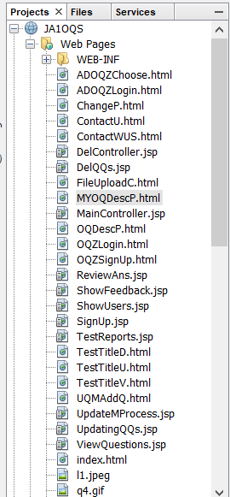 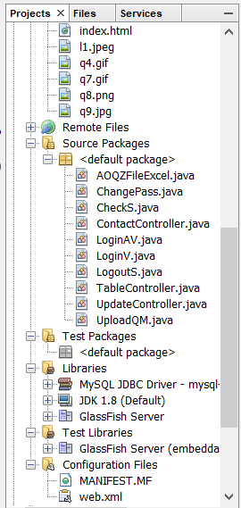

**SOURCE CODES:**

**HTML SOURCE CODE:**

**Index.html:**

<!DOCTYPE html>

<html>

<head>

<title>START YOUR QUIZ</title>

<meta charset="UTF-8">

<meta name="viewport" content="width=device-width, initial-scale=1.0">

<style>

body {

color:rgb(42, 0, 92);

background-image: url("q7.gif");

background-position: 50% 25%;

z-index: -1;

background-repeat: no-repeat;

background-color:snow;

font-size:16px;

}

p{

font-size:21px;

}

button,ol {

text-shadow: 2px 2px 5px red;

border-radius: 25px;

background-color:darkgreen;

font-size:30px;

color:darkgreen;

font-weight:bold;

border: none;

color: white;

padding: 15px 32px;

text-align: center;

text-decoration: none;

display: inline-block;

font-size: 16px;

margin: 4px 2px;

}

ul {

list-style-type: none;

margin: 0;

padding: 0;

overflow: hidden;

background-color: #333;

}

li {

float: left;

border-right:1px solid #bbb;

}

li:last-child {

border-right: none;

}

li a {

display: block;

color: white;

text-align: center;

padding: 14px 16px;

text-decoration: none;

}

li a:hover:not(.active) {

background-color: #111;

}

.active {

background-color: #4CAF50;

}

.logo-img{

position: relative;

margin: 10px 15px 15px 10px;

}.logo-img1{

float:right;

position: relative;

margin: 10px 15px 15px 10px;

}

footer{

background-color:black

}

</style>

</head>

<body>

<ul>

<li><a href="index.html">Home</a></li>

<li><a href="OQZLogin.html">Login</a></li>

<li><a href="OQZSignUp.html">Sign-Up</a></li>

<li><a href="ContactWUS.html">Contact-Us</a></li>

<li><a href="ContactU.html">Feedback</a></li>

<li><a href="ADOQZLogin.html">Admin</a></li>

</ul>

<center>

<img class="logo-img" src="l1.jpeg" width="230" height="145" ALT="align box">

</center>

<hr><hr>

<center><h2> WHY QuizYourIQ??? </h2></center>

<center><h4>LEARNING CAN BE FUN </h4></center>

<p><b>

Using QuizYourIQ for review and/or formative assessment is a great way to make learning fun and engaging. Instead of calling on a few students during review, every student is responsible for reviewing, practicing, and learning important information.

QuizYourIQ keep student's attention focused on review.

QuizYourIQ allow for much easier cumulative review so students don't forget information you want them to know.

Create challenges for high score or fastest completion to increase competition between students and award excellence.

Great for better, before or after a lesson presentation, and/or at the end of class.</b></p>

<br><br>

<hr><hr>

<center>

<h2>OUR BRANDS PARTNERS:</h2>

<img src="q8.png" width="550" height="275" ALT="align box">

<br><br>

<hr><hr>

<h2>Do you QuizYourIQ??? Then Do It</h2>

<br><br>

<button onclick="window.location.href='ADOQZLogin.html'">ADMIN LOGIN</button>

<button onclick="window.location.href='OQZLogin.html'">STUDENT LOGIN</button>

<br><br>

</center>

<footer>

<center><h1 style="color: white">© QuizYourIQ, Inc. ALL RIGHTS RESERVED 2019</h1>

<h2 style="color: white">Created By: NARENDER KESWANI</h2>

</center>

</footer>

</body>

</html>

**ADOQZChoose.html:**

<!DOCTYPE html>

<html>

<head>

<title>START YOUR QUIZ</title>

<meta charset="UTF-8">

<meta name="viewport" content="width=device-width, initial-scale=1.0">

<style>

body {

background-color:snow;

color: snow;

background:url(q9.jpg);

background-position: center;

background-repeat: no-repeat;

background-size: cover;

font-family: Arial, Helvetica, sans-serif;

}

button {

width: 65%;

padding: 15px;

font-weight:bold;

text-shadow: 2px 2px 5px red;

display: inline-block;

font-size: 16px;

border-radius: 25px;

background-color: darkgreen;

color: white;

border: none;

cursor: pointer;

opacity: 0.9;

}

button:hover {

opacity:1;

}

div {

background-image: linear-gradient(#093028,#237A57);

border-radius: 21px;

padding: 10px;

width: 550px;

height: 475px;

}

ul {

list-style-type: none;

margin: 0;

padding: 0;

overflow: hidden;

background-color: #333;

}

li {

float: left;

border-right:1px solid #bbb;

}

li:last-child {

border-right: none;

}

li a {

display: block;

color: white;

text-align: center;

padding: 14px 16px;

text-decoration: none;

}

li a:hover:not(.active) {

background-color: #111;

}

.active {

background-color: #4CAF50;

}

.logo-img{

position: relative;

margin: 10px 15px 15px 10px;

}.logo-img1{

float:right;

position: relative;

margin: 10px 15px 15px 10px;

}

footer{

background-color:black;

}

</style>

</head>

<body>

<center>

<div>

<center>

<img class="logo-img" src="l1.jpeg" width="230" height="145" ALT="align box">

</center>

<center>

<h3>CHOOSE YOUR OPTION</h3>

<button onclick="window.location.href='UQMAddQ.html'">UPLOAD QUESTIONS MANUALLY</button><br><br>

<button onclick="window.location.href='FileUploadC.html'">UPLOAD EXCEL FILE </button>

</center>

</div>

</center>

<footer>

<center><h1 style="color: white">© QuizYourIQ, Inc. ALL RIGHTS RESERVED 2019</h1>

<h2 style="color: white">Created By: NARENDER KESWANI</h2>

</center>

</footer>

</body>

</html>

**ADOQZLogin.html:**

<!DOCTYPE html>

<!--

To change this license header, choose License Headers in Project Properties.

To change this template file, choose Tools | Templates

and open the template in the editor.

-->

<html>

<head>

<style>

body {

background-color:snow;

color: snow;

background:url(q9.jpg);

background-position: center;

background-repeat: no-repeat;

background-size: cover;

font-family: Arial, Helvetica, sans-serif;

}

input[type=text], input[type=password] {

width: 65%;

padding: 15px;

margin: 5px 22px ;

display: inline-block;

border: none;

border-radius: 25px;

}

input[type=submit],input[type=reset],input[type=button]{

width: 45%;

padding: 13px;

font-weight:bold;

text-shadow: 2px 2px 5px red;

display: inline-block;

font-size: 16px;

border-radius: 25px;

color:darkgreen;

background-color: darkgreen;

color: white;

border: none;

cursor: pointer;

opacity: 0.9;

}

input[type=text]:focus, input[type=password]:focus ,input[type=file]:focus,input[type=date]:focus,input[type=email]{

background-color: #ddd;

outline: none;

}

div {

background-image: linear-gradient(#093028,#237A57);

border-radius: 21px;

padding: 10px;

width: 550px;

height: 525px;

}

ul {

list-style-type: none;

margin: 0;

padding: 0;

overflow: hidden;

background-color: #333;

}

li {

float: left;

border-right:1px solid #bbb;

}

li:last-child {

border-right: none;

}

li a {

display: block;

color: white;

text-align: center;

padding: 14px 16px;

text-decoration: none;

}

li a:hover:not(.active) {

background-color: #111;

}

.active {

background-color: #4CAF50;

}

.logo-img{

position: relative;

margin: 10px 15px 15px 10px;

}.logo-img1{

float:right;

position: relative;

margin: 10px 15px 15px 10px;

}

footer{

background-color:black;

}

</style>

<title>LOGIN</title>

<meta charset="UTF-8">

<meta name="viewport" content="width=device-width, initial-scale=1.0">

</head>

<body>

<br><br>

<center>

<div>

<form action="LoginAV" method="POST">

<center>

<img class="logo-img" src="l1.jpeg" width="230" height="145" ALT="align box">

</center>

<center>

<h3>ADMIN LOG IN</h3>

<p><b>Login Here using your username & password</b></p>

<br><br>

<b>

USERNAME: <input type="text" name="uname" placeholder="ENTER YOUR USERNAME"><br><br>

PASSWORD: <input type="password" name="pname" placeholder="ENTER YOUR PASSWORD"><br><br>

<input type="submit" value="SUBMIT">

<input type="reset" value="RESET"><br><br>

</b>

</center>

</form>

</div>

</center>

<footer>

<center><h1 style="color: white">© QuizYourIQ, Inc. ALL RIGHTS RESERVED 2019</h1>

<h2 style="color: white">Created By: NARENDER KESWANI</h2>

</center>

</footer>

</body>

</html>

**ChangeP.html:**

<!DOCTYPE html>

<!--

To change this license header, choose License Headers in Project Properties.

To change this template file, choose Tools | Templates

and open the template in the editor.

-->

<html>

<head>

<title>TODO supply a title</title>

<meta charset="UTF-8">

<meta name="viewport" content="width=device-width, initial-scale=1.0">

<style>

body {

background-color:snow;

color: snow;

background:url(q9.jpg);

background-position: center;

background-repeat: no-repeat;

background-size: cover;

font-family: Arial, Helvetica, sans-serif;

}

input[type=text], input[type=password] {

width: 65%;

padding: 15px;

margin: 5px 22px ;

display: inline-block;

border: none;

border-radius: 25px;

}

input[type=submit],input[type=reset],input[type=button]{

width: 55%;

padding: 7px;

font-weight:bold;

text-shadow: 2px 2px 5px red;

display: inline-block;

font-size: 16px;

border-radius: 25px;

color:darkgreen;

background-color: darkgreen;

color: white;

border: none;

cursor: pointer;

opacity: 0.9;

}

input[type=text]:focus, input[type=password]:focus ,input[type=file]:focus,input[type=date]:focus,input[type=email]{

background-color: #ddd;

outline: none;

}

div {

background-image: linear-gradient(#093028,#237A57);

border-radius: 21px;

padding: 10px;

width: 450px;

height: 550px;

text-align: center;

}

ul {

list-style-type: none;

margin: 0;

padding: 0;

overflow: hidden;

background-color: #333;

}

li {

float: left;

border-right:1px solid #bbb;

}

li:last-child {

border-right: none;

}

li a {

display: block;

color: white;

text-align: center;

padding: 14px 16px;

text-decoration: none;

}

li a:hover:not(.active) {

background-color: #111;

}

.active {

background-color: #4CAF50;

}

.logo-img{

position: relative;

margin: 10px 15px 15px 10px;

}.logo-img1{

float:right;

position: relative;

margin: 10px 15px 15px 10px;

}

footer{

background-color:black;

}

table{

width:350px;

height:350px;

}

table {

border-collapse: collapse;

background-image: linear-gradient(#000428,#004e92);

}

</style>

</head>

<body>

<form action="ChangePass" method="post">

<center>

<div>

<center>

<img class="logo-img" src="l1.jpeg" width="230" height="145" ALT="align box">

</center>

<center><br><br>

User name: <input type="text" name="uname" placeholder="Enter your Username"><br><br>

Current Password: <input type="password" name="current" placeholder="Enter your current Password"><br><br>

New Password: <input type="password" name="new" placeholder="Enter your new Password"><br><br>

<input type="submit" value="Change Password">

</center></div>

</center>

</form>

<footer>

<center><h1 style="color: white">© QuizYourIQ, Inc. ALL RIGHTS RESERVED 2019</h1>

<h2 style="color: white">Created By: NARENDER KESWANI</h2>

</center>

</footer>

</body>

</html>

**ContactU.html:**

<!DOCTYPE html>

<!--

To change this license header, choose License Headers in Project Properties.

To change this template file, choose Tools | Templates

and open the template in the editor.

-->

<html>

<head>

<style>

body {

background-color:snow;

color: snow;

background:url(q9.jpg);

background-position: center;

background-repeat: no-repeat;

background-size: cover;

font-family: Arial, Helvetica, sans-serif;

}

input[type=text], input[type=password] ,input[type=number],input[type=email],textarea {

width: 65%;

padding: 15px;

margin: 5px 22px ;

display: inline-block;

border: none;

border-radius: 25px;

}

input[type=submit],input[type=reset],input[type=file] {

width: 65%;

padding: 15px;

font-weight:bold;

text-shadow: 2px 2px 5px red;

display: inline-block;

font-size: 16px;

border-radius: 25px;

color:darkgreen;

background-color: darkgreen;

color: white;

border: none;

cursor: pointer;

opacity: 0.9;

}

input[type=text]:focus, input[type=password]:focus ,input[type=file]:focus,input[type=date]:focus,input[type=email]:focus{

background-color: #ddd;

outline: none;

}

button,select,date {

width: 65%;

padding: 15px;

font-weight:bold;

text-shadow: 2px 2px 5px red;

display: inline-block;

font-size: 16px;

border-radius: 25px;

color:darkgreen;

background-color: #ddd;

color: white;

border: none;

cursor: pointer;

opacity: 0.9;

}

button:hover {

opacity:1;

}

div {

background-image: linear-gradient(#093028,#237A57);

border-radius: 21px;

padding: 10px;

width: 550px;

height: 625px;

}

ul {

list-style-type: none;

margin: 0;

padding: 0;

overflow: hidden;

background-color: #333;

}

li {

float: left;

border-right:1px solid #bbb;

}

li:last-child {

border-right: none;

}

li a {

display: block;

color: white;

text-align: center;

padding: 14px 16px;

text-decoration: none;

}

li a:hover:not(.active) {

background-color: #111;

}

.active {

background-color: #4CAF50;

}

.logo-img{

position: relative;

margin: 10px 15px 15px 10px;

}.logo-img1{

float:right;

position: relative;

margin: 10px 15px 15px 10px;

}

footer{

background-color:black;

}

</style>

<title>TODO supply a title</title>

<meta charset="UTF-8">

<meta name="viewport" content="width=device-width, initial-scale=1.0">

</head>

<body>

<center>

<div><form action="ContactController" method="post">

<center>

<img class="logo-img" src="l1.jpeg" width="230" height="145" ALT="align box">

</center>

NAME: <input type="text" name="name" placeholder="Enter your Name"><br><br>

PHONE: <input type="number" name="phone" placeholder="Enter your Phone number"><br><br>

EMAIL: <input type="email" name="email" placeholder="Enter your Email Address"><br><br>

FEEDBACK: <textarea placeholder="Enter your query" name="fb"></textarea><br><br>

<input type="submit"><br><br>

<input type="reset">

</form>

</div>

</center>

<footer>

<center><h1 style="color: white">© QuizYourIQ, Inc. ALL RIGHTS RESERVED 2019</h1>

<h2 style="color: white">Created By: NARENDER KESWANI</h2>

</center>

</footer>

</body>

</html>

**ContactWUS.html:**

<!DOCTYPE html>

<!--

To change this license header, choose License Headers in Project Properties.

To change this template file, choose Tools | Templates

and open the template in the editor.

-->

<html>

<head>

<title>TODO supply a title</title>

<meta charset="UTF-8">

<meta name="viewport" content="width=device-width, initial-scale=1.0">

<style>

body {

background-color:snow;

color: snow;

background:url(q9.jpg);

background-position: center;

background-repeat: no-repeat;

background-size: cover;

font-family: Arial, Helvetica, sans-serif;

}

input[type=text], input[type=password] {

width: 65%;

padding: 15px;

margin: 5px 22px ;

display: inline-block;

border: none;

border-radius: 25px;

}

input[type=submit],input[type=reset],input[type=button]{

width: 25%;

padding: 7px;

font-weight:bold;

text-shadow: 2px 2px 5px red;

display: inline-block;

font-size: 16px;

border-radius: 25px;

color:darkgreen;

background-color: darkgreen;

color: white;

border: none;

cursor: pointer;

opacity: 0.9;

}

input[type=text]:focus, input[type=password]:focus ,input[type=file]:focus,input[type=date]:focus,input[type=email]{

background-color: #ddd;

outline: none;

}

p{

color: darkblue;

}

div {

background-image: linear-gradient(#093028,#237A57);

border-radius: 21px;

padding: 10px;

width: 550px;

height: 770px;

text-align: center;

}

ul {

list-style-type: none;

margin: 0;

padding: 0;

overflow: hidden;

background-color: #333;

}

li {

float: left;

border-right:1px solid #bbb;

}

li:last-child {

border-right: none;

}

li a {

display: block;

color: white;

text-align: center;

padding: 14px 16px;

text-decoration: none;

}

li a:hover:not(.active) {

background-color: #111;

}

.active {

background-color: #4CAF50;

}

.logo-img{

position: relative;

margin: 10px 15px 15px 10px;

}.logo-img1{

float:right;

position: relative;

margin: 10px 15px 15px 10px;

}

table {

border-collapse: collapse;

background-image: linear-gradient(#000428,#004e92);

}

footer{

background-color: black;

}

</style>

</head>

<body>

<center>

<div>

<h2>Contact Number:</h2>

<a href="tel:9320907041">Call (+91) 9320907041</a><br><br>

<h2>Email Address:</h2>

<a href = "mailto: narender.rk10@gmail.com">narender.rk10@gmail.com</a><br><br>

<h2>Office Address:</h2>

<p>

SATNAM - 'H' APARTMENT, FLAT NO: 07; 2 nd FLOOR, <br><br>

NEAR ROYAL ALFA MEDICAL STORE, GOL MIADIAN , <br><br>

POST-OFFICE-1 ROAD, ULHASNAGAR, <br><br>

MAHARASHTRA, INDIA - 421001 <br><br></p>

<b>CHECK OUR LOCATION:</b><br>

<iframe src="https://www.google.com/maps/embed?pb=!1m18!1m12!1m3!1d3767.0408451675585!2d73.15625541345852!3d19.237051586995708!2m3!1f0!2f0!3f0!3m2!1i1024!2i768!4f13.1!3m3!1m2!1s0x3be7943d5f3dc2e7%3A0x1d3fe85198bfe917!2zU0FUTkFNIOKAmEjigJkgQVBBUlRNRU5U!5e0!3m2!1sen!2sin!4v1567779760201!5m2!1sen!2sin" width="400" height="300" frameborder="0" style="border:0;" allowfullscreen=""></iframe>

</div>

</center>

<footer>

<center><h1 style="color: white">© QuizYourIQ, Inc. ALL RIGHTS RESERVED 2019</h1></center>

</footer>

</body>

</html>

**FileUploadC.html:**

<!DOCTYPE html>

<!--

To change this license header, choose License Headers in Project Properties.

To change this template file, choose Tools | Templates

and open the template in the editor.

-->

<html>

<head>

<title>EXCEL FILE UPLOAD</title>

<meta charset="UTF-8">

<meta name="viewport" content="width=device-width, initial-scale=1.0">

<style>

body {

background-color:snow;

color: snow;

background:url(q9.jpg);

background-position: center;

background-repeat: no-repeat;

background-size: cover;

font-family: Arial, Helvetica, sans-serif;

}

input[type=text], input[type=password] {

width: 65%;

padding: 15px;

margin: 5px 22px ;

display: inline-block;

border: none;

border-radius: 25px;

}

input[type=submit],input[type=reset],input[type=button],input[type=file],select{

width: 55%;

padding: 11px;

font-weight:bold;

text-shadow: 2px 2px 5px red;

display: inline-block;

font-size: 16px;

border-radius: 25px;

color:darkgreen;

background-color: darkgreen;

color: white;

border: none;

cursor: pointer;

opacity: 0.9;

}

input[type=file]:focus, input[type=password]:focus ,input[type=file]:focus,input[type=date]:focus,input[type=email]{

background-color: #ddd;

outline: none;

}

div {

background-image: linear-gradient(#093028,#237A57);

border-radius: 21px;

padding: 10px;

width: 550px;

height: 500px;

text-align: center;

}

ul {

list-style-type: none;

margin: 0;

padding: 0;

overflow: hidden;

background-color: #333;

}

li {

float: left;

border-right:1px solid #bbb;

}

li:last-child {

border-right: none;

}

li a {

display: block;

color: white;

text-align: center;

padding: 14px 16px;

text-decoration: none;

}

li a:hover:not(.active) {

background-color: #111;

}

.active {

background-color: #4CAF50;

}

.logo-img{

position: relative;

margin: 10px 15px 15px 10px;

}.logo-img1{

float:right;

position: relative;

margin: 10px 15px 15px 10px;

}

footer{

background-color:black;

}

table{

width:350px;

height:350px;

}

table {

border-collapse: collapse;

background-image: linear-gradient(#000428,#004e92);

}

</style>

</head>

<body>

<center>

<div>

<center>

<form action="AOQZFileExcel" method="post" enctype="multipart/form-data">

<center>

<img class="logo-img" src="l1.jpeg" width="230" height="145" ALT="align box">

</center><br><br><br>

<b>

TEST TITLE:

<select name="t1">

<option>JAVA</option>

<option>MYSQL</option>

<option>WEBPROGRAMMING</option>

<option>SOFTWARETESTING</option>

<option>C</option>

<option>COMPUTERNETWORKS</option>

</select><br><br><br>

FILE: <input type="file" name="file"><br><br><br>

<input type="submit" value="UPLOAD YOUR FILE"><br><br>

</b>

</form>

</center>

</div>

</center>

<footer>

<center><h1 style="color: white">© QuizYourIQ, Inc. ALL RIGHTS RESERVED 2019</h1>

<h2 style="color: white">Created By: NARENDER KESWANI</h2>

</center>

</footer>

</body>

</html>

**MYOQDescP.html:**

<!DOCTYPE html>

<html>

<head>

<title>START YOUR QUIZ</title>

<meta charset="UTF-8">

<meta name="viewport" content="width=device-width, initial-scale=1.0">

<style>

body {

background-color:snow;

color: snow;

background:url(q9.jpg);

background-position: center;

background-repeat: no-repeat;

background-size: cover;

font-family: Arial, Helvetica, sans-serif;

}

input[type=text], input[type=password] {

width: 65%;

padding: 15px;

margin: 5px 22px ;

display: inline-block;

border: none;

border-radius: 25px;

}

input[type=submit],input[type=reset],input[type=button],select{

width: 55%;

padding: 7px;

font-weight:bold;

text-shadow: 2px 2px 5px red;

display: inline-block;

font-size: 16px;

border-radius: 25px;

color:darkgreen;

background-color: darkgreen;

color: white;

border: none;

cursor: pointer;

opacity: 0.9;

}

input[type=text]:focus, input[type=password]:focus ,input[type=file]:focus,input[type=date]:focus,input[type=email]{

background-color: #ddd;

outline: none;

}

div {

background-image: linear-gradient(#093028,#237A57);

border-radius: 21px;

padding: 10px;

width: 550px;

height: 550px;

text-align: center;

}

ul {

list-style-type: none;

margin: 0;

padding: 10px;

overflow: hidden;

background-color: #333;

}

li {

float: left;

border-right:1px solid #bbb;

}

li:last-child {

border-right: none;

}

li a {

display: block;

color: white;

text-align: center;

padding: 3px 5px;

text-decoration: none;

}

li a:hover:not(.active) {

background-color: darkgreen;

}

.active {

background-color: #4CAF50;

}

.logo-img{

position: relative;

margin: 10px 15px 15px 10px;

}.logo-img1{

float:right;

position: relative;

margin: 10px 15px 15px 10px;

}

footer{

background-color:black;

}

table{

width:350px;

height:350px;

}

table {

border-collapse: collapse;

background-image: linear-gradient(#000428,#004e92);

}

p{

text-align: left;

}

</style>

</head>

<body>

<center>

<form action="ADOQZChoose.html" method="post">

<ul>

<li><a href="MYOQDescP.html">INSERT QUESTIONS</a></li>

<li><a href="TestTitleU.html">UPDATE QUESTIONS</a></li>

<li><a href="TestTitleD.html">DELETE QUESTIONS</a></li>

<li><a href="TestTitleV.html">VIEW QUESTIONS</a></li>

<li><a href="ShowUsers.jsp">SHOW USERS</a></li>

<li><a href="ShowFeedback.jsp">USERS FEEDBACK</a></li>

<li><a href="LogoutS">LOGOUT</a></li>

</ul>

<br><br>

<div>

<br><br>

<center>

<img class="logo-img" src="l1.jpeg" width="230" height="145" ALT="align box">

</center>

<center>

<h3>INFORMATION OF MAKING A QUIZ</h3>

</center>

<p><b>

1. YOU HAVE 2 OPTIONS FOR UPLOADING QUESTION <br>

2. MANUALLY ENTERING QUESTIONS <br>

3. UPLOADING A EXCEL FILE (.CSV) <br>

4. OUR SYSTEM ONLY ACCEPT .CSV FILE , NOT ANY OTHER EXTENSIONS <br>

5. TOTAL MARK FOR THE ONE QUIZ QUESTION CARRIES 01 MARK <br>

</b></p>

<center>

<input type="submit" value="Make your quiz"/>

</center>

</form>

</div>

</center>

<footer>

<center><h1 style="color: white">© QuizYourIQ, Inc. ALL RIGHTS RESERVED 2019</h1>

<h2 style="color: white">Created By: NARENDER KESWANI</h2>

</center>

</footer>

</body>

</html>

**OQDescP.html:**

<!DOCTYPE html>

<html>

<head>

<title>START YOUR QUIZ</title>

<meta charset="UTF-8">

<meta name="viewport" content="width=device-width, initial-scale=1.0">

<style>

body {

background-color:snow;

color: snow;

background:url(q9.jpg);

background-position: center;

background-repeat: no-repeat;

background-size: cover;

font-family: Arial, Helvetica, sans-serif;

}

input[type=text], input[type=password] {

width: 65%;

padding: 15px;

margin: 5px 22px ;

display: inline-block;

border: none;

border-radius: 25px;

}

input[type=submit],input[type=reset],input[type=button],select{

width: 55%;

padding: 7px;

font-weight:bold;

text-shadow: 2px 2px 5px red;

display: inline-block;

font-size: 16px;

border-radius: 25px;

color:darkgreen;

background-color: darkgreen;

color: white;

border: none;

cursor: pointer;

opacity: 0.9;

}

input[type=text]:focus, input[type=password]:focus ,input[type=file]:focus,input[type=date]:focus,input[type=email]{

background-color: #ddd;

outline: none;

}

div {

background-image: linear-gradient(#093028,#237A57);

border-radius: 21px;

padding: 10px;

width: 550px;

height: 550px;

text-align: center;

}

ul {

list-style-type: none;

margin: 0;

padding: 0;

overflow: hidden;

background-color: #333;

}

li {

float: left;

border-right:1px solid #bbb;

}

li:last-child {

border-right: none;

}

li a {

display: block;

color: white;

text-align: center;

padding: 14px 16px;

text-decoration: none;

}

li a:hover:not(.active) {

background-color: #111;

}

.active {

background-color: #4CAF50;

}

.logo-img{

position: relative;

margin: 10px 15px 15px 10px;

}.logo-img1{

float:right;

position: relative;

margin: 10px 15px 15px 10px;

}

footer{

background-color:black;

}

table{

width:350px;

height:350px;

}

table {

border-collapse: collapse;

background-image: linear-gradient(#000428,#004e92);

}

p{

text-align: left;

}

</style>

</head>

<body>

<center>

<div>

<form action="TableController" method="post">

<br><br>

<center>

<img class="logo-img" src="l1.jpeg" width="230" height="145" ALT="align box">

</center>

<center>

SELECT YOUR QUIZ:

<select name="t1">

<option>JAVA</option>

<option>MYSQL</option>

<option>WEB PROGRAMMING</option>

<option>SOFTWARE TESTING</option>

<option>C++</option>

<option>COMPUTER NETWORKS</option>

</select><br><br>

<h3>INFORMATION OF QUIZ</h3>

</center>

<p><b>

1. EVERY QUESTION CARRIES 1 MARK <br>

2. GIVING A RIGHT ANSWER YOU WILL GET A 1 MARK, IF YOUR ANSWER IS INCORRECT THEN 1 MARK WILL BE DEDUCTED (NEGATIVE MARKING)<br>

3. THERE ARE TOTAL 20 QUESTIONS ARE AVAILABLE <br>

4. TOTAL MARKS FOR THIS QUIZ IS 20 MARKS <br>

</b></p>

<br><br>

<center>

<input type="submit" value="Start your quiz"/>

</center>

</form>

</div>

</center>

<footer>

<center><h1 style="color: white">© QuizYourIQ, Inc. ALL RIGHTS RESERVED 2019</h1>

<h2 style="color: white">Created By: NARENDER KESWANI</h2>

</center>

</footer>

</body>

</html>

**OQZLogin.html:**

<!DOCTYPE html>

<!--

To change this license header, choose License Headers in Project Properties.

To change this template file, choose Tools | Templates

and open the template in the editor.

-->

<html>

<head>

<style>

body {

background-color:snow;

color: snow;

background:url(q9.jpg);

background-position: center;

background-repeat: no-repeat;

background-size: cover;

font-family: Arial, Helvetica, sans-serif;

}

input[type=text], input[type=password] {

width: 65%;

padding: 15px;

margin: 5px 22px ;

display: inline-block;

border: none;

border-radius: 25px;

}

input[type=submit],input[type=reset],input[type=button]{

width: 45%;

padding: 7px;

font-weight:bold;

text-shadow: 2px 2px 5px red;

display: inline-block;

font-size: 16px;

border-radius: 25px;

color:darkgreen;

background-color: darkgreen;

color: white;

border: none;

cursor: pointer;

opacity: 0.9;

}

input[type=text]:focus, input[type=password]:focus ,input[type=file]:focus,input[type=date]:focus,input[type=email]{

background-color: #ddd;

outline: none;

}

div {

background-image: linear-gradient(#093028,#237A57);

border-radius: 21px;

padding: 10px;

width: 550px;

height: 650px;

}

ul {

list-style-type: none;

margin: 0;

padding: 0;

overflow: hidden;

background-color: #333;

}

li {

float: left;

border-right:1px solid #bbb;

}

li:last-child {

border-right: none;

}

li a {

display: block;

color: white;

text-align: center;

padding: 14px 16px;

text-decoration: none;

}

li a:hover:not(.active) {

background-color: #111;

}

.active {

background-color: #4CAF50;

}

.logo-img{

position: relative;

margin: 10px 15px 15px 10px;

}.logo-img1{

float:right;

position: relative;

margin: 10px 15px 15px 10px;

}

footer{

background-color:black;

}

</style>

<title>LOGIN</title>

<meta charset="UTF-8">

<meta name="viewport" content="width=device-width, initial-scale=1.0">

</head>

<body>

<ul>

<li><a href="index.html">Home</a></li>

<li><a href="OQZSignUp.html">Sign-Up</a></li>

<li><a href="ContactWUS.html">Contact-Us</a></li>

<li><a href="ContactU.html">Feedback</a></li>

<li><a href="ADOQZLogin.html">Admin</a></li>

</ul>

<br><br>

<center>

<div>

<form action="LoginV" method="POST">

<center>

<img class="logo-img" src="l1.jpeg" width="230" height="145" ALT="align box">

</center>

<center>

<h3>LOG IN</h3>

<p><b>Login Here using your username & password</b></p>

<br><br>

<b>

USERNAME: <input type="text" name="uname1" placeholder="ENTER YOUR USERNAME"><br><br>

PASSWORD: <input type="password" name="pname1" placeholder="ENTER YOUR PASSWORD"><br><br>

<input type="submit" value="SUBMIT">

<input type="reset" value="RESET"><br><br>

<input type="button" onclick="window.location.href = 'ChangeP.html';" value="CHANGE PASSWORD?">

<input type="button" onclick="window.location.href = 'OQZSignUp.html';" value="NEW USER? SIGN UP NOW">

</b>

</center>

</form>

</div>

</center>

<footer>

<center><h1 style="color: white">© QuizYourIQ, Inc. ALL RIGHTS RESERVED 2019</h1>

<h2 style="color: white">Created By: NARENDER KESWANI</h2>

</center>

</footer>

</body>

</html>

**OQZSignUp.html:**

<!DOCTYPE html>

<!--

To change this license header, choose License Headers in Project Properties.

To change this template file, choose Tools | Templates

and open the template in the editor.

-->

<html>

<head>

<title>SIGN-UP NOW</title>

<meta charset="UTF-8">

<meta name="viewport" content="width=device-width, initial-scale=1.0">

<style>

body {

background-color:snow;

color: snow;

background:url(q9.jpg);

background-position: center;

background-repeat: no-repeat;

background-size: cover;

font-family: Arial, Helvetica, sans-serif;

}

input[type=text], input[type=password],input[type=email] {

width: 65%;

padding: 15px;

margin: 5px 22px ;

display: inline-block;

border: none;

border-radius: 25px;

}

input[type=submit],input[type=reset],input[type=button],select{

width: 75%;

padding: 11px;

font-weight:bold;

text-shadow: 2px 2px 5px red;

display: inline-block;

font-size: 16px;

border-radius: 25px;

color:darkgreen;

background-color: darkgreen;

color: white;

border: none;

cursor: pointer;

opacity: 0.9;

}

input[type=text]:focus, input[type=password]:focus ,input[type=file]:focus,input[type=date]:focus,input[type=email]{

background-color: #ddd;

outline: none;

}

div {

background-image: linear-gradient(#093028,#237A57);

border-radius: 21px;

padding: 10px;

width: 550px;

height: 850px;

text-align: center;

}

ul {

list-style-type: none;

margin: 0;

padding: 0;

overflow: hidden;

background-color: #333;

}

li {

float: left;

border-right:1px solid #bbb;

}

li:last-child {

border-right: none;

}

li a {

display: block;

color: white;

text-align: center;

padding: 14px 16px;

text-decoration: none;

}

li a:hover:not(.active) {

background-color: #111;

}

.active {

background-color: #4CAF50;

}

.logo-img{

position: relative;

margin: 10px 15px 15px 10px;

}.logo-img1{

float:right;

position: relative;

margin: 10px 15px 15px 10px;

}

footer{

background-color:black;

}

table{

width:350px;

height:350px;

}

table {

border-collapse: collapse;

background-image: linear-gradient(#000428,#004e92);

}

p{

text-align: left;

}

</style>

</head>

<body>

<ul>

<li><a href="index.html">Home</a></li>

<li><a href="ContactWUS.html">Contact Us</a></li>

<li><a href="ContactU.html">Feedback</a></li>

</ul>

<br><br><br>

<center>

<div>

<form action="SignUp.jsp" method="post">

<center>

<img class="logo-img" src="l1.jpeg" width="230" height="145" ALT="align box">

</center>

<b>

<br>

For QuizYourIQ SIGN-UP NOW!<br><br><br>

NAME: <input type="text" name="name" placeholder="Enter your Name" required><br><br>

USERNAME: <input type="text" name="uname" placeholder="Enter your username" required><br><br>

PASSWORD:<input type="password" name="pname" placeholder="Enter your password" required><br><br>

PHONE: <input type="text" name="phnn" placeholder="Enter your Phone number" required><br><br>

EMAIL: <input type="email" name="en" placeholder="Enter your Email Address" required><br><br>

OCCUPATION:

<select name="occ">

<option>Student</option>

<option>Other</option>

</select><br><br>

COUNTRY:

<select name="uc">

<option>India</option>

<option>Pakistan</option>

<option>other</option>

</select><br><br>

<input type="Submit" value="SIGN-UP"><br><br>

<input type="Reset" value="RESET"><br><br>

</b>

</form>

</div>

</center>

<footer>

<center><h1 style="color: white">© QuizYourIQ, Inc. ALL RIGHTS RESERVED 2019</h1>

<h2 style="color: white">Created By: NARENDER KESWANI</h2>

</center>

</footer>

</body>

</html>

**TestTitleD.html:**

<!DOCTYPE html>

<!--

To change this license header, choose License Headers in Project Properties.

To change this template file, choose Tools | Templates

and open the template in the editor.

-->

<html>

<head>

<title>TODO supply a title</title>

<meta charset="UTF-8">

<meta name="viewport" content="width=device-width, initial-scale=1.0">

<style>

body {

background-color:snow;

color: snow;

background:url(q9.jpg);

background-position: center;

background-repeat: no-repeat;

background-size: cover;

font-family: Arial, Helvetica, sans-serif;

}

input[type=text], input[type=password] {

width: 65%;

padding: 15px;

margin: 5px 22px ;

display: inline-block;

border: none;

border-radius: 25px;

}

input[type=submit],input[type=reset],input[type=button],select{

width: 55%;

padding: 7px;

font-weight:bold;

text-shadow: 2px 2px 5px red;

display: inline-block;

font-size: 16px;

border-radius: 25px;

color:darkgreen;

background-color: darkgreen;

color: white;

border: none;

cursor: pointer;

opacity: 0.9;

}

input[type=text]:focus, input[type=password]:focus ,input[type=file]:focus,input[type=date]:focus,input[type=email]{

background-color: #ddd;

outline: none;

}

div {

background-image: linear-gradient(#093028,#237A57);

border-radius: 21px;

padding: 10px;

width: 550px;

height: 550px;

text-align: center;

}

ul {

list-style-type: none;

margin: 0;

padding: 0;

overflow: hidden;

background-color: #333;

}

li {

float: left;

border-right:1px solid #bbb;

}

li:last-child {

border-right: none;

}

li a {

display: block;

color: white;

text-align: center;

padding: 14px 6px;

text-decoration: none;

}

li a:hover:not(.active) {

background-color: #111;

}

.active {

background-color: #4CAF50;

}

.logo-img{

position: relative;

margin: 10px 15px 15px 10px;

}.logo-img1{

float:right;

position: relative;

margin: 10px 15px 15px 10px;

}

footer{

background-color:black;

}

table{

width:350px;

height:350px;

}

table {

border-collapse: collapse;

background-image: linear-gradient(#000428,#004e92);

}

p{

text-align: left;

}

</style>

</head>

<body>

<center>

<form action="DelQQs.jsp" method="post">

<ul>

<li><a href="MYOQDescP.html">INSERT QUESTIONS</a></li>

<li><a href="TestTitleU.html">UPDATE QUESTIONS</a></li>

<li><a href="TestTitleD.html">DELETE QUESTIONS</a></li>

<li><a href="TestTitleV.html">VIEW QUESTIONS</a></li>

<li><a href="ShowUsers.jsp">SHOW USERS</a></li>

<li><a href="ShowFeedback.jsp">USERS FEEDBACK</a></li>

<li><a href="LogoutS">LOGOUT</a></li>

</ul>

<br><br>

<div>

<center>

<img class="logo-img" src="l1.jpeg" width="230" height="145" ALT="align box">

</center>

<center>

SELECT YOUR QUIZ:

<select name="t1">

<option>JAVA</option>

<option>MYSQL</option>

<option>WEBPROGRAMMING</option>

<option>SOFTWARETESTING</option>

<option>C</option>

<option>COMPUTERNETWORKS</option>

</select><br><br>

<input type="submit" value="START DELETE">

</form>

<footer>

<center><h1 style="color: white">© QuizYourIQ, Inc. ALL RIGHTS RESERVED 2019</h1>

<h2 style="color: white">Created By: NARENDER KESWANI</h2>

</center>

</footer>

</body>

</html>

**TestTitleU.html:**

<!DOCTYPE html>

<!--

To change this license header, choose License Headers in Project Properties.

To change this template file, choose Tools | Templates

and open the template in the editor.

-->

<html>

<head>

<title>TODO supply a title</title>

<meta charset="UTF-8">

<meta name="viewport" content="width=device-width, initial-scale=1.0">

<style>

body {

background-color:snow;

color: snow;

background:url(q9.jpg);

background-position: center;

background-repeat: no-repeat;

background-size: cover;

font-family: Arial, Helvetica, sans-serif;

}

input[type=text], input[type=password] {

width: 65%;

padding: 15px;

margin: 5px 22px ;

display: inline-block;

border: none;

border-radius: 25px;

}

input[type=submit],input[type=reset],input[type=button],select{

width: 55%;

padding: 7px;

font-weight:bold;

text-shadow: 2px 2px 5px red;

display: inline-block;

font-size: 16px;

border-radius: 25px;

color:darkgreen;

background-color: darkgreen;

color: white;

border: none;

cursor: pointer;

opacity: 0.9;

}

input[type=text]:focus, input[type=password]:focus ,input[type=file]:focus,input[type=date]:focus,input[type=email]{

background-color: #ddd;

outline: none;

}

div {

background-image: linear-gradient(#093028,#237A57);

border-radius: 21px;

padding: 10px;

width: 550px;

height: 550px;

text-align: center;

}

ul {

list-style-type: none;

margin: 0;

padding: 0;

overflow: hidden;

background-color: #333;

}

li {

float: left;

border-right:1px solid #bbb;

}

li:last-child {

border-right: none;

}

li a {

display: block;

color: white;

text-align: center;

padding: 14px 6px;

text-decoration: none;

}

li a:hover:not(.active) {

background-color: #111;

}

.active {

background-color: #4CAF50;

}

.logo-img{

position: relative;

margin: 10px 15px 15px 10px;

}.logo-img1{

float:right;

position: relative;

margin: 10px 15px 15px 10px;

}

footer{

background-color:black;

}

table{

width:350px;

height:350px;

}

table {

border-collapse: collapse;

background-image: linear-gradient(#000428,#004e92);

}

p{

text-align: left;

}

</style>

</head>

<body>

<center>

<form action="UpdatingQQs.jsp" method="post">

<ul>

<li><a href="MYOQDescP.html">INSERT QUESTIONS</a></li>

<li><a href="TestTitleU.html">UPDATE QUESTIONS</a></li>

<li><a href="TestTitleD.html">DELETE QUESTIONS</a></li>

<li><a href="TestTitleV.html">VIEW QUESTIONS</a></li>

<li><a href="ShowUsers.jsp">SHOW USERS</a></li>

<li><a href="ShowFeedback.jsp">USERS FEEDBACK</a></li>

<li><a href="LogoutS">LOGOUT</a></li>

</ul><br><br><br>

<div>

<br><br>

<center>

<img class="logo-img" src="l1.jpeg" width="230" height="145" ALT="align box">

</center>

<center>

SELECT YOUR QUIZ:

<select name="t1">

<option>JAVA</option>

<option>MYSQL</option>

<option>WEBPROGRAMMING</option>

<option>SOFTWARETESTING</option>

<option>C</option>

<option>COMPUTERNETWORKS</option>

</select><br><br>

<input type="submit" value="START UPDATE">

</form>

<footer>

<center><h1 style="color: white">© QuizYourIQ, Inc. ALL RIGHTS RESERVED 2019</h1>

<h2 style="color: white">Created By: NARENDER KESWANI</h2>

</center>

</footer>

</body>

</html>

**TestTitleV.html:**

<!DOCTYPE html>

<!--

To change this license header, choose License Headers in Project Properties.

To change this template file, choose Tools | Templates

and open the template in the editor.

-->

<html>

<head>

<title>TODO supply a title</title>

<meta charset="UTF-8">

<meta name="viewport" content="width=device-width, initial-scale=1.0">

<style>

body {

background-color:snow;

color: snow;

background:url(q9.jpg);

background-position: center;

background-repeat: no-repeat;

background-size: cover;

font-family: Arial, Helvetica, sans-serif;

}

input[type=text], input[type=password] {

width: 65%;

padding: 15px;

margin: 5px 22px ;

display: inline-block;

border: none;

border-radius: 25px;

}

input[type=submit],input[type=reset],input[type=button],select{

width: 55%;

padding: 7px;

font-weight:bold;

text-shadow: 2px 2px 5px red;

display: inline-block;

font-size: 16px;

border-radius: 25px;

color:darkgreen;

background-color: darkgreen;

color: white;

border: none;

cursor: pointer;

opacity: 0.9;

}

input[type=text]:focus, input[type=password]:focus ,input[type=file]:focus,input[type=date]:focus,input[type=email]{

background-color: #ddd;

outline: none;

}

div {

background-image: linear-gradient(#093028,#237A57);

border-radius: 21px;

padding: 10px;

width: 550px;

height: 550px;

text-align: center;

}

ul {

list-style-type: none;

margin: 0;

padding: 0;

overflow: hidden;

background-color: #333;

}

li {

float: left;

border-right:1px solid #bbb;

}

li:last-child {

border-right: none;

}

li a {

display: block;

color: white;

text-align: center;

padding: 14px 6px;

text-decoration: none;

}

li a:hover:not(.active) {

background-color: #111;

}

.active {

background-color: #4CAF50;

}

.logo-img{

position: relative;

margin: 10px 15px 15px 10px;

}.logo-img1{

float:right;

position: relative;

margin: 10px 15px 15px 10px;

}

footer{

background-color:black;

}

table{

width:350px;

height:350px;

}

table {

border-collapse: collapse;

background-image: linear-gradient(#000428,#004e92);

}

p{

text-align: left;

}

</style>

</head>

<body>

<center>

<form action="ViewQuestions.jsp" method="post">

<ul>

<li><a href="MYOQDescP.html">INSERT QUESTIONS</a></li>

<li><a href="TestTitleU.html">UPDATE QUESTIONS</a></li>

<li><a href="TestTitleD.html">DELETE QUESTIONS</a></li>

<li><a href="TestTitleV.html">VIEW QUESTIONS</a></li>

<li><a href="ShowUsers.jsp">SHOW USERS</a></li>

<li><a href="ShowFeedback.jsp">USERS FEEDBACK</a></li>

<li><a href="LogoutS">LOGOUT</a></li>

</ul><br><br>

<div>

<br><br>

<center>

<img class="logo-img" src="l1.jpeg" width="230" height="145" ALT="align box">

</center>

<center>

SELECT YOUR QUIZ:

<select name="t1">

<option>JAVA</option>

<option>MYSQL</option>

<option>WEBPROGRAMMING</option>

<option>SOFTWARETESTING</option>

<option>C</option>

<option>COMPUTERNETWORKS</option>

</select><br><br>

<input type="submit" value="VEW QUESTIONS">

</form>

<footer>

<center><h1 style="color: white">© QuizYourIQ, Inc. ALL RIGHTS RESERVED 2019</h1>

<h2 style="color: white">Created By: NARENDER KESWANI</h2>

</center>

</footer>

</body>

</html>

**UQMAddQ.html:**

<!DOCTYPE html>

<!--

To change this license header, choose License Headers in Project Properties.

To change this template file, choose Tools | Templates

and open the template in the editor.

-->

<html>

<head>

<title>TODO supply a title</title>

<meta charset="UTF-8">

<meta name="viewport" content="width=device-width, initial-scale=1.0">

<style>

body {

background-color:snow;

color: snow;

background:url(q9.jpg);

background-position: center;

background-repeat: no-repeat;

background-size: cover;

font-family: Arial, Helvetica, sans-serif;

}

input[type=text], input[type=password],textarea {

width: 95%;

padding: 15px;

margin: 5px 22px ;

display: inline-block;

border: none;

border-radius: 25px;

}

input[type=submit],input[type=reset],input[type=button],select{

width: 55%;

padding: 11px;

font-weight:bold;

text-shadow: 2px 2px 5px red;

display: inline-block;

font-size: 16px;

border-radius: 25px;

color:darkgreen;

background-color: darkgreen;

color: white;

border: none;

cursor: pointer;

opacity: 0.9;

}

input[type=text]:focus, input[type=password]:focus ,input[type=file]:focus,input[type=date]:focus,input[type=email]{

background-color: #ddd;

outline: none;

}

div {

background-image: linear-gradient(#093028,#237A57);

border-radius: 21px;

padding: 10px;

width: 600px;

height: 750px;

text-align: center;

}

ul {

list-style-type: none;

margin: 0;

padding: 0;

overflow: hidden;

background-color: #333;

}

li {

float: left;

border-right:1px solid #bbb;

}

li:last-child {

border-right: none;

}

li a {

display: block;

color: white;

text-align: center;

padding: 14px 6px;

text-decoration: none;

}

li a:hover:not(.active) {

background-color: #111;

}

.active {

background-color: #4CAF50;

}

.logo-img{

position: relative;

margin: 10px 15px 15px 10px;

}.logo-img1{

float:right;

position: relative;

margin: 10px 15px 15px 10px;

}

footer{

background-color:black;

}

table{

width:350px;

height:350px;

}

table {

border-collapse: collapse;

background-image: linear-gradient(#000428,#004e92);

}

p{

text-align: left;

}

</style>

</head>

<body>

<ul>

<li><a href="MYOQDescP.html">INSERT QUESTIONS</a></li>

<li><a href="TestTitleU.html">UPDATE QUESTIONS</a></li>

<li><a href="TestTitleD.html">DELETE QUESTIONS</a></li>

<li><a href="TestTitleV.html">VIEW QUESTIONS</a></li>

<li><a href="ShowUsers.jsp">SHOW USERS</a></li>

<li><a href="ShowFeedback.jsp">USERS FEEDBACK</a></li>

<li><a href="LogoutS">LOGOUT</a></li>

</ul><br><br>

<center>

<div>

<h2>ENTER YOUR QUESTIONS</h2><br>

<form action="UploadQM" method="post">

<b> TEST TITLE: </b>

<select name="tt">

<option>JAVA</option>

<option>MYSQL</option>

<option>WEBPROGRAMMING</option>

<option>SOFTWARETESTING</option>

<option>C</option>

<option>COMPUTERNETWORKS</option>

</select><br><br>

<center> <table border="1">

<tr><th>QUESTION NUMBER:</th><th>QUESTION:</th></tr>

<tr><td> <input type="text" style="width:120px; height:25px;" name="qid" placeholder="Enter your question number"></td>

<td><textarea rows="2" style="width:150px; height:40px;" cols="30" name="question" placeholder="Enter your question"></textarea></tr>

<tr><th>OPTION 1:</th>

<td><input type="text" style="width:130px; height:30px;" name="op1" placeholder="Enter your option 1"></td></tr>

<tr><th>OPTION 2:</th>

<td><input type="text" style="width:130px; height:30px;" name="op2" placeholder="Enter your option 2"></td></tr>

<tr><th>OPTION 3:</th>

<td><input type="text" style="width:130px; height:30px;" name="op3" placeholder="Enter your option 3"></td></tr>

<tr><th>OPTION 4:</th>

<td><input type="text" style="width:130px; height:30px;" name="op4" placeholder="Enter your option 4"></td></tr>

<tr><th>CORRECT ANSWER:</th>

<td><input type="text" style="width:130px; height:30px;" name="cans" placeholder="Enter your correct answer"></td></tr>

</table></center>

<br><br>

<input type="submit" value="SAVE YOUR QUESTIONS"><br><br><br>

<input type="reset">

</form>

</div>

</center>

<footer>

<center><h1 style="color: white">© QuizYourIQ, Inc. ALL RIGHTS RESERVED 2019</h1>

<h2 style="color: white">Created By: NARENDER KESWANI</h2>

</center>

</footer>

</body>

</html>

**JSP SOURCE CODE:**

**DelController.jsp:**

<%--

Document : DelController

Created on : Sep 5, 2019, 2:02:23 PM

Author : narender

--%>

<%@page import="java.sql.PreparedStatement"%>

<%@page import="java.sql.DriverManager"%>

<%@page import="java.sql.Connection"%>

<%@page contentType="text/html" pageEncoding="UTF-8"%>

<!DOCTYPE html>

<html>

<head>

<meta http-equiv="Content-Type" content="text/html; charset=UTF-8">

<title>DELETE QUIZ QUESTIONS</title>

</head>

<body>

<%

String cb[] =request.getParameterValues("cb");

HttpSession s2=request.getSession(false);

String a=(String)s2.getAttribute("table");

if(cb !=null) {

for(int i=0;i<cb.length;i++) {

Class.forName("com.mysql.jdbc.Driver");

Connection con = DriverManager.getConnection("jdbc:mysql://localhost:3308/JCAOQS","root","Narend-10" );

String query = "delete from "+a+" where q_id='"+cb[i]+"'";

PreparedStatement ps1 = con.prepareStatement(query);

int j= ps1.executeUpdate();

if(j>0){

%>

<jsp:include page="DelQQs.jsp" />

<% }

}

}

%>

<footer>

<center><h1 style="color: white">© QuizYourIQ, Inc. ALL RIGHTS RESERVED 2019</h1>

<h2 style="color: white">Created By: NARENDER KESWANI</h2>

</center>

</footer>

</body>

</html>

**DelQQs.jsp:**

<%--

Document : DelQQs

Created on : Sep 5, 2019, 12:31:05 PM

Author : narender

--%>

<%@page import="java.sql.DriverManager"%>

<%@page import="java.sql.ResultSet"%>

<%@page import="java.sql.PreparedStatement"%>

<%@page import="java.sql.Connection"%>

<%@page contentType="text/html" pageEncoding="UTF-8"%>

<!DOCTYPE html>

<html>

<head>

<meta http-equiv="Content-Type" content="text/html; charset=UTF-8">

<title>DELETE QUESTIONS</title>

<style>

body {

background-color:snow;

color: snow;

background:url(q9.jpg);

background-position: center;

background-repeat: no-repeat;

background-size: cover;

font-family: Arial, Helvetica, sans-serif;

}

input[type=text], input[type=password] {

width: 65%;

padding: 15px;

margin: 5px 22px ;

display: inline-block;

border: none;

border-radius: 25px;

}

input[type=submit],input[type=reset],input[type=button]{

width: 25%;

padding: 7px;

font-weight:bold;

text-shadow: 2px 2px 5px red;

display: inline-block;

font-size: 16px;

border-radius: 25px;

color:darkgreen;

background-color: darkgreen;

color: white;

border: none;

cursor: pointer;

opacity: 0.9;

}

input[type=text]:focus, input[type=password]:focus ,input[type=file]:focus,input[type=date]:focus,input[type=email]{

background-color: #ddd;

outline: none;

}

div {

background-image: linear-gradient(#093028,#237A57);

border-radius: 21px;

padding: 10px;

width: 1000px;

height: 1150px;

text-align: center;

}

ul {

list-style-type: none;

margin: 0;

padding: 0;

overflow: hidden;

background-color: #333;

}

li {

float: left;

border-right:1px solid #bbb;

}

li:last-child {

border-right: none;

}

li a {

display: block;

color: white;

text-align: center;

padding: 14px 16px;

text-decoration: none;

}

li a:hover:not(.active) {

background-color: #111;

}

.active {

background-color: #4CAF50;

}

.logo-img{

position: relative;

margin: 10px 15px 15px 10px;

}.logo-img1{

float:right;

position: relative;

margin: 10px 15px 15px 10px;

}

footer{

background-color:black;

}

table{

width:350px;

height:350px;

font-size:12px;

}

table {

border-collapse: collapse;

background-image: linear-gradient(#000428,#004e92);

}

</style>

</head>

<body>

<form action="DelController.jsp" action="post">

<br><br>

<center>

<img class="logo-img" src="l1.jpeg" width="230" height="145" ALT="align box">

</center><br>

<center> <div><br><br><h2>TICK THE CHECKBOX WHICH YOU WANT TO DELETE THE QUESTIONS</h2> <br><br><center><table border=1>

<tr><th>Question No.</th><th>Question</th><th>A:</th><th>B:</th><th>C:</th><th>D:</th><th>CORRECT ANSWERS</th></tr>

<% String t2=request.getParameter("t1");

HttpSession s2=request.getSession(false);

s2.setAttribute("table",t2);

Class.forName("com.mysql.jdbc.Driver");

Connection con = DriverManager.getConnection("jdbc:mysql://localhost:3308/JCAOQS","root","Narend-10" );

String query = "select * from "+t2+"";

PreparedStatement ps1 = con.prepareStatement(query);

ResultSet rs= ps1.executeQuery();

while (rs.next()) {

String qid=rs.getString(1);

String b=rs.getString(2);

String c=rs.getString(3);

String d=rs.getString(4);

String e=rs.getString(5);

String f=rs.getString(6);

String g=rs.getString(7);

%>

<tr><th><input type="checkbox" name="cb" value=<%= qid %>></td><td><%= b %></td><td><%= c %></td><td><%= d %></td><td><%= e %></td><td><%= f %></td><td><%= g %></td></tr>

<% } %>

</table></center>

<br><br>

<input type="submit" value="DELETE YOUR QUESTIONS">

</div></center>

</form>

<footer>

<center><h1 style="color: white">© QuizYourIQ, Inc. ALL RIGHTS RESERVED 2019</h1>

<h2 style="color: white">Created By: NARENDER KESWANI</h2>

</center>

</footer>

</body>

</html>

**MainController.jsp:**

<%--

Document : MainController

Created on : Sep 2, 2019, 1:12:24 PM

Author : narender

--%>

<%@page import="java.sql.DriverManager"%>

<%@page import="java.sql.ResultSet"%>

<%@page import="java.sql.PreparedStatement"%>

<%@page import="java.sql.Connection"%>

<%@page language="java" import="java.util.*" %>

<head>

<meta http-equiv="Content-Type" content="text/html; charset=utf-8" />

<title>Welcome to QuizYourIQ</title>

<style>

body {

background-color:snow;

color: snow;

background:url(q9.jpg);

background-position: center;

background-repeat: no-repeat;

background-size: cover;

font-family: Arial, Helvetica, sans-serif;

}

input[type=text]{

width: 65%;

padding: 15px;

margin: 5px 22px ;

display: inline-block;

border: none;

border-radius: 25px;

}

textarea {

width: 90%;

padding: 15px;

margin: 5px 22px ;

display: inline-block;

border: none;

border-radius: 25px;

}

input[type=text]:focus, input[type=password]:focus ,input[type=file]:focus,input[type=date]:focus,input[type=email]{

background-color: #ddd;

outline: none;

}

div {

background-image: linear-gradient(#093028,#237A57);

border-radius: 21px;

padding: 10px;

width: 650px;

height: 750px;

text-align: center;

}

input[type=submit],input[type=reset],input[type=button],select{

width: 65%;

padding: 11px;

font-weight:bold;

text-shadow: 2px 2px 5px red;

display: inline-block;

font-size: 16px;

border-radius: 25px;

color:darkgreen;

background-color: darkgreen;

color: white;

border: none;

cursor: pointer;

opacity: 0.9;

}

ul {

list-style-type: none;

margin: 0;

padding: 0;

overflow: hidden;

background-color: #333;

}

li {

float: left;

border-right:1px solid #bbb;

}

li:last-child {

border-right: none;

}

li a {

display: block;

color: white;

text-align: center;

padding: 14px 16px;

text-decoration: none;

}

li a:hover:not(.active) {

background-color: #111;

}

.active {

background-color: #4CAF50;

}

.logo-img{

position: relative;

margin: 10px 15px 15px 10px;

}.logo-img1{

float:right;

position: relative;

margin: 10px 15px 15px 10px;

}

footer{

background-color:black;

}

table{

width:350px;

height:350px;

}

table {

border-collapse: collapse;

background-image: linear-gradient(#000428,#004e92);

}

p{

text-align: left;

}

</style>

</head>

<body>

<form action="TableController" method="post">

<% HttpSession s2=request.getSession(false);

String t=(String)s2.getAttribute("uname1");%>

<center>

<img class="logo-img" src="l1.jpeg" width="230" height="145" ALT="align box">

</center>

<center><div><h2 <span id="timer"></span></h2>

<center><table border="1">

<%

out.println("<center><h2>WELCOME TO QuizYourIQ! ALL THE BEST:</h2><h5>USERNAME: "+t+"</h5></center>");

Date d = new Date();

out.println("TEST DATE:"+ d.toString());

s2.setAttribute("td",d.toString());

int current = 0;

int num=1;

Object qlist=s2.getAttribute("qlist");

Object qlist2=s2.getAttribute("qlist1");

List qlist1= (ArrayList)qlist;

List qlist3= (ArrayList)qlist2;

ListIterator itr=qlist1.listIterator();

ListIterator itr2=qlist3.listIterator();

String qid=request.getParameter("qid");

response.setHeader("Cache-Control","no-cache, no-store, must-revalidate");

response.setHeader("Pragma","no-cache");

response.setHeader ("Expires", "0");

if (request.getParameter("hidden") != null)

{

current = Integer.parseInt(request.getParameter("hidden"));

}

if(current==20){

response.sendRedirect("CheckS");

}

for (int i = 0; i < current; i++)

{

itr.next();

itr.next();

itr.next();

itr.next();

itr.next();

itr.next();

itr.next();

num++;

}

for (int j = 0; j < current; j++)

{

itr2.next();

itr2.next();

itr2.next();

itr2.next();

}

if(itr.hasNext())

{

%>

<tr><td><input type="hidden" name="qid" value="<%=itr.next() %>"><input type="text" name="qid" Disabled Readonly id="qid" value="<%=num %>"/></td>

<td><textarea name="question" cols="50" rows="5" Disabled Readonly id="question"><%=itr.next() %></textarea></td>

<tr><td>A)</td><td><input type="radio" name="option" value="<%=itr2.next()%>"><%=itr.next()%></td></tr>

<tr><td>B)</td><td><input type="radio" name="option" value="<%=itr2.next()%>"><%=itr.next()%></td></tr>

<tr><td>C)</td><td><input type="radio" name="option" value="<%=itr2.next()%>"><%=itr.next() %></td></tr>

<tr><td>D)</td><td><input type="radio" name="option" value="<%=itr2.next()%>"><%=itr.next()%></td></tr>

<input type="hidden" name="corans" value="<%=itr.next() %>">

</table></center><br><br>

<input type="hidden" name="hidden" value="<%=current+1 %>">

<input type="submit" value="NEXT QUESTION"><br><br>

<input type="button" value="FINISH EXAM" onclick="location.href='CheckS'">

<%

}

%>

</form>

</table>

</div>

</center>

<script type="text/javascript">

var count = 60;

var redirect = "CheckS";

function countDown(){

var timer = document.getElementById("timer");

if(count > 0){

count--;

timer.innerHTML = "Quiz ends in "+count+" seconds.";

setTimeout("countDown()", 1000);

}else{

window.location.href = redirect;

}

}

countDown();

</script>

<footer>

<center><h1 style="color: white">© QuizYourIQ, Inc. ALL RIGHTS RESERVED 2019</h1>

<h2 style="color: white">Created By: NARENDER KESWANI</h2>

</center>

</footer>

</body>

</html>

**ReviewAns.jsp:**

<%--

Document : ReviewAns

Created on : Sep 7, 2019, 8:26:57 AM

Author : narender

--%>

<%@page import="java.sql.ResultSet"%>

<%@page import="java.sql.PreparedStatement"%>

<%@page import="java.sql.DriverManager"%>

<%@page import="java.sql.Connection"%>

<%@page contentType="text/html" pageEncoding="UTF-8"%>

<!DOCTYPE html>

<html>

<head>

<meta http-equiv="Content-Type" content="text/html; charset=UTF-8">

<title>JSP Page</title>

<style>

body {

background-color:snow;

color: snow;

background:url(q9.jpg);

background-position: center;

background-repeat: no-repeat;

background-size: cover;

font-family: Arial, Helvetica, sans-serif;

}

input[type=text], input[type=password] {

width: 65%;

padding: 15px;

margin: 5px 22px ;

display: inline-block;

border: none;

border-radius: 25px;

}

input[type=submit],input[type=reset],input[type=button]{

width: 25%;

padding: 7px;

font-weight:bold;

text-shadow: 2px 2px 5px red;

display: inline-block;

font-size: 16px;

border-radius: 25px;

color:darkgreen;

background-color: darkgreen;

color: white;

border: none;

cursor: pointer;

opacity: 0.9;

}

input[type=text]:focus, input[type=password]:focus ,input[type=file]:focus,input[type=date]:focus,input[type=email]{

background-color: #ddd;

outline: none;

}

ul {

list-style-type: none;

margin: 0;

padding: 0;

overflow: hidden;

background-color: #333;

}

li {

float: left;

border-right:1px solid #bbb;

}

li:last-child {

border-right: none;

}

li a {

display: block;

color: white;

text-align: center;

padding: 14px 16px;

text-decoration: none;

}

li a:hover:not(.active) {

background-color: #111;

}

.active {

background-color: #4CAF50;

}

.logo-img{

position: relative;

margin: 10px 15px 15px 10px;

}.logo-img1{

float:right;

position: relative;

margin: 10px 15px 15px 10px;

}

footer{

background-color:black;

}

table{

font-size:12px;

}

table {

border-collapse: collapse;

background-image: linear-gradient(#000428,#004e92);

}

.panel, .flip {

padding: 5px;

text-align: center;

background-color: #e5eecc;

border: solid 1px #c3c3c3;

background-image: linear-gradient(#093028,#237A57);

border-radius: 21px;

}

.panel {

padding: 10px;

display: none;

width:25%;

height:150px;

text-align: left;

background-image: linear-gradient(#093028,#237A57);

border-radius: 21px;

}

</style>

<script src="https://ajax.googleapis.com/ajax/libs/jquery/3.4.1/jquery.min.js"></script>

<script>

$(document).ready(function(){

$(".flip").click(function(){

$(".panel").slideToggle(1000);

});

});

</script>

</head>

<body>

<form>

<center>

<img class="logo-img" src="l1.jpeg" width="230" height="145" ALT="align box">

</center>

<center>

<h4>CHECK YOUR QUESTIONS /REVIEW IT</h4> </center>

<%

Class.forName("com.mysql.jdbc.Driver");

Connection con = DriverManager.getConnection("jdbc:mysql://localhost:3308/JCAOQS","root","Narend-10" );

PreparedStatement ps = con.prepareStatement("select distinct * from java order by rand() limit 20");

ResultSet rs = ps.executeQuery();

int num=0;

while(rs.next())

{

String a= rs.getString(1);

String b= rs.getString(2);

String c= rs.getString(3);

String d= rs.getString(4);

String e= rs.getString(5);

String f= rs.getString(6);

String g= rs.getString(7);

num++;

%>

<center><div class="flip"><input type="hidden" name="qid" value="<%=a%>"><%=num%>) <%=b%></div><br>

<div class="panel">A:<%=c%><br>B:<%=d%><br>C:<%=e%><br>D:<%=f%><br>CORRECT ANSWER:<%=g%></div></center><br>

<% } %>

<footer>

<center><h1 style="color: white">© QuizYourIQ, Inc. ALL RIGHTS RESERVED 2019</h1>

<h2 style="color: white">Created By: NARENDER KESWANI</h2>

</center>

</footer>

</body>

</html>

**ShowFeedback.jsp:**

<%--

Document : ShowFeedback

Created on : Sep 6, 2019, 7:17:00 PM

Author : narender

--%>

<%@page import="java.sql.ResultSet"%>

<%@page import="java.sql.PreparedStatement"%>

<%@page import="java.sql.DriverManager"%>

<%@page import="java.sql.Connection"%>

<%@page contentType="text/html" pageEncoding="UTF-8"%>

<!DOCTYPE html>

<html>

<head>

<meta http-equiv="Content-Type" content="text/html; charset=UTF-8">

<title>SHOW FEEDBACK OF USERS</title>

<style>

body {

background-color:snow;

color: snow;

background:url(q9.jpg);

background-position: center;

background-repeat: no-repeat;

background-size: cover;

font-family: Arial, Helvetica, sans-serif;

}

input[type=text], input[type=password] {

width: 65%;

padding: 15px;

margin: 5px 22px ;

display: inline-block;

border: none;

border-radius: 25px;

}

input[type=submit],input[type=reset],input[type=button]{

width: 25%;

padding: 7px;

font-weight:bold;

text-shadow: 2px 2px 5px red;

display: inline-block;

font-size: 16px;

border-radius: 25px;

color:darkgreen;

background-color: darkgreen;

color: white;

border: none;

cursor: pointer;

opacity: 0.9;

}

input[type=text]:focus, input[type=password]:focus ,input[type=file]:focus,input[type=date]:focus,input[type=email]{

background-color: #ddd;

outline: none;

}

div {

background-image: linear-gradient(#093028,#237A57);

border-radius: 21px;

padding: 10px;

width: 750px;

height: 1500px;

text-align: center;

}

ul {

list-style-type: none;

margin: 0;

padding: 0;

overflow: hidden;

background-color: #333;

}

li {

float: left;

border-right:1px solid #bbb;

}

li:last-child {

border-right: none;

}

li a {

display: block;

color: white;

text-align: center;

padding: 14px 6px;

text-decoration: none;

}

li a:hover:not(.active) {

background-color: #111;

}

.active {

background-color: #4CAF50;

}

.logo-img{

position: relative;

margin: 10px 15px 15px 10px;

}.logo-img1{

float:right;

position: relative;

margin: 10px 15px 15px 10px;

}

footer{

background-color:black;

}

table{

width:350px;

height:350px;

}

table {

border-collapse: collapse;

background-image: linear-gradient(#000428,#004e92);

}

</style>

</head>

<body>

<ul>

<li><a href="MYOQDescP.html">INSERT QUESTIONS</a></li>

<li><a href="TestTitleU.html">UPDATE QUESTIONS</a></li>

<li><a href="TestTitleD.html">DELETE QUESTIONS</a></li>

<li><a href="TestTitleV.html">VIEW QUESTIONS</a></li>

<li><a href="ShowUsers.jsp">SHOW USERS</a></li>

<li><a href="ShowFeedback.jsp">USERS FEEDBACK</a></li>

<li><a href="LogoutS">LOGOUT</a></li>

</ul><br><br>

<center>

<img class="logo-img" src="l1.jpeg" width="230" height="145" ALT="align box">

</center>

<center>

<div><center><br><br>

<h4>SEE YOUR USER'S FEEDBACK WHAT THINKING ABOUT THE SYSTEM?</h4>

<table border="1">

<tr><th>ID</th><th>NAME</th><th>MOBILE NUMBER</th><th>EMAIL ADDRESS</th><th>FEEDBACK</th></tr>

<% Class.forName("com.mysql.jdbc.Driver");

Connection con = DriverManager.getConnection("jdbc:mysql://localhost:3308/JCAOQS","root","Narend-10" );

String query = "select * from feedback";

PreparedStatement ps1 = con.prepareStatement(query);

ResultSet rs= ps1.executeQuery();

int id=0;

while (rs.next()) {

id++;

String n=rs.getString(1);

String p=rs.getString(2);

String e=rs.getString(3);

String fb=rs.getString(4);

%>

<tr><td><%=id%></td><td><%=n%></td><td><%=p%></td><td><%=e%></td><td><%=fb%></td><tr>

<% } %>

</table>

</center>

</div>

</center>

<footer>

<center><h1 style="color: white">© QuizYourIQ, Inc. ALL RIGHTS RESERVED 2019</h1>

<h2 style="color: white">Created By: NARENDER KESWANI</h2>

</center>

</footer>

</body>

</html>

**ShowUsers.jsp:**

<%--

Document : ShowUsers

Created on : Sep 6, 2019, 10:02:35 AM

Author : narender

--%>

<%@page import="java.sql.ResultSet"%>

<%@page import="java.sql.PreparedStatement"%>

<%@page import="java.sql.DriverManager"%>

<%@page import="java.sql.Connection"%>

<%@page contentType="text/html" pageEncoding="UTF-8"%>

<!DOCTYPE html>

<html>

<head>

<meta http-equiv="Content-Type" content="text/html; charset=UTF-8">

<title>CHECK USERS</title>

<style>

body {

background-color:snow;

color: snow;

background:url(q9.jpg);

background-position: center;

background-repeat: no-repeat;

background-size: cover;

font-family: Arial, Helvetica, sans-serif;

}

input[type=text], input[type=password] {

width: 65%;

padding: 15px;

margin: 5px 22px ;

display: inline-block;

border: none;

border-radius: 25px;

}

input[type=submit],input[type=reset],input[type=button]{

width: 25%;

padding: 7px;

font-weight:bold;

text-shadow: 2px 2px 5px red;

display: inline-block;

font-size: 16px;

border-radius: 25px;

color:darkgreen;

background-color: darkgreen;

color: white;

border: none;

cursor: pointer;

opacity: 0.9;

}

input[type=text]:focus, input[type=password]:focus ,input[type=file]:focus,input[type=date]:focus,input[type=email]{

background-color: #ddd;

outline: none;

}

div {

background-image: linear-gradient(#093028,#237A57);

border-radius: 21px;

padding: 10px;

width: 750px;

height: 1500px;

text-align: center;

}

ul {

list-style-type: none;

margin: 0;

padding: 0;

overflow: hidden;

background-color: #333;

}

li {

float: left;

border-right:1px solid #bbb;

}

li:last-child {

border-right: none;

}

li a {

display: block;

color: white;

text-align: center;

padding: 14px 16px;

text-decoration: none;

}

li a:hover:not(.active) {

background-color: #111;

}

.active {

background-color: #4CAF50;

}

.logo-img{

position: relative;

margin: 10px 15px 15px 10px;

}.logo-img1{

float:right;

position: relative;

margin: 10px 15px 15px 10px;

}

footer{

background-color:black;

}

table{

width:350px;

height:350px;

}

table {

border-collapse: collapse;

background-image: linear-gradient(#000428,#004e92);

}

</style>

</head>

<body>

<ul>

<li><a href="MYOQDescP.html">INSERT QUESTIONS</a></li>

<li><a href="TestTitleU.html">UPDATE QUESTIONS</a></li>

<li><a href="TestTitleD.html">DELETE QUESTIONS</a></li>

<li><a href="TestTitleV.html">VIEW QUESTIONS</a></li>

<li><a href="ShowUsers.jsp">SHOW USERS</a></li>

<li><a href="ShowFeedback.jsp">USERS FEEDBACK</a></li>

<li><a href="LogoutS">LOGOUT</a></li>

</ul>

<center>

<img class="logo-img" src="l1.jpeg" width="230" height="145" ALT="align box">

</center>

<center>

<% Class.forName("com.mysql.jdbc.Driver");

Connection con = DriverManager.getConnection("jdbc:mysql://localhost:3308/JCAOQS","root","Narend-10" );

String query = "select * from login";

String query1="select count(uname) from login";

PreparedStatement ps1 = con.prepareStatement(query);

PreparedStatement ps2 = con.prepareStatement(query1);

ResultSet rs= ps1.executeQuery();

ResultSet rs1= ps2.executeQuery();

String count=null;

while (rs1.next()) {

count=rs1.getString(1);

}

%>

<div><center><br><br>

<table border="1">

<h3>TOTAL REGISTERED USERS WITH THE SYSTEM ARE : <%= count %></h3><br><br>

<tr><th>ID</th><th>NAME</th><th>USER NAME</th><th>MOBILE NUMBER</th><th>EMAIL ADDRESS</th><th>OCCUPATION</th><th>COUNTRY</th></tr>

<% int id=0;

while (rs.next()) {

id++;

String un=rs.getString(1);

String n=rs.getString(3);

String p=rs.getString(4);

String e=rs.getString(5);

String o=rs.getString(6);

String c=rs.getString(7);

%>

<tr><td><%=id%></td><td><%=n%></td><td><%=un%></td><td><%=p%></td><td><%=e%></td><td><%=o%></td><td><%=c%></td></tr>

<% } %>

</table>

</center>

</div>

</center>

<footer>

<center><h1 style="color: white">© QuizYourIQ, Inc. ALL RIGHTS RESERVED 2019</h1>

<h2 style="color: white">Created By: NARENDER KESWANI</h2>

</center>

</footer>

</body>

</html>

**SignUp.jsp:**

<%--

Document : SignUp

Created on : Sep 8, 2019, 9:42:10 PM

Author : narender

--%>

<%@page import="java.sql.DriverManager"%>

<%@page import="java.sql.PreparedStatement"%>

<%@page import="java.sql.Connection"%>

<%@page contentType="text/html" pageEncoding="UTF-8"%>

<!DOCTYPE html>

<html>

<head>

<meta http-equiv="Content-Type" content="text/html; charset=UTF-8">

<title>Sign Up Process</title>

<style>

body {

background-color:snow;

color: snow;

background:url(q9.jpg);

background-position: center;

background-repeat: no-repeat;

background-size: cover;

font-family: Arial, Helvetica, sans-serif;

}

input[type=text], input[type=password] ,input[type=date],input[type=email] {

width: 65%;

padding: 15px;

margin: 5px 22px ;

display: inline-block;

border: none;

border-radius: 25px;

}

input[type=submit],input[type=reset],input[type=file] {

width: 65%;

padding: 15px;

font-weight:bold;

text-shadow: 2px 2px 5px red;

display: inline-block;

font-size: 16px;

border-radius: 25px;

color:darkgreen;

background-color: darkgreen;

color: white;

border: none;

cursor: pointer;

opacity: 0.9;

}

input[type=text]:focus, input[type=password]:focus ,input[type=file]:focus,input[type=date]:focus,input[type=email]:focus{

background-color: #ddd;

outline: none;

}

button,select,date {

width: 65%;

padding: 15px;

font-weight:bold;

text-shadow: 2px 2px 5px red;

display: inline-block;

font-size: 16px;

border-radius: 25px;

color:darkgreen;

background-color: #ddd;

color: white;

border: none;

cursor: pointer;

opacity: 0.9;

}

button:hover {

opacity:1;

}

div {

background-image: linear-gradient(#093028,#237A57);

border-radius: 21px;

padding: 10px;

width: 550px;

height: 950px;

}

ul {

list-style-type: none;

margin: 0;

padding: 0;

overflow: hidden;

background-color: #333;

}

li {

float: left;

border-right:1px solid #bbb;

}

li:last-child {

border-right: none;

}

li a {

display: block;

color: white;

text-align: center;

padding: 14px 16px;

text-decoration: none;

}

li a:hover:not(.active) {

background-color: #111;

}

.active {

background-color: #4CAF50;

}

.logo-img{

position: relative;

margin: 10px 15px 15px 10px;

}.logo-img1{

float:right;

position: relative;

margin: 10px 15px 15px 10px;

}

footer{

background-color:black;

}

</style>

</head>

<body>

<form action='OQZLogin.html' method='post'>

<center>

<div>

<center>

<%

String n=request.getParameter("uname");

String p=request.getParameter("pname");

String name=request.getParameter("name");

String phnn=request.getParameter("phnn");

String en=request.getParameter("en");

String occ=request.getParameter("occ");

String uc=request.getParameter("uc");

HttpSession s2=request.getSession(false);

response.setHeader("Cache-Control","no-cache, no-store, must-revalidate");

response.setHeader("Pragma","no-cache");

response.setHeader ("Expires", "0");

s2.setAttribute("n",n);

s2.setAttribute("name",name);

s2.setAttribute("phnn",phnn);

s2.setAttribute("en",en);

s2.setAttribute("occ",occ);

s2.setAttribute("uc",uc);

String t=(String)s2.getAttribute("n");

String u=(String)s2.getAttribute("name");

String v=(String)s2.getAttribute("phnn");

String w=(String)s2.getAttribute("en");

String x=(String)s2.getAttribute("occ");

String y=(String)s2.getAttribute("uc");

Class.forName("com.mysql.jdbc.Driver");

Connection con=DriverManager.getConnection("jdbc:mysql://localhost:3308/JCAOQS","root","Narend-10" );

PreparedStatement ps = con.prepareStatement("insert into login values(?,?,?,?,?,?,?)");

ps.setString(1,n);

ps.setString(2,p);

ps.setString(3,name);

ps.setString(4,phnn);

ps.setString(5,en);

ps.setString(6,occ);

ps.setString(7,uc);

int i=ps.executeUpdate();

if(i>0){

out.println("<h4>You have sucessfully registered with us!</h4>");

out.println("<h4>Your Details are:</h4>");

out.println("<h4>USERNAME:"+t+"</h4>");

out.println("<h4>NAME:"+u+"</h4>");

out.println("<h4>MOBILE NUMBER:"+v+"</h4>");

out.println("<h4>EMAIL:"+w+"</h4>");

out.println("<h4>OCCUPATION:"+x+"</h4>");

out.println("<h4>COUNTRY:"+y+"</h4>");

out.println("<br>");

out.println("<input type=\"submit\" value=\"LOGIN\">");

}

else{

out.println("ERROR: UNABLE TO ADD YOU IN OUR DATABASE! TRT AGAIN");

RequestDispatcher rd=request.getRequestDispatcher("OQZSignUp.html");

rd.include(request, response);

}

%>

</center>

</div>

</center>

</form>

<footer>

<center><h1 style="color: white">© QuizYourIQ, Inc. ALL RIGHTS RESERVED 2019</h1>

<h2 style="color: white">Created By: NARENDER KESWANI</h2>

</center>

</footer>

</body>

</html>

**UpdateMProcess.jsp:**

<%--

Document : UpdateMProcess

Created on : Sep 6, 2019, 1:56:33 AM

Author : narender

--%>

<%@page import="java.sql.DriverManager"%>

<%@page import="java.sql.ResultSet"%>

<%@page import="java.sql.PreparedStatement"%>

<%@page import="java.sql.Connection"%>

<%@page contentType="text/html" pageEncoding="UTF-8"%>

<!DOCTYPE html>

<html>

<head>

<meta http-equiv="Content-Type" content="text/html; charset=UTF-8">

<title>JSP Page</title>

<style>

body {

background-color:snow;

color: snow;

background:url(q9.jpg);

background-position: center;

background-repeat: no-repeat;

background-size: cover;

font-family: Arial, Helvetica, sans-serif;

}

input[type=text], input[type=password] {

width: 65%;

padding: 15px;

margin: 5px 22px ;

display: inline-block;

border: none;

border-radius: 25px;

}

input[type=submit],input[type=reset],input[type=button]{

width: 85%;

padding: 7px;

font-weight:bold;

text-shadow: 2px 2px 5px red;

display: inline-block;

font-size: 16px;

border-radius: 25px;

color:darkgreen;

background-color: darkgreen;

color: white;

border: none;

cursor: pointer;

opacity: 0.9;

}

input[type=text]:focus, input[type=password]:focus ,input[type=file]:focus,input[type=date]:focus,input[type=email]{

background-color: #ddd;

outline: none;

}

div {

background-image: linear-gradient(#093028,#237A57);

border-radius: 21px;

padding: 10px;

width: 550px;

height: 700px;

text-align: center;

}

ul {

list-style-type: none;

margin: 0;

padding: 0;

overflow: hidden;

background-color: #333;

}

li {

float: left;

border-right:1px solid #bbb;

}

li:last-child {

border-right: none;

}

li a {

display: block;

color: white;

text-align: center;

padding: 14px 6px;

text-decoration: none;

}

li a:hover:not(.active) {

background-color: #111;

}

.active {

background-color: #4CAF50;

}

.logo-img{

position: relative;

margin: 10px 15px 15px 10px;

}.logo-img1{

float:right;

position: relative;

margin: 10px 15px 15px 10px;

}

footer{

background-color:black;

}

table{

width:350px;

height:350px;

}

table {

border-collapse: collapse;

background-image: linear-gradient(#000428,#004e92);

}

</style>

</head>

<body>

<form action="UpdateController" method="post">

<ul>

<li><a href="MYOQDescP.html">INSERT QUESTIONS</a></li>

<li><a href="TestTitleU.html">UPDATE QUESTIONS</a></li>

<li><a href="TestTitleD.html">DELETE QUESTIONS</a></li>

<li><a href="TestTitleV.html">VIEW QUESTIONS</a></li>

<li><a href="ShowUsers.jsp">SHOW USERS</a></li>

<li><a href="ShowFeedback.jsp">USERS FEEDBACK</a></li>

<li><a href="LogoutS">LOGOUT</a></li>

</ul><br><br>

<center><div>

<center>

<img class="logo-img" src="l1.jpeg" width="230" height="145" ALT="align box">

</center>

<% String bid=request.getParameter("id");

HttpSession s2=request.getSession(false);

String a=(String)s2.getAttribute("tableU");

Class.forName("com.mysql.jdbc.Driver");

Connection con = DriverManager.getConnection("jdbc:mysql://localhost:3308/JCAOQS","root","Narend-10" );

String query = "select * from "+a+" where q_id='"+bid+"'";

PreparedStatement ps1 = con.prepareStatement(query);

ResultSet rs= ps1.executeQuery();

while (rs.next()) {

String qid=rs.getString(1);

String b=rs.getString(2);

String c=rs.getString(3);

String d=rs.getString(4);

String e=rs.getString(5);

String f=rs.getString(6);

String g=rs.getString(7);

%>

<center><table border=1>

<tr><th>Question No.</th><th>Question</th></tr>

<tr><th><input type="text" name="qid" value="<%= qid %>" ></th>

<td><input type="text" name="question" value="<%= b %>"></td></tr>

<tr><th>A:</th><td><input type="text" name="o1" value="<%= c %>"></td></tr>

<tr><th>B:</th><td><input type="text" name="o2" value="<%= d %>"></td></tr>

<tr><th>C:</th><td><input type="text" name="o3" value="<%= e %>"></td></tr>

<tr><th>D:</th><td><input type="text" name="o4" value="<%= f %>"></td></tr>

<tr><th>CORRECT ANSWER:</th><td><input type="text" name="cans" value="<%= g %>"></td></tr><br><br>

</table></center><br><br>

<center><input type="submit" value="UPDATE YOUR QUESTIONS" <a href="UpdateController?qid=<%=rs.getString(1)%>"></a></center>

<% } %>

</div></center>

</form>

<footer>

<center><h1 style="color: white">© QuizYourIQ, Inc. ALL RIGHTS RESERVED 2019</h1>

<h2 style="color: white">Created By: NARENDER KESWANI</h2>

</center>

</footer>

</body>

</html>

**UpdatingQQs.jsp:**

<%--

Document : UpdatingQQs

Created on : Sep 5, 2019, 5:47:06 PM

Author : narender

--%>

<%@page import="java.sql.ResultSet"%>

<%@page import="java.sql.PreparedStatement"%>

<%@page import="java.sql.DriverManager"%>

<%@page import="java.sql.Connection"%>

<%@page contentType="text/html" pageEncoding="UTF-8"%>

<!DOCTYPE html>

<html>

<head>

<meta http-equiv="Content-Type" content="text/html; charset=UTF-8">

<title>UPDATING QUIZ QUESTIONS</title>

<style>

body {

background-color:snow;

color: snow;

background:url(q9.jpg);

background-position: center;

background-repeat: no-repeat;

background-size: cover;

font-family: Arial, Helvetica, sans-serif;

}

input[type=text], input[type=password] {

width: 65%;

padding: 15px;

margin: 5px 22px ;

display: inline-block;

border: none;

border-radius: 25px;

}

input[type=submit],input[type=reset],input[type=button],button{

background-color: #4CAF50;

border: none;

color: white;

padding: 10px;

text-align: center;

text-decoration: none;

display: inline-block;

font-size: 16px;

margin: 4px 2px;

width: 100%;

font-weight:bold;

border-radius: 25px;

cursor: pointer;

opacity: 0.9;

}

input[type=text]:focus, input[type=password]:focus ,input[type=file]:focus,input[type=date]:focus,input[type=email]{

background-color: #ddd;

outline: none;

}

div {

background-image: linear-gradient(#093028,#237A57);

border-radius: 21px;

padding: 10px;

width: 1020px;

height: 1120px;

text-align: center;

}

ul {

list-style-type: none;

margin: 0;

padding: 0;

overflow: hidden;

background-color: #333;

}

li {

float: left;

border-right:1px solid #bbb;

}

li:last-child {

border-right: none;

}

li a {

display: block;

color: white;

text-align: center;

padding: 13px 6px;

text-decoration: none;

}

li a:hover:not(.active) {

background-color: #111;

}

.active {

background-color: #4CAF50;

}

.logo-img{

position: relative;

margin: 10px 15px 15px 10px;

}.logo-img1{

float:right;

position: relative;

margin: 10px 15px 15px 10px;

}

footer{

background-color:black;

}

table {

border-collapse: collapse;

background-image: linear-gradient(#000428,#004e92);

}

table,th,td {

width: 15px;

height:15px;

font-size:12px;

}

</style>

</head>

<body>

<form action="UpdateMProcess.jsp" method="post">

<ul>

<li><a href="MYOQDescP.html">INSERT QUESTIONS</a></li>

<li><a href="TestTitleU.html">UPDATE QUESTIONS</a></li>

<li><a href="TestTitleD.html">DELETE QUESTIONS</a></li>

<li><a href="TestTitleV.html">VIEW QUESTIONS</a></li>

<li><a href="ShowUsers.jsp">SHOW USERS</a></li>

<li><a href="ShowFeedback.jsp">USERS FEEDBACK</a></li>

<li><a href="LogoutS">LOGOUT</a></li>

</ul>

<center>

<img class="logo-img" src="l1.jpeg" width="230" height="145" ALT="align box">

</center>

<center><div><center><br><br><h3>CLICK UPDATE BUTTON FOR UPDATING SPECIFIED QUESTION</h3><br><br><table border="1">

<tr><th>Question No.</th><th>Question</th><th>A:</th><th>B:</th><th>C:</th><th>D:</th><th>CORRECT ANSWER:</th><th>Click for Update</th></tr>

<% String t2=request.getParameter("t1");

HttpSession s2=request.getSession(false);

s2.setAttribute("tableU",t2);

Class.forName("com.mysql.jdbc.Driver");

Connection con = DriverManager.getConnection("jdbc:mysql://localhost:3308/JCAOQS","root","Narend-10" );

String query = "select * from "+t2+"";

PreparedStatement ps1 = con.prepareStatement(query);

ResultSet rs= ps1.executeQuery();

int id=0;

while (rs.next()) {

id++;

String qid=rs.getString(1);

String b=rs.getString(2);

String c=rs.getString(3);

String d=rs.getString(4);

String e=rs.getString(5);

String f=rs.getString(6);

String g=rs.getString(7);

%>

<tr><th><%= qid %></th>

<td><%= b %></td>

<td><%= c %></td>

<td><%= d %></td>

<td><%= e %></td>

<td><%= f %></td>

<td><%= g %></td>

<td><button><a href="UpdateMProcess.jsp?id=<%=rs.getString(1)%>">UPDATE</a></button></td></tr>

<% } %>

</table></center></div></center>

</form>

<footer>

<center><h1 style="color: white">© QuizYourIQ, Inc. ALL RIGHTS RESERVED 2019</h1>

<h2 style="color: white">Created By: NARENDER KESWANI</h2>

</center>

</footer>

</body>

</html>

**ViewQuestions.jsp:**

<%--

Document : ViewQuestions

Created on : Sep 6, 2019, 7:07:56 PM

Author : narender

--%>

<%@page import="java.sql.ResultSet"%>

<%@page import="java.sql.PreparedStatement"%>

<%@page import="java.sql.DriverManager"%>

<%@page import="java.sql.Connection"%>

<%@page contentType="text/html" pageEncoding="UTF-8"%>

<!DOCTYPE html>

<html>

<head>

<meta http-equiv="Content-Type" content="text/html; charset=UTF-8">

<title>View Questions</title>

<style>

body {

background-color:snow;

color: snow;

background:url(q9.jpg);

background-position: center;

background-repeat: no-repeat;

background-size: cover;

font-family: Arial, Helvetica, sans-serif;

}

input[type=text], input[type=password] {

width: 65%;

padding: 15px;

margin: 5px 22px ;

display: inline-block;

border: none;

border-radius: 25px;

}

input[type=submit],input[type=reset],input[type=button]{

width: 25%;

padding: 7px;

font-weight:bold;

text-shadow: 2px 2px 5px red;

display: inline-block;

font-size: 16px;

border-radius: 25px;

color:darkgreen;

background-color: darkgreen;

color: white;

border: none;

cursor: pointer;

opacity: 0.9;

}

input[type=text]:focus, input[type=password]:focus ,input[type=file]:focus,input[type=date]:focus,input[type=email]{

background-color: #ddd;

outline: none;

}

div {

background-image: linear-gradient(#093028,#237A57);

border-radius: 21px;

padding: 10px;

width: 950px;

height: 1150px;

text-align: center;

}

ul {

list-style-type: none;

margin: 0;

padding: 0;

overflow: hidden;

background-color: #333;

}

li {

float: left;

border-right:1px solid #bbb;

}

li:last-child {

border-right: none;

}

li a {

display: block;

color: white;

text-align: center;

padding: 14px 6px;

text-decoration: none;

}

li a:hover:not(.active) {

background-color: #111;

}

.active {

background-color: #4CAF50;

}

.logo-img{

position: relative;

margin: 10px 15px 15px 10px;

}.logo-img1{

float:right;

position: relative;

margin: 10px 15px 15px 10px;

}

footer{

background-color:black;

}

table{

font-size:12px;

}

table {

border-collapse: collapse;

background-image: linear-gradient(#000428,#004e92);

}

</style>

</head>

<body>

<ul>

<li><a href="MYOQDescP.html">INSERT QUESTIONS</a></li>

<li><a href="TestTitleU.html">UPDATE QUESTIONS</a></li>

<li><a href="TestTitleD.html">DELETE QUESTIONS</a></li>

<li><a href="TestTitleV.html">VIEW QUESTIONS</a></li>

<li><a href="ShowUsers.jsp">SHOW USERS</a></li>

<li><a href="ShowFeedback.jsp">USERS FEEDBACK</a></li>

<li><a href="LogoutS">LOGOUT</a></li>

</ul> <br><br>

<form>

<center>

<img class="logo-img" src="l1.jpeg" width="230" height="145" ALT="align box">

</center>

<center><div><br><table border="1">

<h4>CHECK YOUR QUESTIONS /REVIEW IT</h4>

<tr><th>Question No.</th><th>Question</th><th>A:</th><th>B:</th><th>C:</th><th>D:</th><th>CORRECT ANSWER:</th></tr>

<% String a=request.getParameter("t1");

Class.forName("com.mysql.jdbc.Driver");

Connection con = DriverManager.getConnection("jdbc:mysql://localhost:3308/JCAOQS","root","Narend-10" );

String query = "select * from "+a+"";

PreparedStatement ps1 = con.prepareStatement(query);

ResultSet rs= ps1.executeQuery();

int id=0;

while (rs.next()) {

id++;

String qid=rs.getString(1);

String b=rs.getString(2);

String c=rs.getString(3);

String d=rs.getString(4);

String e=rs.getString(5);

String f=rs.getString(6);

String g=rs.getString(7);

%>

<tr><th><%= qid %></th>

<td><%= b %></td>

<td><%= c %></td>

<td><%= d %></td>

<td><%= e %></td>

<td><%= f %></td>

<td><%= g %></td>

<% } %>

</table></div></center>

</form>

<footer>

<center><h1 style="color: white">© QuizYourIQ, Inc. ALL RIGHTS RESERVED 2019</h1>

<h2 style="color: white">Created By: NARENDER KESWANI</h2>

</center>

</footer>

</body>

</html>

**TestReports.jsp:**

<%--

Document : TestReports

Created on : Sep 6, 2019, 6:36:22 PM

Author : narender

--%>

<%@page import="java.sql.ResultSet"%>

<%@page import="java.sql.PreparedStatement"%>

<%@page import="java.sql.DriverManager"%>

<%@page import="java.sql.Connection"%>

<%@page contentType="text/html" pageEncoding="UTF-8"%>

<!DOCTYPE html>

<html>

<head>

<meta http-equiv="Content-Type" content="text/html; charset=UTF-8">

<title>JSP Page</title>

<style>

body {

background-color:snow;

color: snow;

background:url(q9.jpg);

background-position: center;

background-repeat: no-repeat;

background-size: cover;

font-family: Arial, Helvetica, sans-serif;

}

input[type=text], input[type=password] {

width: 65%;

padding: 15px;

margin: 5px 22px ;

display: inline-block;

border: none;

border-radius: 25px;

}

input[type=submit],input[type=reset],input[type=button]{

width: 55%;

padding: 11px;

font-weight:bold;

text-shadow: 2px 2px 5px red;

display: inline-block;

font-size: 16px;

border-radius: 25px;

color:darkgreen;

background-color: darkgreen;

color: white;

border: none;

cursor: pointer;

opacity: 0.9;

}

input[type=text]:focus, input[type=password]:focus ,input[type=file]:focus,input[type=date]:focus,input[type=email]{

background-color: #ddd;

outline: none;

}

ul {

list-style-type: none;

margin: 0;

padding: 0;

overflow: hidden;

background-color: #333;

}

li {

float: left;

border-right:1px solid #bbb;

}

li:last-child {

border-right: none;

}

li a {

display: block;

color: white;

text-align: center;

padding: 14px 16px;

text-decoration: none;

}

li a:hover:not(.active) {

background-color: #111;

}

.active {

background-color: #4CAF50;

}

.logo-img{

position: relative;

margin: 10px 15px 15px 10px;

}.logo-img1{

float:right;

position: relative;

margin: 10px 15px 15px 10px;

}

footer{

background-color:black;

}

table {

border-collapse: collapse;

background-image: linear-gradient(#000428,#004e92);

}

div {

background-image: linear-gradient(#093028,#237A57);

border-radius: 21px;

padding: 10px;

width: 550px;

text-align: center;

}

</style>

</head>

<body>

<center>

<img class="logo-img" src="l1.jpeg" width="230" height="145" ALT="align box">

</center>

<center><div>

<center> <h4>CHECK YOUR SCORE</h4> </center>

<center><table border="1">

<tr><th>NAME OF THE STUDENT</th><th>TEST DATE & TIME</th><th>SCORE</th></tr>

<% HttpSession s2=request.getSession(false);

String a=(String)s2.getAttribute("uname1");

Class.forName("com.mysql.jdbc.Driver");

Connection con = DriverManager.getConnection("jdbc:mysql://localhost:3308/JCAOQS","root","Narend-10" );

String query1 = "select * from reports where uname=?";

PreparedStatement ps2 = con.prepareStatement(query1);

ps2.setString(1, a);

ResultSet rs1= ps2.executeQuery();

while(rs1.next()){

String b=rs1.getString(2);

String c=rs1.getString(3);

int d=rs1.getInt(4);

%>

<tr><td><%=b%></td><td><%=c%></td><td><%=d%></td></tr>

<%

}

%>

</table></center><br><br>

<input type=button onclick=window.location.href='ReviewAns.jsp' value='REVIEW THE CORRECT ANSWERS'>

<br><br>

<input type=button onclick=window.location.href='LogoutS' value='LOGOUT'>

</div></center><br>

<footer>

<center><h1 style="color: white">© QuizYourIQ, Inc. ALL RIGHTS RESERVED 2019</h1>

<h2 style="color: white">Created By: NARENDER KESWANI</h2>

</center>

</footer>

</body>

</html>

**SERVLET SOURCE CODE:**

**ADOQZFileExcel.java:**

/*

* To change this license header, choose License Headers in Project Properties.

* To change this template file, choose Tools | Templates

* and open the template in the editor.

*/

import java.io.File;

import java.io.FileOutputStream;

import java.io.IOException;

import java.io.InputStream;

import java.io.OutputStream;

import java.io.PrintWriter;

import java.sql.Connection;

import java.sql.DriverManager;

import java.sql.PreparedStatement;

import java.sql.SQLException;

import java.util.logging.Level;

import java.util.logging.Logger;

import javax.servlet.RequestDispatcher;

import javax.servlet.ServletException;

import javax.servlet.annotation.MultipartConfig;

import javax.servlet.annotation.WebServlet;

import javax.servlet.http.HttpServlet;

import javax.servlet.http.HttpServletRequest;

import javax.servlet.http.HttpServletResponse;

import javax.servlet.http.Part;

/**

*

* @author narender

*/

@MultipartConfig

@WebServlet(urlPatterns = {"/AOQZFileExcel"})

public class AOQZFileExcel extends HttpServlet {

/**

* Processes requests for both HTTP <code>GET</code> and <code>POST</code>

* methods.

*

* @param request servlet request

* @param response servlet response

* @throws ServletException if a servlet-specific error occurs

* @throws IOException if an I/O error occurs

*/

protected void processRequest(HttpServletRequest request, HttpServletResponse response)

throws ServletException, IOException {

response.setContentType("text/html;charset=UTF-8");

try (PrintWriter out = response.getWriter()) {

out.println("<html>");

out.println("<head>");

out.println(" <style>\n" +

" body {\n" +

" background-color:darkgreen;\n" +

" }\n" +

" div { \n" +

" border-radius: 25px;\n" +

" border: 2px solid darkgreen;\n" +

" padding: 6.6px; \n" +

" width: 550px;\n" +

" height: 300px; \n" +

"}\n" +

"input[type=submit],input[type=file]{\n" +

" text-shadow: 2px 2px 5px red;\n" +

" border-radius: 25px;\n" +

" background-color:darkgreen;\n" +

" font-size:30px;\n" +

" color:darkgreen;\n" +

" font-weight:bold;\n" +

" border: none;\n" +

" color: white;\n" +

" padding: 15px 32px;\n" +

" text-align: center;\n" +

" text-decoration: none;\n" +

" display: inline-block;\n" +

" font-size: 16px;\n" +

" margin: 4px 2px;\n" +

"} footer{ background-color:black;}\n" +

"</style>");

out.println("</head>");

String tt=request.getParameter("t1");

Part filepart=request.getPart("file");

String des="C:/Users/keswani/Desktop";

String filename=filepart.getSubmittedFileName();

out.println("<center>");

out.println("Your file submitted name is "+filename+"<br>");

InputStream is=null;

OutputStream os=null;

os=new FileOutputStream(new File(des+File.separator+filename));

is=filepart.getInputStream();

int read=0;

while((read=is.read())!=-1)

{

os.write(read);

}

Class.forName("com.mysql.jdbc.Driver");

Connection con=DriverManager.getConnection("jdbc:mysql://localhost:3308/JCAOQS","root","Narend-10" );

String path = "C:/Users/keswani/Desktop/"+filename;

String importexcel = "LOAD DATA LOCAL INFILE '"+path+"' INTO TABLE "+tt+" \n" +

"FIELDS TERMINATED BY ','\n" +

"LINES TERMINATED BY '\\n'\n" +

"IGNORE 1 LINES\n" +

"(q_id,question,op_1,op_2,op_3,op_4,c_ans)";

PreparedStatement ps = con.prepareStatement(importexcel);

int i=ps.executeUpdate();

RequestDispatcher rd=request.getRequestDispatcher("FileUploadC.html");

if(i>0){

out.println("<center><h2 style=color:green>Sucessfully your file was uploaded in our system</h2></center>");

rd.include(request, response);

}

else{

out.println("<center><h2 style=color:red>Due to techniclal issue, your request is not processed</h2></center>");

rd.include(request, response);

}

out.println("<b>");

out.println("</center>");

out.println("<footer>\n" +

" <center><h1 style=\"color: white\">© QuizYourIQ, Inc. ALL RIGHTS RESERVED 2019</h1></center>\n" +

"</footer>");

out.println("<footer>\n" +

" <center><h1 style=\"color: white\">© QuizYourIQ, Inc. ALL RIGHTS RESERVED 2019</h1>\n" +

" <h2 style=\"color: white\">Created By: NARENDER KESWANI</h2>\n" +

" </center>\n" +

"</footer></body>");

out.println("</html>");

} catch (ClassNotFoundException | SQLException ex) {

Logger.getLogger(AOQZFileExcel.class.getName()).log(Level.SEVERE, null, ex);

}

}

// <editor-fold defaultstate="collapsed" desc="HttpServlet methods. Click on the + sign on the left to edit the code.">

/**

* Handles the HTTP <code>GET</code> method.

*

* @param request servlet request

* @param response servlet response

* @throws ServletException if a servlet-specific error occurs

* @throws IOException if an I/O error occurs

*/

@Override

protected void doGet(HttpServletRequest request, HttpServletResponse response)

throws ServletException, IOException {

processRequest(request, response);

}

/**

* Handles the HTTP <code>POST</code> method.

*

* @param request servlet request

* @param response servlet response

* @throws ServletException if a servlet-specific error occurs

* @throws IOException if an I/O error occurs

*/

@Override

protected void doPost(HttpServletRequest request, HttpServletResponse response)

throws ServletException, IOException {

processRequest(request, response);

}

/**

* Returns a short description of the servlet.

*

* @return a String containing servlet description

*/

@Override

public String getServletInfo() {

return "Short description";

}// </editor-fold>

}

**ChangePass.java:**

/*

* To change this license header, choose License Headers in Project Properties.

* To change this template file, choose Tools | Templates

* and open the template in the editor.

*/

import java.io.IOException;

import java.io.PrintWriter;

import java.sql.Connection;

import java.sql.DriverManager;

import java.sql.PreparedStatement;

import java.sql.ResultSet;

import java.sql.SQLException;

import java.util.logging.Level;

import java.util.logging.Logger;

import javax.servlet.RequestDispatcher;

import javax.servlet.ServletException;

import javax.servlet.annotation.WebServlet;

import javax.servlet.http.HttpServlet;

import javax.servlet.http.HttpServletRequest;

import javax.servlet.http.HttpServletResponse;

/**

*

* @author narender

*/

@WebServlet(urlPatterns = {"/ChangePass"})

public class ChangePass extends HttpServlet {

/**

* Processes requests for both HTTP <code>GET</code> and <code>POST</code>

* methods.

*

* @param request servlet request

* @param response servlet response

* @throws ServletException if a servlet-specific error occurs

* @throws IOException if an I/O error occurs

*/

protected void processRequest(HttpServletRequest request, HttpServletResponse response)

throws ServletException, IOException {

response.setContentType("text/html;charset=UTF-8");

try (PrintWriter out = response.getWriter()) {

/* TODO output your page here. You may use following sample code. */

out.println("<!DOCTYPE html>");

out.println("<html>");

out.println("<head>");

out.println("<title>Servlet ChangePass</title>");

out.println(" <style>\n" +

" body {\n" +

" background-color:snow;\n" +

" color: snow;\n" +

" background:url(q9.jpg);\n" +

" background-position: center;\n" +

" background-repeat: no-repeat;\n" +

" background-size: cover;\n" +

" font-family: Arial, Helvetica, sans-serif;\n" +

" }\n" +

"input[type=text], input[type=password] {\n" +

" width: 65%;\n" +

" padding: 15px;\n" +

" margin: 5px 22px ;\n" +

" display: inline-block;\n" +

" border: none;\n" +

" border-radius: 25px;\n" +

"}\n" +

"input[type=submit],input[type=reset],input[type=button]{\n" +

" width: 25%;\n" +

" padding: 7px;\n" +

" font-weight:bold;\n" +

" text-shadow: 2px 2px 5px red;\n" +

" display: inline-block;\n" +

" font-size: 16px;\n" +

" border-radius: 25px;\n" +

" color:darkgreen;\n" +

" background-color: darkgreen;\n" +

" color: white;\n" +

" border: none;\n" +

" cursor: pointer;\n" +

" opacity: 0.9;\n" +

"}\n" +

"input[type=text]:focus, input[type=password]:focus ,input[type=file]:focus,input[type=date]:focus,input[type=email]{\n" +

" background-color: #ddd;\n" +

" outline: none;\n" +

"}\n" +

" div {\n" +

" background-image: linear-gradient(#093028,#237A57);\n" +

" border-radius: 21px;\n" +

" padding: 10px; \n" +

" width: 550px;\n" +

" height: 500px;\n" +

" text-align: center;\n" +

"}\n" +

"ul {\n" +

" list-style-type: none;\n" +

" margin: 0;\n" +

" padding: 0;\n" +

" overflow: hidden;\n" +

" background-color: #333;\n" +

"}\n" +

"li {\n" +

" float: left;\n" +

" border-right:1px solid #bbb;\n" +

"}\n" +

"li:last-child {\n" +

" border-right: none;\n" +

"}\n" +

"li a {\n" +

" display: block;\n" +

" color: white;\n" +

" text-align: center;\n" +

" padding: 14px 16px;\n" +

" text-decoration: none;\n" +

"}\n" +

"li a:hover:not(.active) {\n" +

" background-color: #111;\n" +

"}\n" +

".active {\n" +

" background-color: #4CAF50;\n" +

"}\n" +

".logo-img{\n" +

" position: relative;\n" +

" margin: 10px 15px 15px 10px;\n" +

"}.logo-img1{\n" +

" float:right;\n" +

" position: relative;\n" +

" margin: 10px 15px 15px 10px;\n" +

"}\n" +

"footer{\n" +

" background-color:black;\n" +

"}\n" +

"table{\n" +

" width:350px;\n" +

" height:350px;\n" +

"}\n" +

"table {\n" +

" border-collapse: collapse;\n" +

" background-image: linear-gradient(#000428,#004e92);\n" +

"}\n" +

"</style>");

out.println("</head>");

out.println("<body>");

out.println("<form action='ChangeP.html' method='post'");

String current=request.getParameter("current");

String newp=request.getParameter("new");

String uname=request.getParameter("uname");

Class.forName("com.mysql.jdbc.Driver");

Connection con=DriverManager.getConnection("jdbc:mysql://localhost:3308/JCAOQS","root","Narend-10" );

PreparedStatement ps = con.prepareStatement("select uname,pname from login where uname=? and pname=?");

ps.setString(1, uname);

ps.setString(2, current);

ResultSet rs = ps.executeQuery();

int i;

String pass=null;

while(rs.next()) {

pass=rs.getString(2);

}

if(pass.equals(current)){

PreparedStatement ps1 = con.prepareStatement("update login set pname=? where uname=?");

ps1.setString(1, newp);

ps1.setString(2, uname);

i=ps1.executeUpdate();

if(i>0){

out.println("<center><h2 style=color:green>PASSWORD CHANGED SUCESSFULLY</h2></center>");

RequestDispatcher rd1=request.getRequestDispatcher("ChangeP.html");

rd1.include(request, response);

}

}

else{

out.println("<center><h2 style=color:red>INCORRECT CURRENT PASSWORD</h2></center>");

/* RequestDispatcher rd=request.getRequestDispatcher("ChangeP.html");

rd.include(request, response); */

out.println("<button onclick=\"window.location.href='ChangeP.html'\">Try Again</button>");

}

out.println("</form>");

out.println("<footer>\n" +

" <center><h1 style=\"color: white\">© QuizYourIQ, Inc. ALL RIGHTS RESERVED 2019</h1>\n" +

" <h2 style=\"color: white\">Created By: NARENDER KESWANI</h2>\n" +

" </center>\n" +

"</footer>");

out.println("</body>");

out.println("</html>");

} catch (ClassNotFoundException | SQLException ex) {

Logger.getLogger(ChangePass.class.getName()).log(Level.SEVERE, null, ex);

}

}

// <editor-fold defaultstate="collapsed" desc="HttpServlet methods. Click on the + sign on the left to edit the code.">

/**

* Handles the HTTP <code>GET</code> method.

*

* @param request servlet request

* @param response servlet response

* @throws ServletException if a servlet-specific error occurs

* @throws IOException if an I/O error occurs

*/

@Override

protected void doGet(HttpServletRequest request, HttpServletResponse response)

throws ServletException, IOException {

processRequest(request, response);

}

/**

* Handles the HTTP <code>POST</code> method.

*

* @param request servlet request

* @param response servlet response

* @throws ServletException if a servlet-specific error occurs

* @throws IOException if an I/O error occurs

*/

@Override

protected void doPost(HttpServletRequest request, HttpServletResponse response)

throws ServletException, IOException {

processRequest(request, response);

}

/**

* Returns a short description of the servlet.

*

* @return a String containing servlet description

*/

@Override

public String getServletInfo() {

return "Short description";

}// </editor-fold>

}

**CheckS.java:**

/*

* To change this license header, choose License Headers in Project Properties.

* To change this template file, choose Tools | Templates

* and open the template in the editor.

*/

import java.io.IOException;

import java.io.PrintWriter;

import java.sql.Connection;

import java.sql.DriverManager;

import java.sql.PreparedStatement;

import java.sql.ResultSet;

import java.sql.SQLException;

import java.util.logging.Level;

import java.util.logging.Logger;

import javax.servlet.ServletException;

import javax.servlet.http.HttpServlet;

import javax.servlet.http.HttpServletRequest;

import javax.servlet.http.HttpServletResponse;

import javax.servlet.http.HttpSession;

/**

*

* @author narender

*/

public class CheckS extends HttpServlet {

/**

* Processes requests for both HTTP <code>GET</code> and <code>POST</code>

* methods.

*

* @param request servlet request

* @param response servlet response

* @throws ServletException if a servlet-specific error occurs

* @throws IOException if an I/O error occurs

*/

protected void processRequest(HttpServletRequest request, HttpServletResponse response)

throws ServletException, IOException {

response.setContentType("text/html;charset=UTF-8");

try (PrintWriter out = response.getWriter()) {

out.println("<!DOCTYPE html>");

out.println("<html>");

out.println("<head>");

out.println("<title>Servlet CheckS</title>");

out.println("<style>\n" +

" body {\n" +

" background-color:snow;\n" +

" color: snow;\n" +

" background:url(q9.jpg);\n" +

" background-position: center;\n" +

" background-repeat: no-repeat;\n" +

" background-size: cover;\n" +

" font-family: Arial, Helvetica, sans-serif;\n" +

" }\n" +

"input[type=text], input[type=password] {\n" +

" width: 65%;\n" +

" padding: 15px;\n" +

" margin: 5px 22px ;\n" +

" display: inline-block;\n" +

" border: none;\n" +

" border-radius: 25px;\n" +

"}\n" +

"input[type=submit],input[type=reset],input[type=button],button{\n" +

" width: 45%;\n" +

" padding: 7px;\n" +

" font-weight:bold;\n" +

" text-shadow: 2px 2px 5px red;\n" +

" display: inline-block;\n" +

" font-size: 16px;\n" +

" border-radius: 25px;\n" +

" color:darkgreen;\n" +

" background-color: darkgreen;\n" +

" color: white;\n" +

" border: none;\n" +

" cursor: pointer;\n" +

" opacity: 0.9;\n" +

"}\n" +

"input[type=text]:focus, input[type=password]:focus ,input[type=file]:focus,input[type=date]:focus,input[type=email]{\n" +

" background-color: #ddd;\n" +

" outline: none;\n" +

"}\n" +

" div {\n" +

" background-image: linear-gradient(#093028,#237A57);\n" +

" border-radius: 21px;\n" +

" padding: 10px; \n" +

" width: 650px;\n" +

" text-align: center;\n" +

"}\n" +

"ul {\n" +

" list-style-type: none;\n" +

" margin: 0;\n" +

" padding: 0;\n" +

" overflow: hidden;\n" +

" background-color: #333;\n" +

"}\n" +

"li {\n" +

" float: left;\n" +

" border-right:1px solid #bbb;\n" +

"}\n" +

"li:last-child {\n" +

" border-right: none;\n" +

"}\n" +

"li a {\n" +

" display: block;\n" +

" color: white;\n" +

" text-align: center;\n" +

" padding: 14px 16px;\n" +

" text-decoration: none;\n" +

"}\n" +

"li a:hover:not(.active) {\n" +

" background-color: #111;\n" +

"}\n" +

".active {\n" +

" background-color: #4CAF50;\n" +

"}\n" +

".logo-img{\n" +

" position: relative;\n" +

" margin: 10px 15px 15px 10px;\n" +

"}.logo-img1{\n" +

" float:right;\n" +

" position: relative;\n" +

" margin: 10px 15px 15px 10px;\n" +

"}\n" +

"footer{\n" +

" background-color:black;\n" +

"}\n" +

"table{\n" +

" width:550px;\n" +

" height:550px; padding:15px;\n" +

"}\n" +

"table {\n" +

" border-collapse: collapse;\n" +

" background-image: linear-gradient(#000428,#004e92);padding:25px;}");

out.println("td,th,tr{padding:15px;}");

out.println("#p1{color:green;font-size:20px}");

out.println("#p2{color:red;font-size:20px}");

out.println("#p3{color:black;font-size:25px}");

out.println("</style>");

out.println("</head>");

out.println("<body>");

HttpSession s2=request.getSession(false);

String u=(String)s2.getAttribute("name");

String v=(String)s2.getAttribute("phnn");

String w=(String)s2.getAttribute("en");

String x=(String)s2.getAttribute("occ");

String y=(String)s2.getAttribute("uc");

String a=(String)s2.getAttribute("uname1");

String b=(String)s2.getAttribute("sid");

String c=(String)s2.getAttribute("td");

response.setHeader("Cache-Control","no-cache, no-store, must-revalidate");

response.setHeader("Pragma","no-cache");

response.setHeader ("Expires", "0");

out.println("<form action=\"LogoutS\" method=\"post\">");

out.println("<center><div>");

out.println("<center><table border=1 bgcolor=\"#00FF00\">"

+ "<tr><td colspan='4'> <center>\n" +

" <img class=\"logo-img\" src=\"l1.jpeg\" width=\"230\" height=\"145\" ALT=\"align box\">\n" +

" </center></td></tr><tr><td colspan='4'><center><h1> REPORT CARD</h1></center></td></tr>"

+ "<tr><th colspan='4'> NAME OF THE STUDENT: "+u+"</th></tr>"

+ "<tr><th colspan='4'> TEST DATE AND TIME: "+c+" </th></tr>"

+ "<tr><th colspan='2'>MOBILE NUMBER: "+v+"</th><th colspan='2'>EMAIL: "+w+"</th></tr>"

+ "<tr><th colspan='2'>OCCUPATION: "+x+ "</th><th colspan='2'> COUNTRY: "+y+" </th></tr>");

Class.forName("com.mysql.jdbc.Driver");

Connection con = DriverManager.getConnection("jdbc:mysql://localhost:3308/JCAOQS","root","Narend-10" );

String query1 = "select * from result where name=? and sesid=?";

PreparedStatement ps2 = con.prepareStatement(query1);

ps2.setString(1, a);

ps2.setString(2, b);

ResultSet rs1= ps2.executeQuery();

int count=0;

int e=0;

while(rs1.next()){

String cans=rs1.getString(3);

String uans=rs1.getString(4);

e++;

if(cans.equals(uans))

{

count++;

out.println("<tr><td colspan='3'><p id='p1'>"+e+"):You have Selected CORRECT Answer MARK:[+1]</p></td></tr>");

}

else{

count--;

out.println("<tr><td colspan='3'><p id='p2'>"+e+"):You have Selected INCORRECT Answer MARK:[-1]</p></td></tr>");

}

}

rs1.close();

ps2.close();

con.close();

out.println("<tr><td colspan='4'><center><p id='p3'>YOUR SCORE IS "+count+"</p></center></td></tr>");

Connection con1 = DriverManager.getConnection("jdbc:mysql://localhost:3308/JCAOQS","root","Narend-10" );

String query2 = "insert into reports values(?,?,?,?);";

PreparedStatement ps3 = con1.prepareStatement(query2);

ps3.setString(1,a);

ps3.setString(2,u);

ps3.setString(3,c);

ps3.setInt(4,count);

ps3.executeUpdate();

ps3.close();

con1.close();

out.println("</table></center><br><br>");

out.println("<input type=submit value=LOGOUT>");

out.println("<input type=button onclick=window.location.href='TestReports.jsp' value='CHECK YOUR ALL RESULTS'>");

out.println("<input type=button onclick=window.location.href='ReviewAns.jsp' value='REVIEW THE CORRECT ANSWERS'>");

out.println("</div></center>");

out.println("<footer>\n" +

" <center><h1 style=\"color: white\">© QuizYourIQ, Inc. ALL RIGHTS RESERVED 2019</h1>\n" +

" <h2 style=\"color: white\">Created By: NARENDER KESWANI</h2>\n" +

" </center>\n" +

"</footer>");

out.println("</body>");

out.println("</html>");

} catch (ClassNotFoundException | SQLException ex) {

Logger.getLogger(CheckS.class.getName()).log(Level.SEVERE, null, ex);

}

/* TODO output your page here. You may use following sample code. */

}

// <editor-fold defaultstate="collapsed" desc="HttpServlet methods. Click on the + sign on the left to edit the code.">

/**

* Handles the HTTP <code>GET</code> method.

*

* @param request servlet request

* @param response servlet response

* @throws ServletException if a servlet-specific error occurs

* @throws IOException if an I/O error occurs

*/

@Override

protected void doGet(HttpServletRequest request, HttpServletResponse response)

throws ServletException, IOException {

processRequest(request, response);

}

/**

* Handles the HTTP <code>POST</code> method.

*

* @param request servlet request

* @param response servlet response

* @throws ServletException if a servlet-specific error occurs

* @throws IOException if an I/O error occurs

*/

@Override

protected void doPost(HttpServletRequest request, HttpServletResponse response)

throws ServletException, IOException {

processRequest(request, response);

}

/**

* Returns a short description of the servlet.

*

* @return a String containing servlet description

*/

@Override

public String getServletInfo() {

return "Short description";

}// </editor-fold>

}

**ContactController.java:**

/*

* To change this license header, choose License Headers in Project Properties.

* To change this template file, choose Tools | Templates

* and open the template in the editor.

*/

import java.io.IOException;

import java.io.PrintWriter;

import java.sql.Connection;

import java.sql.DriverManager;

import java.sql.PreparedStatement;

import java.sql.SQLException;

import java.util.logging.Level;

import java.util.logging.Logger;

import javax.servlet.RequestDispatcher;

import javax.servlet.ServletException;

import javax.servlet.annotation.WebServlet;

import javax.servlet.http.HttpServlet;

import javax.servlet.http.HttpServletRequest;

import javax.servlet.http.HttpServletResponse;

/**

*

* @author narender

*/

@WebServlet(urlPatterns = {"/ContactController"})

public class ContactController extends HttpServlet {

/**

* Processes requests for both HTTP <code>GET</code> and <code>POST</code>

* methods.

*

* @param request servlet request

* @param response servlet response

* @throws ServletException if a servlet-specific error occurs

* @throws IOException if an I/O error occurs

*/

protected void processRequest(HttpServletRequest request, HttpServletResponse response)

throws ServletException, IOException {

response.setContentType("text/html;charset=UTF-8");

try (PrintWriter out = response.getWriter()) {

/* TODO output your page here. You may use following sample code. */

out.println("<!DOCTYPE html>");

out.println("<html>");

out.println("<head>");

out.println("<title>Servlet ContactController</title>");

out.println(" <style>\n" +

" body {\n" +

" background-color:snow;\n" +

" color: snow;\n" +

" background:url(q9.jpg);\n" +

" background-position: center;\n" +

" background-repeat: no-repeat;\n" +

" background-size: cover;\n" +

" font-family: Arial, Helvetica, sans-serif;\n" +

" }\n" +

"\n" +

"input[type=text], input[type=password] ,input[type=date],input[type=email],textarea {\n" +

" width: 65%;\n" +

" padding: 15px;\n" +

" margin: 5px 22px ;\n" +

" display: inline-block;\n" +

" border: none;\n" +

" border-radius: 25px;\n" +

"}\n" +

"input[type=submit],input[type=reset],input[type=file] {\n" +

" width: 65%;\n" +

" padding: 15px;\n" +

" font-weight:bold;\n" +

" text-shadow: 2px 2px 5px red;\n" +

" display: inline-block;\n" +

" font-size: 16px;\n" +

" border-radius: 25px;\n" +

" color:darkgreen;\n" +

" background-color: darkgreen;\n" +

" color: white;\n" +

" border: none;\n" +

" cursor: pointer;\n" +

" opacity: 0.9;\n" +

"}\n" +

"input[type=text]:focus, input[type=password]:focus ,input[type=file]:focus,input[type=date]:focus,input[type=email]:focus{\n" +

" background-color: #ddd;\n" +

" outline: none;\n" +

"}\n" +

"button,select,date {\n" +

" width: 65%;\n" +

" padding: 15px;\n" +

" font-weight:bold;\n" +

" text-shadow: 2px 2px 5px red;\n" +

" display: inline-block;\n" +

" font-size: 16px;\n" +

" border-radius: 25px;\n" +

" color:darkgreen;\n" +

" background-color: #ddd;\n" +

" color: white;\n" +

" border: none;\n" +

" cursor: pointer;\n" +

" opacity: 0.9;\n" +

"}\n" +

"\n" +

"button:hover {\n" +

" opacity:1;\n" +

"}\n" +

" div {\n" +

" background-image: linear-gradient(#093028,#237A57);\n" +

" border-radius: 21px;\n" +

" padding: 10px; \n" +

" width: 550px;\n" +

" height: 625px;\n" +

" \n" +

"}\n" +

"ul {\n" +

" list-style-type: none;\n" +

" margin: 0;\n" +

" padding: 0;\n" +

" overflow: hidden;\n" +

" background-color: #333;\n" +

"}\n" +

"\n" +

"li {\n" +

" float: left;\n" +

" border-right:1px solid #bbb;\n" +

"}\n" +

"\n" +

"li:last-child {\n" +

" border-right: none;\n" +

"}\n" +

"\n" +

"li a {\n" +

" display: block;\n" +

" color: white;\n" +

" text-align: center;\n" +

" padding: 14px 16px;\n" +

" text-decoration: none;\n" +

"}\n" +

"\n" +

"li a:hover:not(.active) {\n" +

" background-color: #111;\n" +

"}\n" +

"\n" +

".active {\n" +

" background-color: #4CAF50;\n" +

"}\n" +

"\n" +

".logo-img{\n" +

" position: relative;\n" +

" margin: 10px 15px 15px 10px;\n" +

"}.logo-img1{\n" +

" float:right;\n" +

" position: relative;\n" +

" margin: 10px 15px 15px 10px;\n" +

"}\n" +

"footer{\n" +

" background-color:black;\n" +

"}\n" +

"</style>");

out.println("</head>");

out.println("<body>");

String n=request.getParameter("name");

String p=request.getParameter("phone");

String e=request.getParameter("email");

String f=request.getParameter("fb");

Class.forName("com.mysql.jdbc.Driver");

Connection con = DriverManager.getConnection("jdbc:mysql://localhost:3308/JCAOQS","root","Narend-10" );

String query = "insert into feedback values(?,?,?,?)";

PreparedStatement ps1 = con.prepareStatement(query);

ps1.setString(1, n);

ps1.setString(2, p);

ps1.setString(3, e);

ps1.setString(4, f);

int i=ps1.executeUpdate();

if(i>0){

out.println("<center><h2 style=color:green>Sucessfully your feedback entered with us</h2></center>");

RequestDispatcher rd1=request.getRequestDispatcher("ContactU.html");

rd1.include(request, response);

}

else{

response.sendRedirect("ContactU.html");

}

out.println("<footer>\n" +

" <center><h1 style=\"color: white\">© QuizYourIQ, Inc. ALL RIGHTS RESERVED 2019</h1>\n" +

" <h2 style=\"color: white\">Created By: NARENDER KESWANI</h2>\n" +

" </center>\n" +

"</footer>");

out.println("</body>");

out.println("</html>");

}

catch (ClassNotFoundException ex) {

Logger.getLogger(ContactController.class.getName()).log(Level.SEVERE, null, ex);

} catch (SQLException ex) {

Logger.getLogger(ContactController.class.getName()).log(Level.SEVERE, null, ex);

}

}

// <editor-fold defaultstate="collapsed" desc="HttpServlet methods. Click on the + sign on the left to edit the code.">

/**

* Handles the HTTP <code>GET</code> method.

*

* @param request servlet request

* @param response servlet response

* @throws ServletException if a servlet-specific error occurs

* @throws IOException if an I/O error occurs

*/

@Override

protected void doGet(HttpServletRequest request, HttpServletResponse response)

throws ServletException, IOException {

processRequest(request, response);

}

/**

* Handles the HTTP <code>POST</code> method.

*

* @param request servlet request

* @param response servlet response

* @throws ServletException if a servlet-specific error occurs

* @throws IOException if an I/O error occurs

*/

@Override

protected void doPost(HttpServletRequest request, HttpServletResponse response)

throws ServletException, IOException {

processRequest(request, response);

}

/**

* Returns a short description of the servlet.

*

* @return a String containing servlet description

*/

@Override

public String getServletInfo() {

return "Short description";

}// </editor-fold>

}

**LoginAV.java:**

/*

* To change this license header, choose License Headers in Project Properties.

* To change this template file, choose Tools | Templates

* and open the template in the editor.

*/

import java.io.IOException;

import java.io.PrintWriter;

import java.sql.Connection;

import java.sql.DriverManager;

import java.sql.PreparedStatement;

import java.sql.ResultSet;

import java.sql.SQLException;

import java.util.logging.Level;

import java.util.logging.Logger;

import javax.servlet.RequestDispatcher;

import javax.servlet.ServletException;

import javax.servlet.annotation.WebServlet;

import javax.servlet.http.HttpServlet;

import javax.servlet.http.HttpServletRequest;

import javax.servlet.http.HttpServletResponse;

/**

*

* @author narender

*/

@WebServlet(urlPatterns = {"/LoginAV"})

public class LoginAV extends HttpServlet {

/**

* Processes requests for both HTTP <code>GET</code> and <code>POST</code>

* methods.

*

* @param request servlet request

* @param response servlet response

* @throws ServletException if a servlet-specific error occurs

* @throws IOException if an I/O error occurs

*/

protected void processRequest(HttpServletRequest request, HttpServletResponse response)

throws ServletException, IOException {

response.setContentType("text/html;charset=UTF-8");

try (PrintWriter out = response.getWriter()) {

/* TODO output your page here. You may use following sample code. */

out.println("<!DOCTYPE html>");

out.println("<html>");

out.println("<head>");

out.println("<title>Servlet LoginAV</title>");

out.println(" <style>\n" +

" body {\n" +

" background-color:snow;\n" +

" color: snow;\n" +

" background:url(q9.jpg);\n" +

" background-position: center;\n" +

" background-repeat: no-repeat;\n" +

" background-size: cover;\n" +

" font-family: Arial, Helvetica, sans-serif;\n" +

" }\n" +

"input[type=text], input[type=password] {\n" +

" width: 65%;\n" +

" padding: 15px;\n" +

" margin: 5px 22px ;\n" +

" display: inline-block;\n" +

" border: none;\n" +

" border-radius: 25px;\n" +

"}\n" +

"input[type=submit],input[type=reset],input[type=button],select{\n" +

" width: 55%;\n" +

" padding: 7px;\n" +

" font-weight:bold;\n" +

" text-shadow: 2px 2px 5px red;\n" +

" display: inline-block;\n" +

" font-size: 16px;\n" +

" border-radius: 25px;\n" +

" color:darkgreen;\n" +

" background-color: darkgreen;\n" +

" color: white;\n" +

" border: none;\n" +

" cursor: pointer;\n" +

" opacity: 0.9;\n" +

"}\n" +

"input[type=text]:focus, input[type=password]:focus ,input[type=file]:focus,input[type=date]:focus,input[type=email]{\n" +

" background-color: #ddd;\n" +

" outline: none;\n" +

"}\n" +

"div {\n" +

" background-image: linear-gradient(#093028,#237A57);\n" +

" border-radius: 21px;\n" +

" padding: 10px; \n" +

" width: 550px;\n" +

" height: 550px;\n" +

" text-align: center;\n" +

"}\n" +

"ul {\n" +

" list-style-type: none;\n" +

" margin: 0;\n" +

" padding: 0;\n" +

" overflow: hidden;\n" +

" background-color: #333;\n" +

"}\n" +

"li {\n" +

" float: left;\n" +

" border-right:1px solid #bbb;\n" +

"}\n" +

"li:last-child {\n" +

" border-right: none;\n" +

"}\n" +

"li a {\n" +

" display: block;\n" +

" color: white;\n" +

" text-align: center;\n" +

" padding: 14px 16px;\n" +

" text-decoration: none;\n" +

"}\n" +

"li a:hover:not(.active) {\n" +

" background-color: #111;\n" +

"}\n" +

".active {\n" +

" background-color: #4CAF50;\n" +

"}\n" +

".logo-img{\n" +

" position: relative;\n" +

" margin: 10px 15px 15px 10px;\n" +

"}.logo-img1{\n" +

" float:right;\n" +

" position: relative;\n" +

" margin: 10px 15px 15px 10px;\n" +

"}\n" +

"footer{\n" +

" background-color:black;\n" +

"}\n" +

"table{\n" +

" width:350px;\n" +

" height:350px;\n" +

"}\n" +

"table {\n" +

" border-collapse: collapse;\n" +

" background-image: linear-gradient(#000428,#004e92);\n" +

"}\n" +

"p{\n" +

" text-align: left;\n" +

"}\n" +

"</style>\n" +

" </head>\n" +

" \n" +

" <center>\n" +

" <img class=\"logo-img\" src=\"l1.jpeg\" width=\"230\" height=\"145\" ALT=\"align box\">\n" +

" </center>");

out.println("<body>");

String a=request.getParameter("uname");

String b=request.getParameter("pname");

Class.forName("com.mysql.jdbc.Driver");

Connection con = DriverManager.getConnection("jdbc:mysql://localhost:3308/JCAOQS","root","Narend-10" );

String query = "select * from adminlogin where uname='"+a+"' and pname='"+b+"'";

PreparedStatement ps1 = con.prepareStatement(query);

ResultSet rs= ps1.executeQuery();

String c=null;

String d=null;

while (rs.next()) {

c=rs.getString(1);

d=rs.getString(2);

}

if(a.equals(c)&&b.equals(d)){

response.sendRedirect("MYOQDescP.html");

}

else{

out.println("<center><h2 style=color:red>INCORRECT USERNAME OR PASSWORD! TRY AGAIN</h2></center>");

RequestDispatcher rd1=request.getRequestDispatcher("ADOQZLogin.html");

rd1.include(request, response);

}

out.println("<footer>\n" +

" <center><h1 style=\"color: white\">© QuizYourIQ, Inc. ALL RIGHTS RESERVED 2019</h1>\n" +

" <h2 style=\"color: white\">Created By: NARENDER KESWANI</h2>\n" +

" </center>\n" +

"</footer>");

out.println("</body>");

out.println("</html>");

} catch (ClassNotFoundException | SQLException ex) {

Logger.getLogger(LoginAV.class.getName()).log(Level.SEVERE, null, ex);

}

}

// <editor-fold defaultstate="collapsed" desc="HttpServlet methods. Click on the + sign on the left to edit the code.">

/**

* Handles the HTTP <code>GET</code> method.

*

* @param request servlet request

* @param response servlet response

* @throws ServletException if a servlet-specific error occurs

* @throws IOException if an I/O error occurs

*/

@Override

protected void doGet(HttpServletRequest request, HttpServletResponse response)

throws ServletException, IOException {

processRequest(request, response);

}

/**

* Handles the HTTP <code>POST</code> method.

*

* @param request servlet request

* @param response servlet response

* @throws ServletException if a servlet-specific error occurs

* @throws IOException if an I/O error occurs

*/

@Override

protected void doPost(HttpServletRequest request, HttpServletResponse response)

throws ServletException, IOException {

processRequest(request, response);

}

/**

* Returns a short description of the servlet.

*

* @return a String containing servlet description

*/

@Override

public String getServletInfo() {

return "Short description";

}// </editor-fold>

}

**LoginV.java:**

/*

* To change this license header, choose License Headers in Project Properties.

* To change this template file, choose Tools | Templates

* and open the template in the editor.

*/

import java.io.IOException;

import java.io.PrintWriter;

import java.sql.Connection;

import java.sql.DriverManager;

import java.sql.PreparedStatement;

import java.sql.ResultSet;

import java.sql.SQLException;

import java.util.logging.Level;

import java.util.logging.Logger;

import javax.servlet.RequestDispatcher;

import javax.servlet.ServletException;

import javax.servlet.annotation.WebServlet;

import javax.servlet.http.HttpServlet;

import javax.servlet.http.HttpServletRequest;

import javax.servlet.http.HttpServletResponse;

import javax.servlet.http.HttpSession;

/**

*

* @author narender

*/

@WebServlet(urlPatterns = {"/LoginV"})

public class LoginV extends HttpServlet {

/**

* Processes requests for both HTTP <code>GET</code> and <code>POST</code>

* methods.

*

* @param request servlet request

* @param response servlet response

* @throws ServletException if a servlet-specific error occurs

* @throws IOException if an I/O error occurs

*/

protected void processRequest(HttpServletRequest request, HttpServletResponse response)

throws ServletException, IOException {

response.setContentType("text/html;charset=UTF-8");

try (PrintWriter out = response.getWriter()) {

/* TODO output your page here. You may use following sample code. */

out.println("<!DOCTYPE html>");

out.println("<html>");

out.println("<head>");

out.println(" <style>\n" +

" body {\n" +

" background-color:snow;\n" +

" color: snow;\n" +

" background:url(q9.jpg);\n" +

" background-position: center;\n" +

" background-repeat: no-repeat;\n" +

" background-size: cover;\n" +

" font-family: Arial, Helvetica, sans-serif;\n" +

" }\n" +

"input[type=text], input[type=password] {\n" +

" width: 65%;\n" +

" padding: 15px;\n" +

" margin: 5px 22px ;\n" +

" display: inline-block;\n" +

" border: none;\n" +

" border-radius: 25px;\n" +

"}\n" +

"input[type=submit],input[type=reset],input[type=button]{\n" +

" width: 25%;\n" +

" padding: 7px;\n" +

" font-weight:bold;\n" +

" text-shadow: 2px 2px 5px red;\n" +

" display: inline-block;\n" +

" font-size: 16px;\n" +

" border-radius: 25px;\n" +

" color:darkgreen;\n" +

" background-color: darkgreen;\n" +

" color: white;\n" +

" border: none;\n" +

" cursor: pointer;\n" +

" opacity: 0.9;\n" +

"}\n" +

"input[type=text]:focus, input[type=password]:focus ,input[type=file]:focus,input[type=date]:focus,input[type=email]{\n" +

" background-color: #ddd;\n" +

" outline: none;\n" +

"}\n" +

" div {\n" +

" background-image: linear-gradient(#093028,#237A57);\n" +

" border-radius: 21px;\n" +

" padding: 10px; \n" +

" width: 550px;\n" +

" height: 500px;\n" +

" text-align: center;\n" +

"}\n" +

"ul {\n" +

" list-style-type: none;\n" +

" margin: 0;\n" +

" padding: 0;\n" +

" overflow: hidden;\n" +

" background-color: #333;\n" +

"}\n" +

"li {\n" +

" float: left;\n" +

" border-right:1px solid #bbb;\n" +

"}\n" +

"li:last-child {\n" +

" border-right: none;\n" +

"}\n" +

"li a {\n" +

" display: block;\n" +

" color: white;\n" +

" text-align: center;\n" +

" padding: 14px 16px;\n" +

" text-decoration: none;\n" +

"}\n" +

"li a:hover:not(.active) {\n" +

" background-color: #111;\n" +

"}\n" +

".active {\n" +

" background-color: #4CAF50;\n" +

"}\n" +

".logo-img{\n" +

" position: relative;\n" +

" margin: 10px 15px 15px 10px;\n" +

"}.logo-img1{\n" +

" float:right;\n" +

" position: relative;\n" +

" margin: 10px 15px 15px 10px;\n" +

"}\n" +

"footer{\n" +

" background-color:black;\n" +

"}\n" +

"table{\n" +

" width:350px;\n" +

" height:350px;\n" +

"}\n" +

"table {\n" +

" border-collapse: collapse;\n" +

" background-image: linear-gradient(#000428,#004e92);\n" +

"}\n" +

"</style>");

out.println("<title>Servlet LoginV</title>");

out.println("</head>");

out.println("<body>");

out.println("<form action='OQDescP.html' method='post'");

String a=request.getParameter("uname1");

String b=request.getParameter("pname1");

HttpSession s2=request.getSession();

s2.setAttribute("uname1",a);

response.setHeader("Cache-Control","no-cache, no-store, must-revalidate");

response.setHeader("Pragma","no-cache");

response.setHeader ("Expires", "0");

Class.forName("com.mysql.jdbc.Driver");

Connection con=DriverManager.getConnection("jdbc:mysql://localhost:3308/JCAOQS","root","Narend-10" );

PreparedStatement ps = con.prepareStatement("select * from login where uname=? and pname=?");

ps.setString(1, a);

ps.setString(2, b);

ResultSet rs = ps.executeQuery();

String c=null;

String d=null;

while (rs.next()){

c=rs.getString(1);

d=rs.getString(2);

String e=rs.getString(3);

String f=rs.getString(4);

String g=rs.getString(5);

String h=rs.getString(6);

String j=rs.getString(7);

s2.setAttribute("name", e);

s2.setAttribute("phnn", f);

s2.setAttribute("en", g);

s2.setAttribute("occ", h);

s2.setAttribute("uc", j);

}

if(a.equals(c)&&b.equals(d)){

response.sendRedirect("OQDescP.html");

}

else{

out.println("<center><h2>INCORRECT PASSWORD! TRY AGAIN</h2></center>");

RequestDispatcher rd1=request.getRequestDispatcher("OQZLogin.html");

rd1.include(request, response);

}

out.println("</form>");

out.println("<footer>\n" +

" <center><h1 style=\"color: white\">© QuizYourIQ, Inc. ALL RIGHTS RESERVED 2019</h1>\n" +

" <h2 style=\"color: white\">Created By: NARENDER KESWANI</h2>\n" +

" </center>\n" +

"</footer>");

out.println("</body>");

out.println("</html>");

} catch (ClassNotFoundException | SQLException ex) {

Logger.getLogger(LoginV.class.getName()).log(Level.SEVERE, null, ex);

}

}

// <editor-fold defaultstate="collapsed" desc="HttpServlet methods. Click on the + sign on the left to edit the code.">

/**

* Handles the HTTP <code>GET</code> method.

*

* @param request servlet request

* @param response servlet response

* @throws ServletException if a servlet-specific error occurs

* @throws IOException if an I/O error occurs

*/

@Override

protected void doGet(HttpServletRequest request, HttpServletResponse response)

throws ServletException, IOException {

processRequest(request, response);

}

/**

* Handles the HTTP <code>POST</code> method.

*

* @param request servlet request

* @param response servlet response

* @throws ServletException if a servlet-specific error occurs

* @throws IOException if an I/O error occurs

*/

@Override

protected void doPost(HttpServletRequest request, HttpServletResponse response)

throws ServletException, IOException {

processRequest(request, response);

}

/**

* Returns a short description of the servlet.

*

* @return a String containing servlet description

*/

@Override

public String getServletInfo() {

return "Short description";

}// </editor-fold>

}

**LogoutS.java:**

/*

* To change this license header, choose License Headers in Project Properties.

* To change this template file, choose Tools | Templates

* and open the template in the editor.

*/

import java.io.IOException;

import java.io.PrintWriter;

import javax.servlet.ServletException;

import javax.servlet.annotation.WebServlet;

import javax.servlet.http.HttpServlet;

import javax.servlet.http.HttpServletRequest;

import javax.servlet.http.HttpServletResponse;

import javax.servlet.http.HttpSession;

/**

*

* @author narender

*/

@WebServlet(urlPatterns = {"/LogoutS"})

public class LogoutS extends HttpServlet {

/**

* Processes requests for both HTTP <code>GET</code> and <code>POST</code>

* methods.

*

* @param request servlet request

* @param response servlet response

* @throws ServletException if a servlet-specific error occurs

* @throws IOException if an I/O error occurs

*/

protected void processRequest(HttpServletRequest request, HttpServletResponse response)

throws ServletException, IOException {

response.setContentType("text/html;charset=UTF-8");

try (PrintWriter out = response.getWriter()) {

/* TODO output your page here. You may use following sample code. */

out.println("<!DOCTYPE html>");

out.println("<html>");

out.println("<head>");

out.println("<title>Servlet LogoutS</title>");

out.println(" <style>\n" +

" body {\n" +

" background-color:snow;\n" +

" color: snow;\n" +

" background:url(q9.jpg);\n" +

" background-position: center;\n" +

" background-repeat: no-repeat;\n" +

" background-size: cover;\n" +

" font-family: Arial, Helvetica, sans-serif;\n" +

" }\n" +

"input[type=text], input[type=password] {\n" +

" width: 65%;\n" +

" padding: 15px;\n" +

" margin: 5px 22px ;\n" +

" display: inline-block;\n" +

" border: none;\n" +

" border-radius: 25px;\n" +

"}\n" +

"input[type=submit],input[type=reset],input[type=button],button{\n" +

" width: 55%;\n" +

" padding: 7px;\n" +

" font-weight:bold;\n" +

" text-shadow: 2px 2px 5px red;\n" +

" display: inline-block;\n" +

" font-size: 16px;\n" +

" border-radius: 25px;\n" +

" color:darkgreen;\n" +

" background-color: darkgreen;\n" +

" color: white;\n" +

" border: none;\n" +

" cursor: pointer;\n" +

" opacity: 0.9;\n" +

"}\n" +

"input[type=text]:focus, input[type=password]:focus ,input[type=file]:focus,input[type=date]:focus,input[type=email]{\n" +

" background-color: #ddd;\n" +

" outline: none;\n" +

"}\n" +

"div {\n" +

" background-image: linear-gradient(#093028,#237A57);\n" +

" border-radius: 21px;\n" +

" padding: 10px; \n" +

" width: 550px;\n" +

" height: 350px;\n" +

" text-align: center;\n" +

"}\n" +

"ul {\n" +

" list-style-type: none;\n" +

" margin: 0;\n" +

" padding: 0;\n" +

" overflow: hidden;\n" +

" background-color: #333;\n" +

"}\n" +

"li {\n" +

" float: left;\n" +

" border-right:1px solid #bbb;\n" +

"}\n" +

"li:last-child {\n" +

" border-right: none;\n" +

"}\n" +

"li a {\n" +

" display: block;\n" +

" color: white;\n" +

" text-align: center;\n" +

" padding: 14px 16px;\n" +

" text-decoration: none;\n" +

"}\n" +

"li a:hover:not(.active) {\n" +

" background-color: #111;\n" +

"}\n" +

".active {\n" +

" background-color: #4CAF50;\n" +

"}\n" +

".logo-img{\n" +

" position: relative;\n" +

" margin: 10px 15px 15px 10px;\n" +

"}.logo-img1{\n" +

" float:right;\n" +

" position: relative;\n" +

" margin: 10px 15px 15px 10px;\n" +

"}\n" +

"footer{\n" +

" background-color:black;\n" +

"}\n" +

"table {\n" +

" border-collapse: collapse;\n" +

" background-image: linear-gradient(#000428,#004e92);\n" +

"}\n" +

"table,th,td {\n" +

" width: 15px;\n" +

" height:15px;\n" +

" font-size:12px;\n" +

"}");

out.println("</style>");

out.println("</head>");

out.println("<body>");

response.setHeader("Cache-Control","no-cache, no-store, must-revalidate");

response.setHeader("Pragma","no-cache");

response.setHeader ("Expires", "0");

out.println("<center><div><center>\n" +

" <img class=\"logo-img\" src=\"l1.jpeg\" width=\"230\" height=\"145\" ALT=\"align box\">\n" +

" </center>");

out.println("<form action=\"index.html\" method=\"post\">");

HttpSession s2=request.getSession();

if (s2 != null){

s2.invalidate();

out.println("<h3>YOU ARE SUCESSFULLY LOGOUT</h3>");

}

out.println("<b>RELOGIN CLICK HERE:</b><br><br>");

out.println("<input type=submit value=LOGIN>");

out.println("</form>");

out.println("</div></center>");

out.println("<footer>\n" +

" <center><h1 style=\"color: white\">© QuizYourIQ, Inc. ALL RIGHTS RESERVED 2019</h1>\n" +

" <h2 style=\"color: white\">Created By: NARENDER KESWANI</h2>\n" +

" </center>\n" +

"</footer>");

out.println("</body>");

out.println("</html>");

}

}

// <editor-fold defaultstate="collapsed" desc="HttpServlet methods. Click on the + sign on the left to edit the code.">

/**

* Handles the HTTP <code>GET</code> method.

*

* @param request servlet request

* @param response servlet response

* @throws ServletException if a servlet-specific error occurs

* @throws IOException if an I/O error occurs

*/

@Override

protected void doGet(HttpServletRequest request, HttpServletResponse response)

throws ServletException, IOException {

processRequest(request, response);

}

/**

* Handles the HTTP <code>POST</code> method.

*

* @param request servlet request

* @param response servlet response

* @throws ServletException if a servlet-specific error occurs

* @throws IOException if an I/O error occurs

*/

@Override

protected void doPost(HttpServletRequest request, HttpServletResponse response)

throws ServletException, IOException {

processRequest(request, response);

}

/**

* Returns a short description of the servlet.

*

* @return a String containing servlet description

*/

@Override

public String getServletInfo() {

return "Short description";

}// </editor-fold>

}

**TableController.java:**

/*

* To change this license header, choose License Headers in Project Properties.

* To change this template file, choose Tools | Templates

* and open the template in the editor.

*/

import java.io.IOException;

import java.io.PrintWriter;

import java.sql.Connection;

import java.sql.DriverManager;

import java.sql.PreparedStatement;

import java.sql.ResultSet;

import java.sql.SQLException;

import java.util.ArrayList;

import java.util.Arrays;

import java.util.Collections;

import java.util.List;

import java.util.logging.Level;

import java.util.logging.Logger;

import javax.servlet.RequestDispatcher;

import javax.servlet.ServletException;

import javax.servlet.annotation.WebServlet;

import javax.servlet.http.HttpServlet;

import javax.servlet.http.HttpServletRequest;

import javax.servlet.http.HttpServletResponse;

import javax.servlet.http.HttpSession;

/**

*

* @author narender

*/

@WebServlet(name = "TableController", urlPatterns = {"/TableController"})

public class TableController extends HttpServlet {

/**

* Processes requests for both HTTP <code>GET</code> and <code>POST</code>

* methods.

*

* @param request servlet request

* @param response servlet response

* @throws ServletException if a servlet-specific error occurs

* @throws IOException if an I/O error occurs

*/

protected void processRequest(HttpServletRequest request, HttpServletResponse response)

throws ServletException, IOException {

response.setContentType("text/html;charset=UTF-8");

try (PrintWriter out = response.getWriter()) {

/* TODO output your page here. You may use following sample code. */

out.println("<!DOCTYPE html>");

out.println("<html>");

out.println("<head>");

out.println("<title>Servlet TableController</title>");

out.println("</head>");

out.println("<body>");

response.setHeader("Cache-Control","no-cache, no-store, must-revalidate");

response.setHeader("Pragma","no-cache");

response.setHeader ("Expires", "0");

HttpSession s2=request.getSession(false);

List qlist=new ArrayList();

List qlist1=new ArrayList();

Class.forName("com.mysql.jdbc.Driver");

try (Connection con = DriverManager.getConnection("jdbc:mysql://localhost:3308/JCAOQS","root","Narend-10" );

PreparedStatement ps = con.prepareStatement("select distinct * from java order by rand() limit 20");

ResultSet rs = ps.executeQuery()) {

while(rs.next())

{

String a= rs.getString(1);

String b= rs.getString(2);

String c= rs.getString(3);

String d= rs.getString(4);

String e= rs.getString(5);

String f= rs.getString(6);

String g= rs.getString(7);

String[] array=new String[]{c,d,e,f};

List<String> l1=Arrays.asList(array);

Collections.shuffle(l1);

String k=l1.get(0);

String l=l1.get(1);

String m=l1.get(2);

String n=l1.get(3);

qlist.add(a);

qlist.add(b);

qlist.add(k);

qlist.add(l);

qlist.add(m);

qlist.add(n);

qlist.add(g);

qlist1.add(k);

qlist1.add(l);

qlist1.add(m);

qlist1.add(n);

}

s2.setAttribute("qlist",qlist);

s2.setAttribute("qlist1",qlist);

s2.setAttribute("qlist1",qlist1);

RequestDispatcher rd=request.getRequestDispatcher("MainController.jsp");

rd.forward(request, response);

}

}catch (ClassNotFoundException | SQLException ex) {

Logger.getLogger(TableController.class.getName()).log(Level.SEVERE, null, ex);

}

try (PrintWriter out = response.getWriter())

{ HttpSession s2=request.getSession(false);

String name=(String)s2.getAttribute("uname1");

String qid=request.getParameter("qid");

String corans=request.getParameter("corans");

String option=request.getParameter("option");

String sesid=s2.getId();

Class.forName("com.mysql.jdbc.Driver");

try (Connection con1 = DriverManager.getConnection("jdbc:mysql://localhost:3308/JCAOQS","root","Narend-10" );

PreparedStatement ps1 = con1.prepareStatement("INSERT INTO RESULT values(?,?,?,?,?)")) {

ps1.setString(1,name);

ps1.setString(2,qid);

ps1.setString(3,corans);

ps1.setString(4,option);

ps1.setString(5,sesid);

int d=ps1.executeUpdate();

}

s2.setAttribute("sid", sesid);

out.println("</body>");

out.println("</html>");

} catch (ClassNotFoundException | SQLException ex) {

Logger.getLogger(TableController.class.getName()).log(Level.SEVERE, null, ex);

}

}

// <editor-fold defaultstate="collapsed" desc="HttpServlet methods. Click on the + sign on the left to edit the code.">

/**

* Handles the HTTP <code>GET</code> method.

*

* @param request servlet request

* @param response servlet response

* @throws ServletException if a servlet-specific error occurs

* @throws IOException if an I/O error occurs

*/

@Override

protected void doGet(HttpServletRequest request, HttpServletResponse response)

throws ServletException, IOException {

processRequest(request, response);

}

/**

* Handles the HTTP <code>POST</code> method.

*

* @param request servlet request

* @param response servlet response

* @throws ServletException if a servlet-specific error occurs

* @throws IOException if an I/O error occurs

*/

@Override

protected void doPost(HttpServletRequest request, HttpServletResponse response)

throws ServletException, IOException {

processRequest(request, response);

}

/**

* Returns a short description of the servlet.

*

* @return a String containing servlet description

*/

@Override

public String getServletInfo() {

return "Short description";

}// </editor-fold>

}

**UpdateController.java:**

/*

* To change this license header, choose License Headers in Project Properties.

* To change this template file, choose Tools | Templates

* and open the template in the editor.

*/

import java.io.IOException;

import java.io.PrintWriter;

import java.sql.Connection;

import java.sql.DriverManager;

import java.sql.PreparedStatement;

import java.sql.SQLException;

import java.util.logging.Level;

import java.util.logging.Logger;

import javax.servlet.RequestDispatcher;

import javax.servlet.ServletException;

import javax.servlet.annotation.WebServlet;

import javax.servlet.http.HttpServlet;

import javax.servlet.http.HttpServletRequest;

import javax.servlet.http.HttpServletResponse;

import javax.servlet.http.HttpSession;

/**

*

* @author narender

*/

@WebServlet(urlPatterns = {"/UpdateController"})

public class UpdateController extends HttpServlet {

/**

* Processes requests for both HTTP <code>GET</code> and <code>POST</code>

* methods.

*

* @param request servlet request

* @param response servlet response

* @throws ServletException if a servlet-specific error occurs

* @throws IOException if an I/O error occurs

*/

protected void processRequest(HttpServletRequest request, HttpServletResponse response)

throws ServletException, IOException {

response.setContentType("text/html;charset=UTF-8");

try (PrintWriter out = response.getWriter()) {

/* TODO output your page here. You may use following sample code. */

out.println("<!DOCTYPE html>");

out.println("<html>");

out.println("<head>");

out.println("<title>Servlet UpdateController</title>");

out.println(" <style>\n" +

" body {\n" +

" background-color:snow;\n" +

" color: snow;\n" +

" background:url(q9.jpg);\n" +

" background-position: center;\n" +

" background-repeat: no-repeat;\n" +

" background-size: cover;\n" +

" font-family: Arial, Helvetica, sans-serif;\n" +

" }\n" +

"input[type=text], input[type=password] {\n" +

" width: 65%;\n" +

" padding: 15px;\n" +

" margin: 5px 22px ;\n" +

" display: inline-block;\n" +

" border: none;\n" +

" border-radius: 25px;\n" +

"}\n" +

"input[type=submit],input[type=reset],input[type=button],select{\n" +

" width: 55%;\n" +

" padding: 7px;\n" +

" font-weight:bold;\n" +

" text-shadow: 2px 2px 5px red;\n" +

" display: inline-block;\n" +

" font-size: 16px;\n" +

" border-radius: 25px;\n" +

" color:darkgreen;\n" +

" background-color: darkgreen;\n" +

" color: white;\n" +

" border: none;\n" +

" cursor: pointer;\n" +

" opacity: 0.9;\n" +

"}\n" +

"input[type=text]:focus, input[type=password]:focus ,input[type=file]:focus,input[type=date]:focus,input[type=email]{\n" +

" background-color: #ddd;\n" +

" outline: none;\n" +

"}\n" +

"div {\n" +

" background-image: linear-gradient(#093028,#237A57);\n" +

" border-radius: 21px;\n" +

" padding: 10px; \n" +

" width: 550px;\n" +

" height: 550px;\n" +

" text-align: center;\n" +

"}\n" +

"ul {\n" +

" list-style-type: none;\n" +

" margin: 0;\n" +

" padding: 0;\n" +

" overflow: hidden;\n" +

" background-color: #333;\n" +

"}\n" +

"li {\n" +

" float: left;\n" +

" border-right:1px solid #bbb;\n" +

"}\n" +

"li:last-child {\n" +

" border-right: none;\n" +

"}\n" +

"li a {\n" +

" display: block;\n" +

" color: white;\n" +

" text-align: center;\n" +

" padding: 14px 16px;\n" +

" text-decoration: none;\n" +

"}\n" +

"li a:hover:not(.active) {\n" +

" background-color: #111;\n" +

"}\n" +

".active {\n" +

" background-color: #4CAF50;\n" +

"}\n" +

".logo-img{\n" +

" position: relative;\n" +

" margin: 10px 15px 15px 10px;\n" +

"}.logo-img1{\n" +

" float:right;\n" +

" position: relative;\n" +

" margin: 10px 15px 15px 10px;\n" +

"}\n" +

"footer{\n" +

" background-color:black;\n" +

"}\n" +

"table{\n" +

" width:350px;\n" +

" height:350px;\n" +

"}\n" +

"table {\n" +

" border-collapse: collapse;\n" +

" background-image: linear-gradient(#000428,#004e92);\n" +

"}\n" +

"p{\n" +

" text-align: left;\n" +

"}\n" +

"</style>\n" +

" </head>\n" +

" \n" +

" <center>\n" +

" <img class=\"logo-img\" src=\"l1.jpeg\" width=\"230\" height=\"145\" ALT=\"align box\">\n" +

" </center>");

out.println("<body>");

HttpSession s2=request.getSession(false);

String a=(String)s2.getAttribute("tableU");

String qid =request.getParameter("qid");

String question =request.getParameter("question");

String op1 =request.getParameter("o1");

String op2 =request.getParameter("o2");

String op3 =request.getParameter("o3");

String op4 =request.getParameter("o4");

String cans =request.getParameter("cans");

Class.forName("com.mysql.jdbc.Driver");

Connection con = DriverManager.getConnection("jdbc:mysql://localhost:3308/JCAOQS","root","Narend-10" );

PreparedStatement ps1=null;

String query = "update "+a+" set question='"+question+"', op_1='"+op1+"' ,op_2='"+op2+"' , op_3='"+op3+"' , op_4='"+op4+"' , c_ans='"+cans+"' where q_id='"+qid+"'";

ps1 = con.prepareStatement(query);

int i=ps1.executeUpdate();

RequestDispatcher rd=request.getRequestDispatcher("UpdatingQQs.jsp");

if(i>0){

out.println("<center><h2 style=color:green>Sucessfully updated your questions</h2></center>");

rd.include(request, response);

}

out.println("<footer>\n" +

" <center><h1 style=\"color: white\">© QuizYourIQ, Inc. ALL RIGHTS RESERVED 2019</h1>\n" +

" <h2 style=\"color: white\">Created By: NARENDER KESWANI</h2>\n" +

" </center>\n" +

"</footer>");

out.println("</body>");

out.println("</html>");

} catch (ClassNotFoundException ex) {

Logger.getLogger(UpdateController.class.getName()).log(Level.SEVERE, null, ex);

} catch (SQLException ex) {

Logger.getLogger(UpdateController.class.getName()).log(Level.SEVERE, null, ex);

}

}

// <editor-fold defaultstate="collapsed" desc="HttpServlet methods. Click on the + sign on the left to edit the code.">

/**

* Handles the HTTP <code>GET</code> method.

*

* @param request servlet request

* @param response servlet response

* @throws ServletException if a servlet-specific error occurs

* @throws IOException if an I/O error occurs

*/

@Override

protected void doGet(HttpServletRequest request, HttpServletResponse response)

throws ServletException, IOException {

processRequest(request, response);

}

/**

* Handles the HTTP <code>POST</code> method.

*

* @param request servlet request

* @param response servlet response

* @throws ServletException if a servlet-specific error occurs

* @throws IOException if an I/O error occurs

*/

@Override

protected void doPost(HttpServletRequest request, HttpServletResponse response)

throws ServletException, IOException {

processRequest(request, response);

}

/**

* Returns a short description of the servlet.

*

* @return a String containing servlet description

*/

@Override

public String getServletInfo() {

return "Short description";

}// </editor-fold>

}

**UploadQM.java:**

/*

* To change this license header, choose License Headers in Project Properties.

* To change this template file, choose Tools | Templates

* and open the template in the editor.

*/

import java.io.IOException;

import java.io.PrintWriter;

import java.sql.Connection;

import java.sql.DriverManager;

import java.sql.PreparedStatement;

import java.sql.SQLException;

import java.util.Enumeration;

import java.util.logging.Level;

import java.util.logging.Logger;

import javax.servlet.RequestDispatcher;

import javax.servlet.ServletException;

import javax.servlet.annotation.WebServlet;

import javax.servlet.http.HttpServlet;

import javax.servlet.http.HttpServletRequest;

import javax.servlet.http.HttpServletResponse;

/**

*

* @author narender

*/

@WebServlet(urlPatterns = {"/UploadQM"})

public class UploadQM extends HttpServlet {

/**

* Processes requests for both HTTP <code>GET</code> and <code>POST</code>

* methods.

*

* @param request servlet request

* @param response servlet response

* @throws ServletException if a servlet-specific error occurs

* @throws IOException if an I/O error occurs

*/

protected void processRequest(HttpServletRequest request, HttpServletResponse response)

throws ServletException, IOException {

response.setContentType("text/html;charset=UTF-8");

try (PrintWriter out = response.getWriter()) {

/* TODO output your page here. You may use following sample code. */

out.println("<html>");

out.println("</body>");

String qid =request.getParameter("qid");

String question =request.getParameter("question");

String op1 =request.getParameter("op1");

String op2 =request.getParameter("op2");

String op3 =request.getParameter("op3");

String op4 =request.getParameter("op4");

String cans =request.getParameter("cans");

String tt=request.getParameter("tt");

Class.forName("com.mysql.jdbc.Driver");

Connection con = DriverManager.getConnection("jdbc:mysql://localhost:3308/JCAOQS","root","Narend-10" );

String query1="insert into "+tt+" values('"+qid+"','"+question+"','"+op1+"','"+op2+"','"+op3+"','"+op4+"','"+cans+"')";

PreparedStatement ps2 = con.prepareStatement(query1);

int i=ps2.executeUpdate();

RequestDispatcher rd=request.getRequestDispatcher("UQMAddQ.html");

if(i>0){

out.println("<center><h2>Sucessfully uploaded your questions</h2></center>");

rd.include(request, response);

}

else{

out.println("<center><h2>Due to techniclal issue, your request is not processed</h2></center>");

rd.include(request, response);

}

out.println("</body>");

out.println("</html>");

} catch (SQLException ex) {

Logger.getLogger(UploadQM.class.getName()).log(Level.SEVERE, null, ex);

} catch (ClassNotFoundException ex) {

Logger.getLogger(UploadQM.class.getName()).log(Level.SEVERE, null, ex);

}

}

// <editor-fold defaultstate="collapsed" desc="HttpServlet methods. Click on the + sign on the left to edit the code.">

/**

* Handles the HTTP <code>GET</code> method.

*

* @param request servlet request

* @param response servlet response

* @throws ServletException if a servlet-specific error occurs

* @throws IOException if an I/O error occurs

*/

@Override

protected void doGet(HttpServletRequest request, HttpServletResponse response)

throws ServletException, IOException {

processRequest(request, response);

}

/**

* Handles the HTTP <code>POST</code> method.

*

* @param request servlet request

* @param response servlet response

* @throws ServletException if a servlet-specific error occurs

* @throws IOException if an I/O error occurs

*/

@Override

protected void doPost(HttpServletRequest request, HttpServletResponse response)

throws ServletException, IOException {

processRequest(request, response);

}

/**

* Returns a short description of the servlet.

*

* @return a String containing servlet description

*/

@Override

public String getServletInfo() {

return "Short description";

}// </editor-fold>

}

**MYSQL [BACK-END/DATABASE]:**

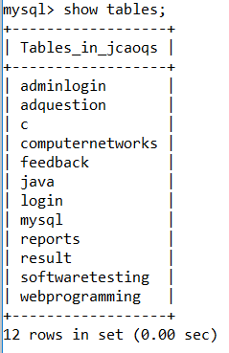

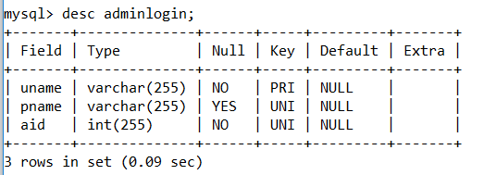

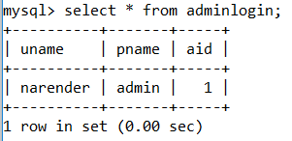

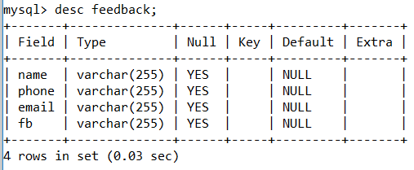

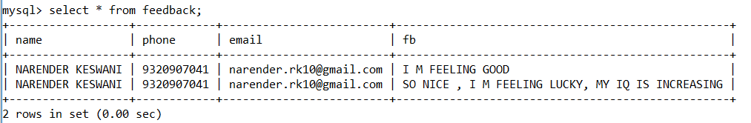

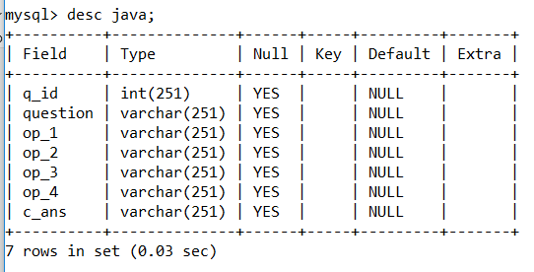

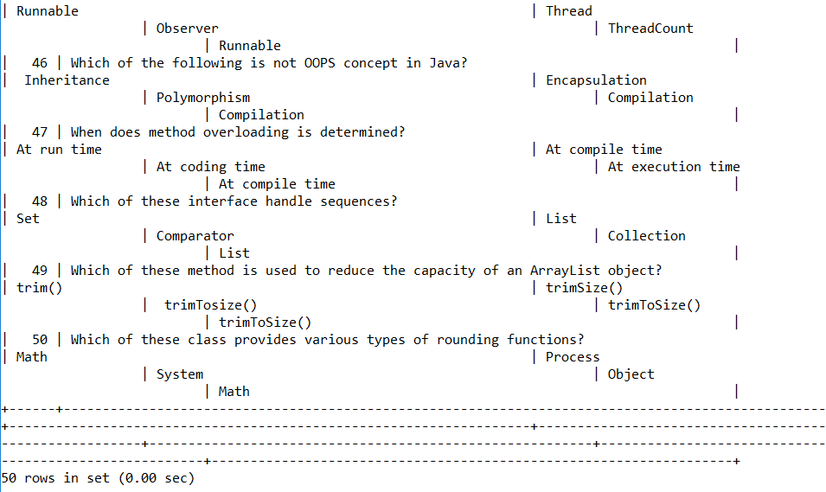

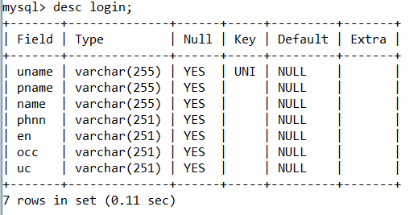

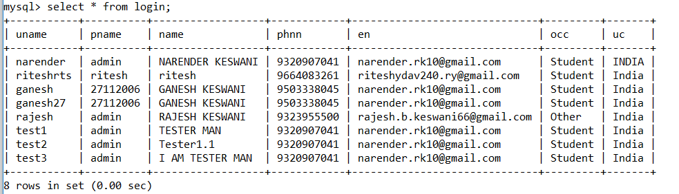

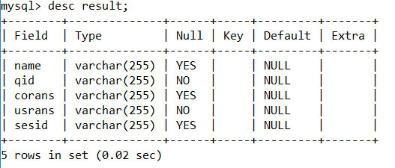

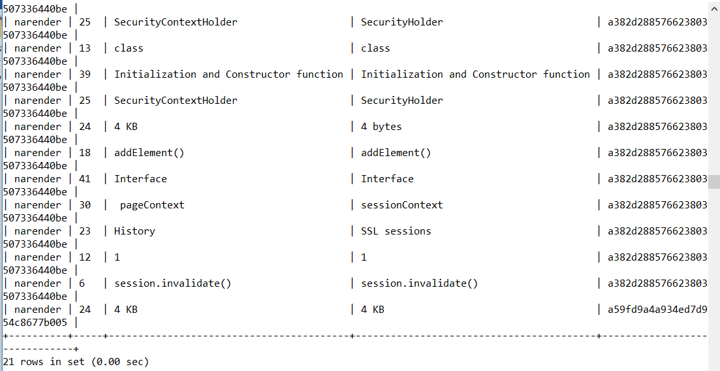

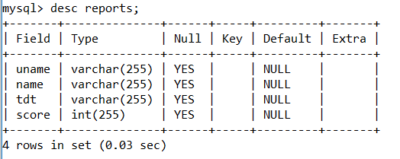

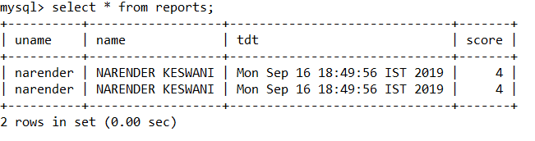

**OUTPUT:**

1. **MAINPAGE (HOMEPAGE):**

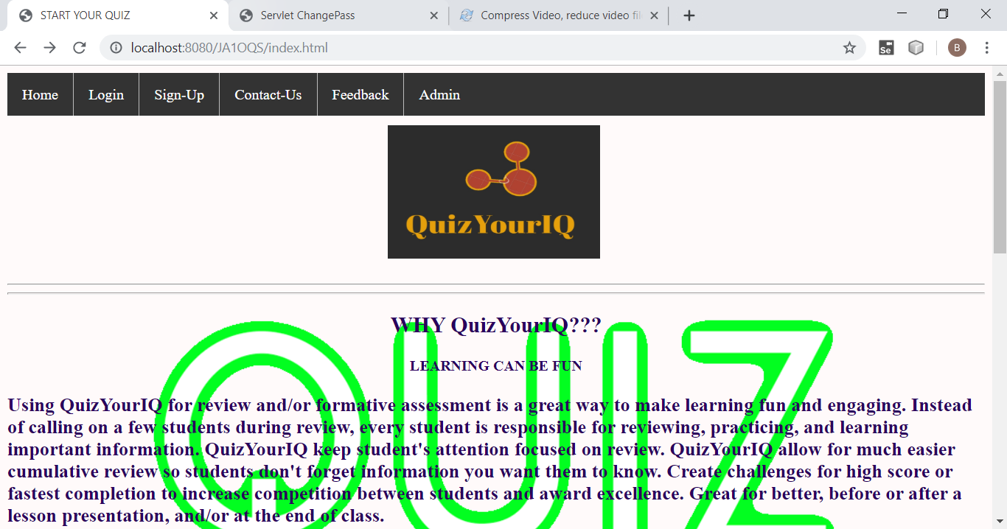

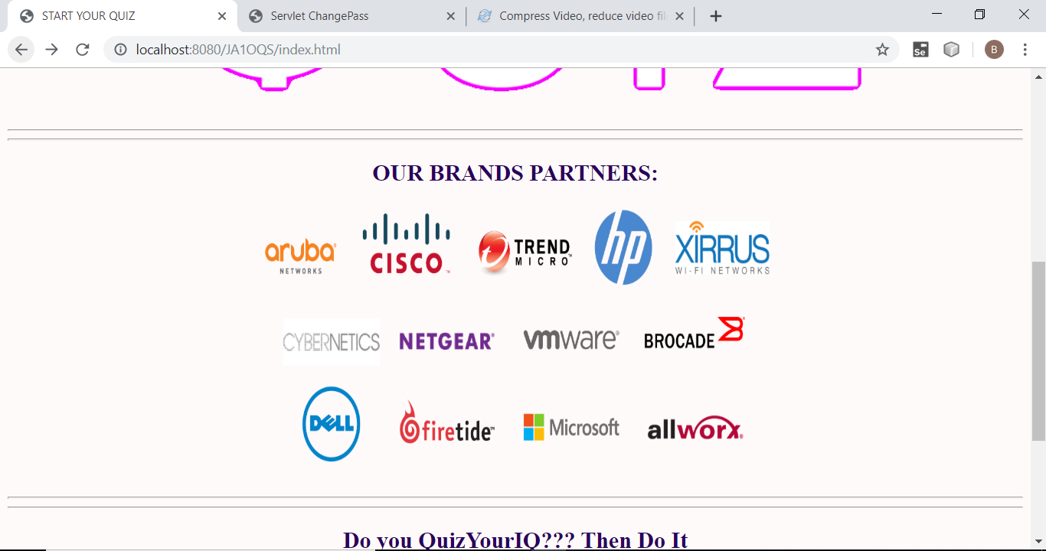

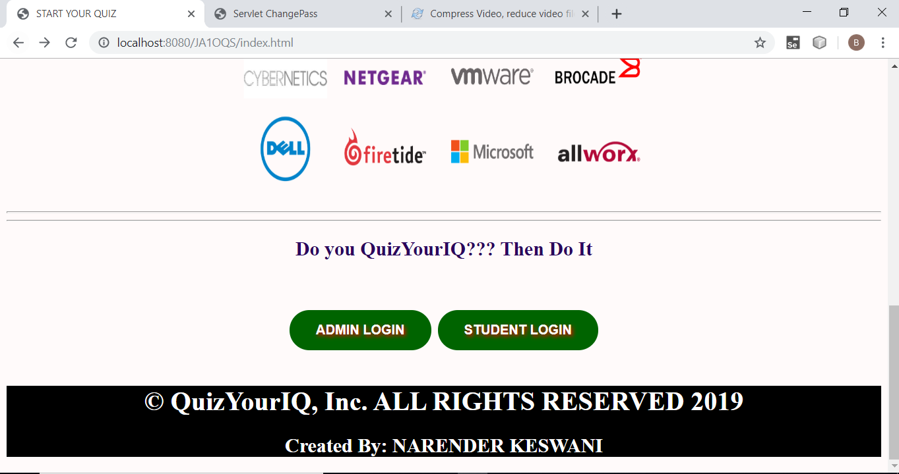

1. **PRESS STUDENT LOGIN FOR TO PLAY THE QUIZ:**

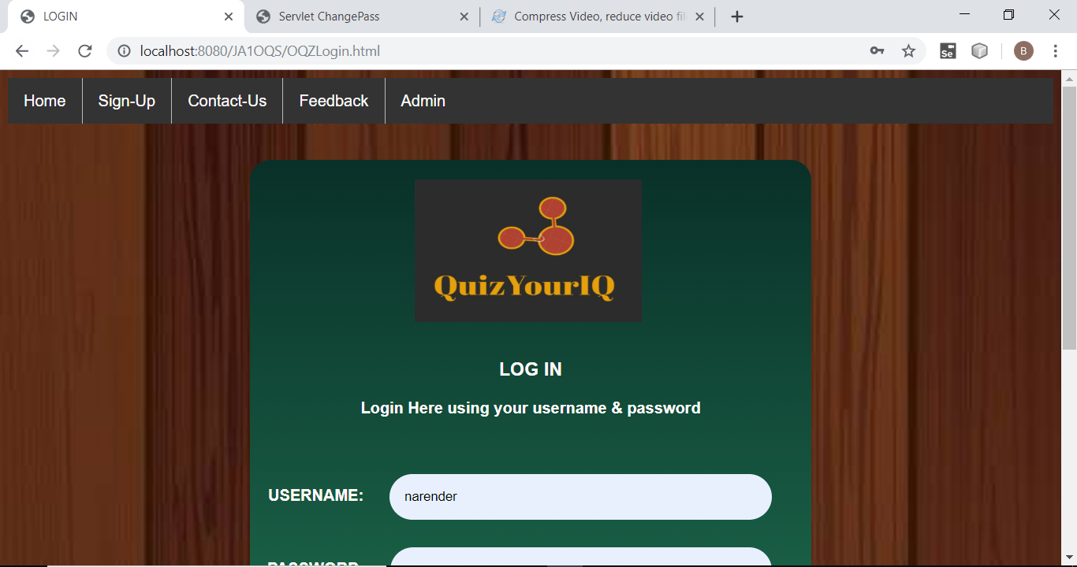

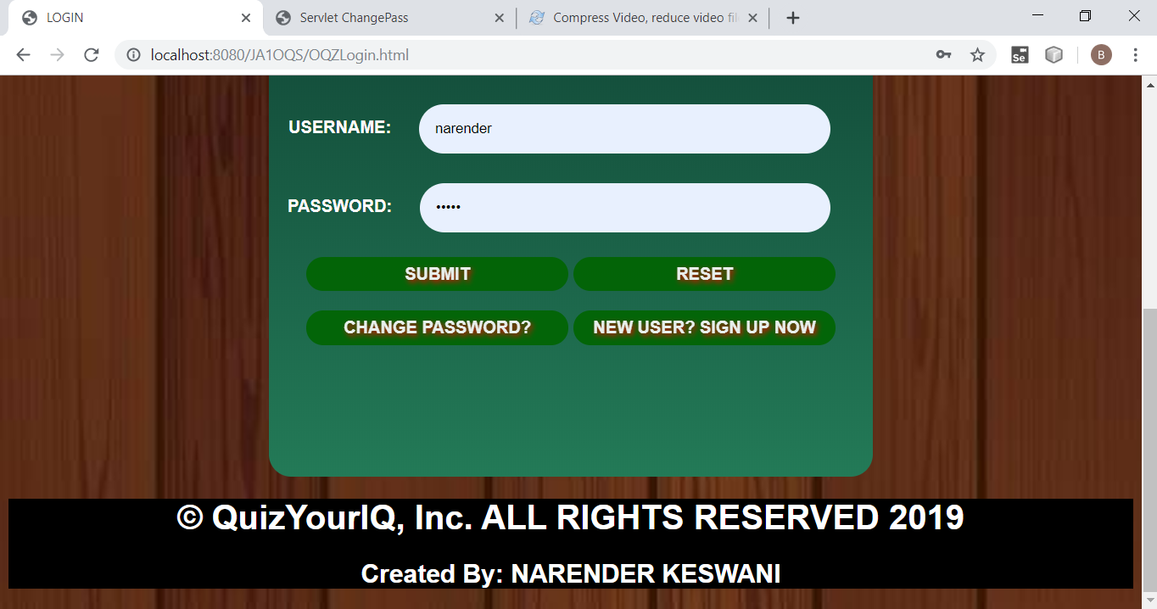

**PRESS SUBMIT FOR LOGIN:**

**IF YOU ENTER THE CORRECT PASSWORD YOU WILL GET THE ACCESS TO PLAY THE QUIZ:**

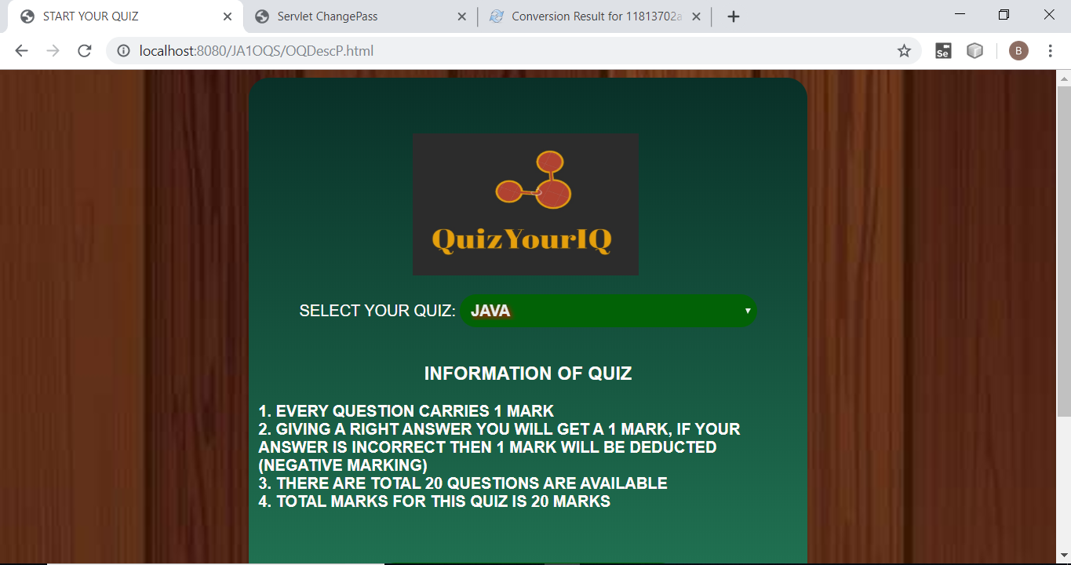

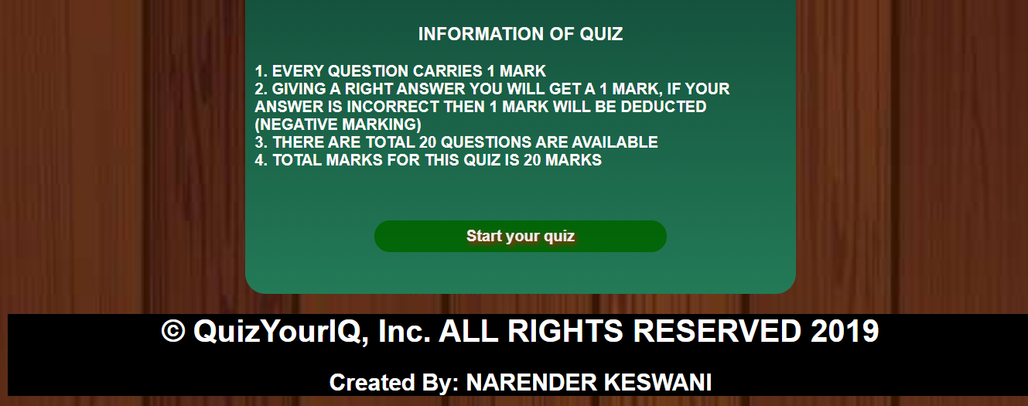

**IF USER ENTERS INVALID USERNAME/PASSWORD THEN:**

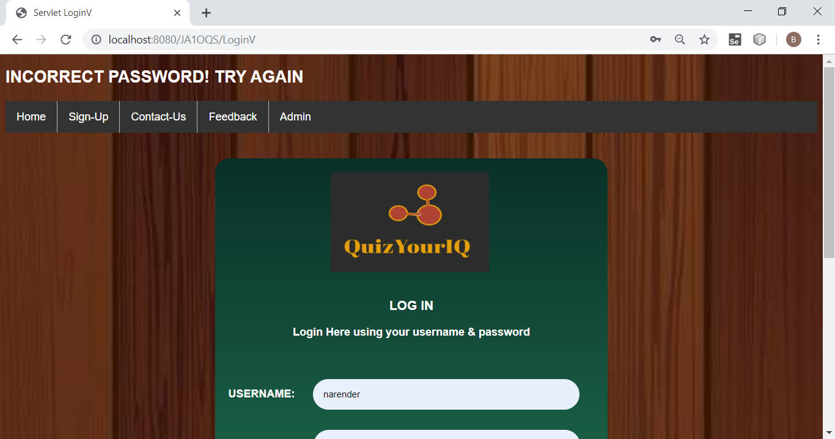

1. **PRESS START YOUR QUIZ:**



**NOTE:**

**IF TIMER BECOMES ZERO(0) YOUR ANSWERS ARE SUBMITTED DIRECTLY TO THE SYSTEM**

**SO PLAY WITHIN THE TIME**

**YOU CAN DIRECTLY FINISH THE QUIZ**

**Q1:**

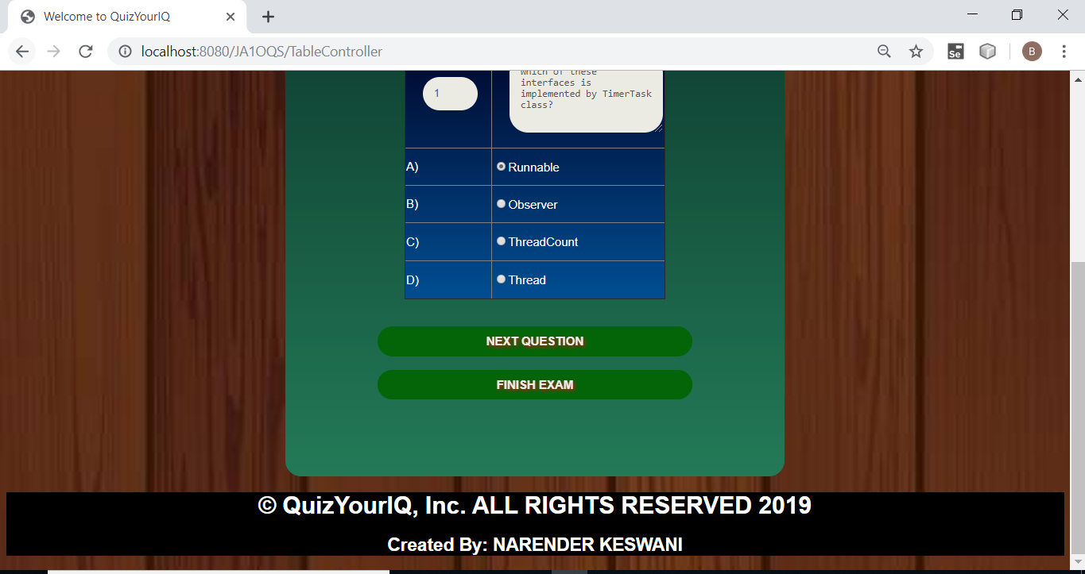

**Q2:**

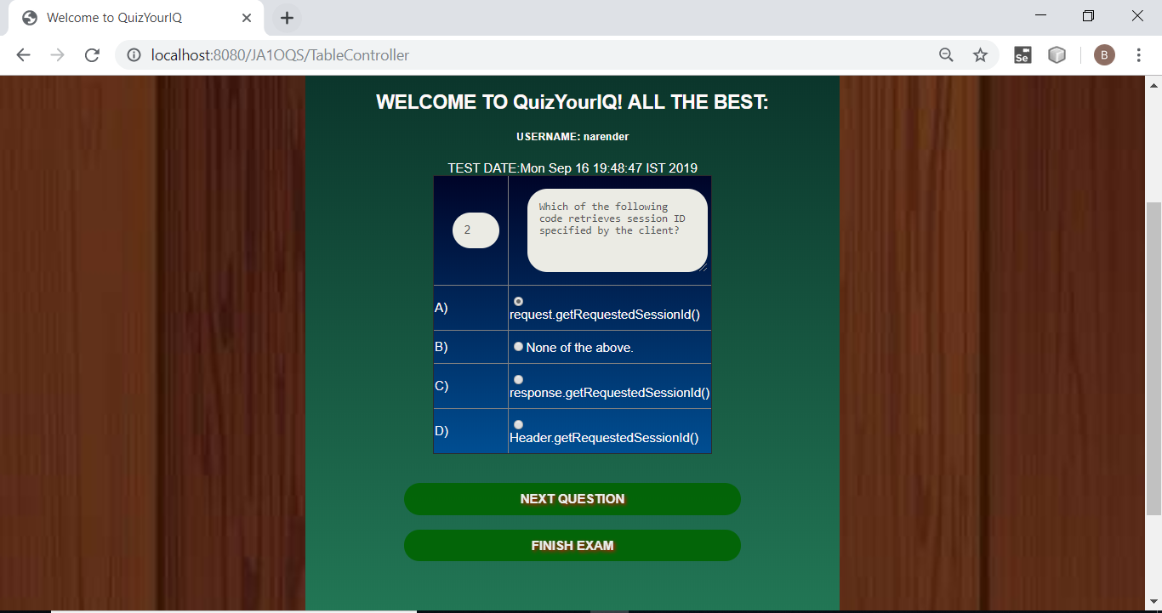

**Q3:**

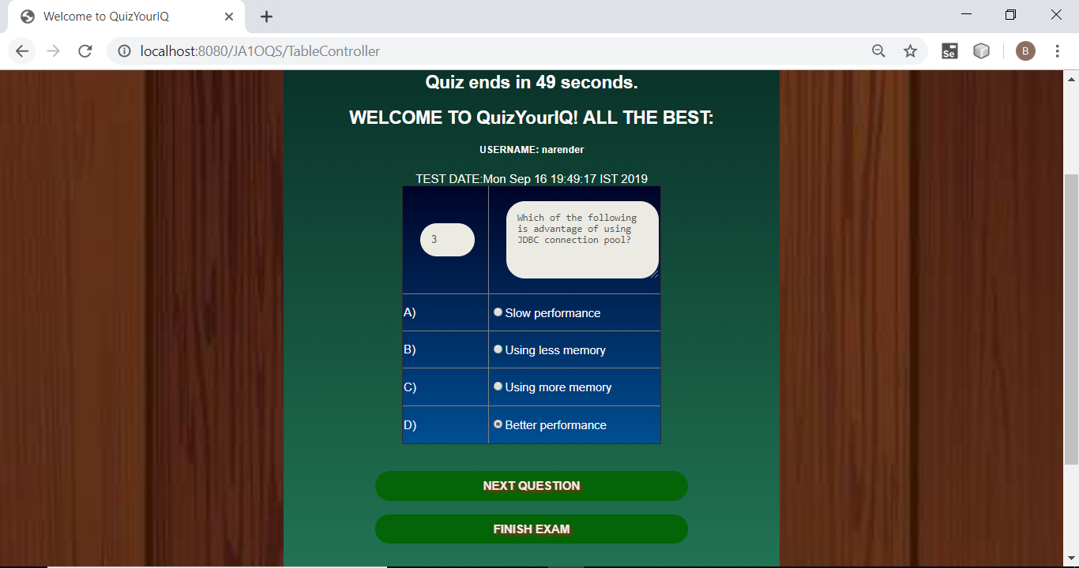

**Q4:**

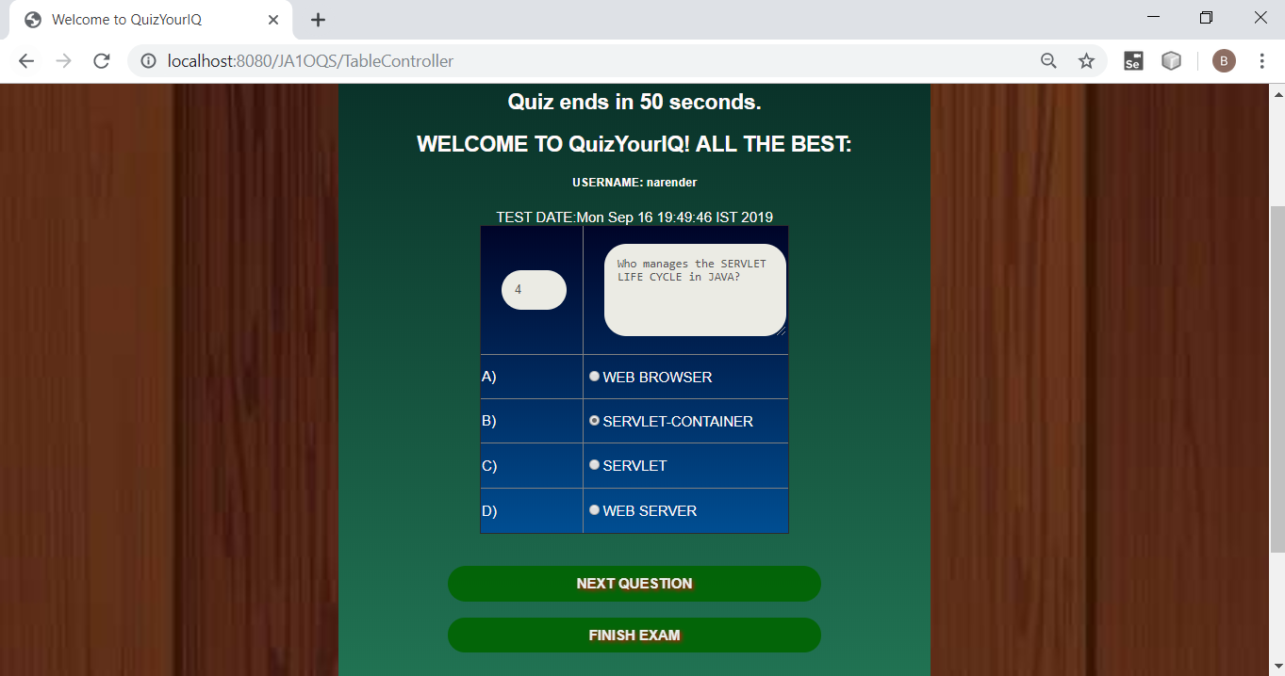

**Q5:**

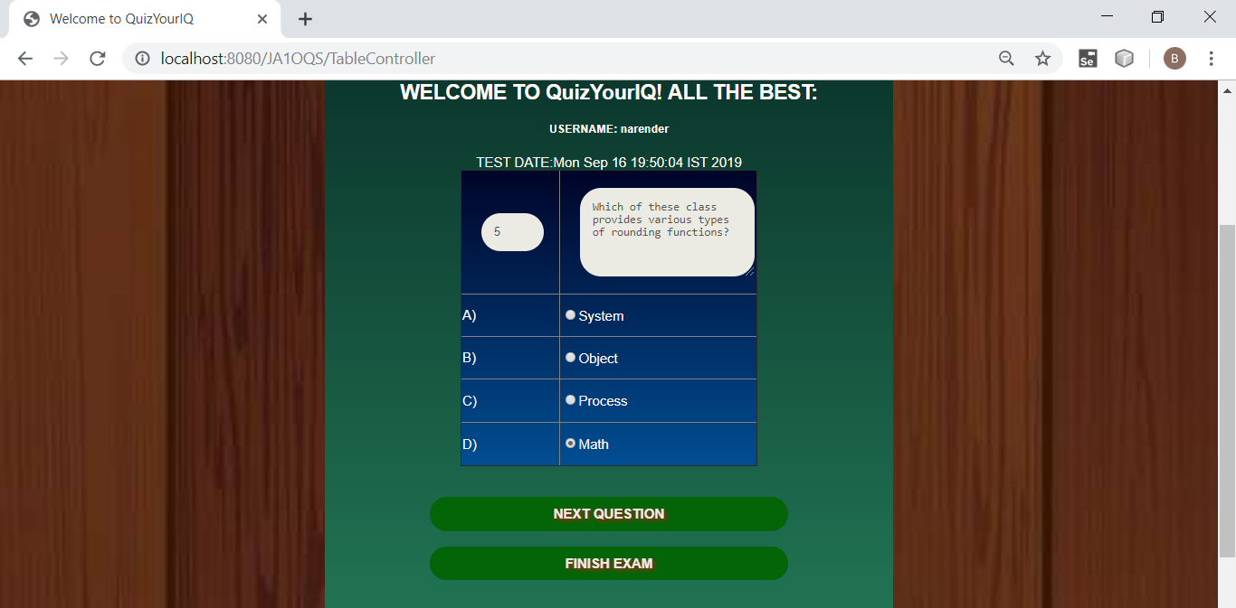

**Q6:**

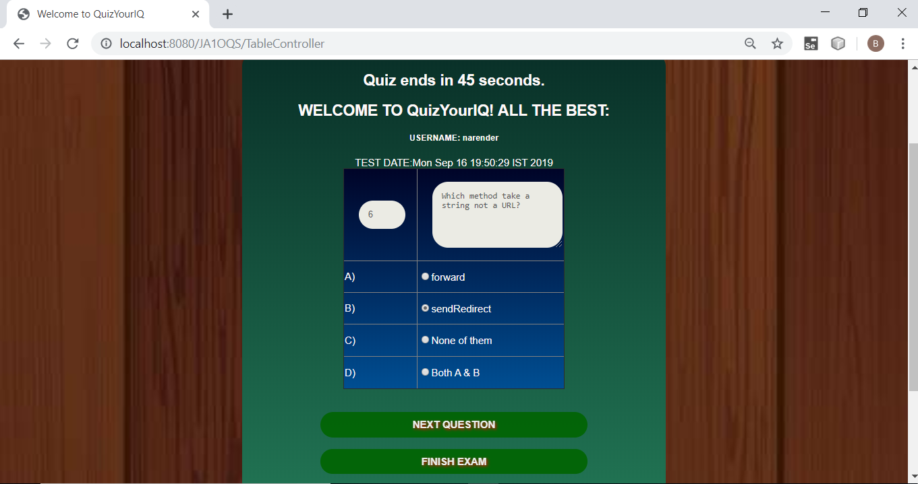

**Q7:**

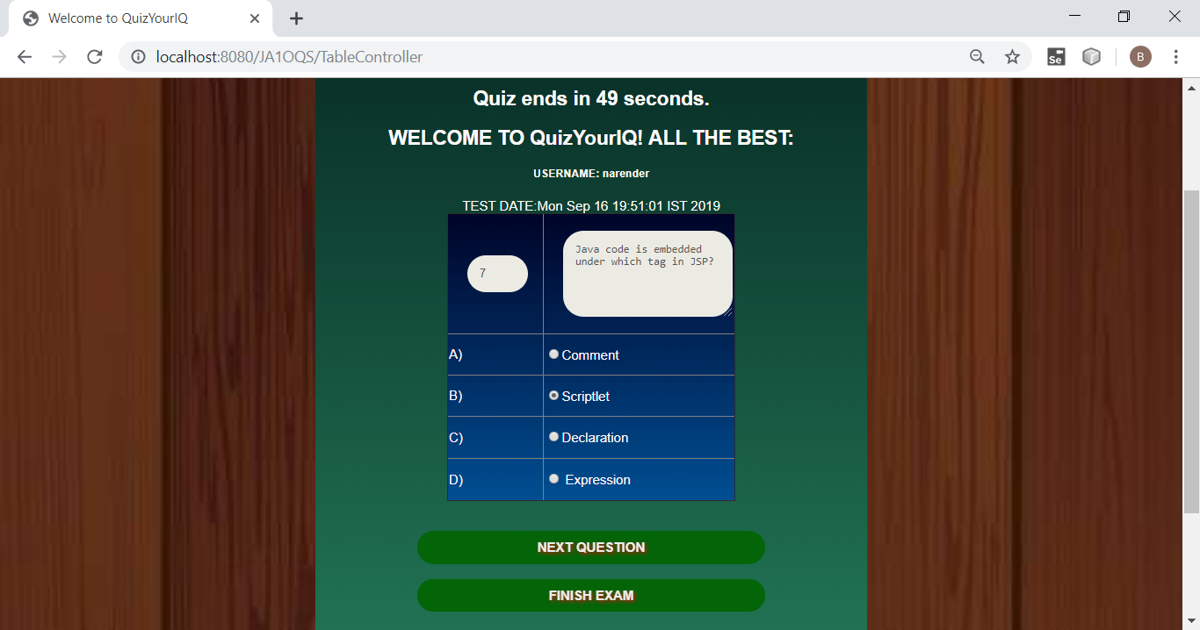

**Q8:**

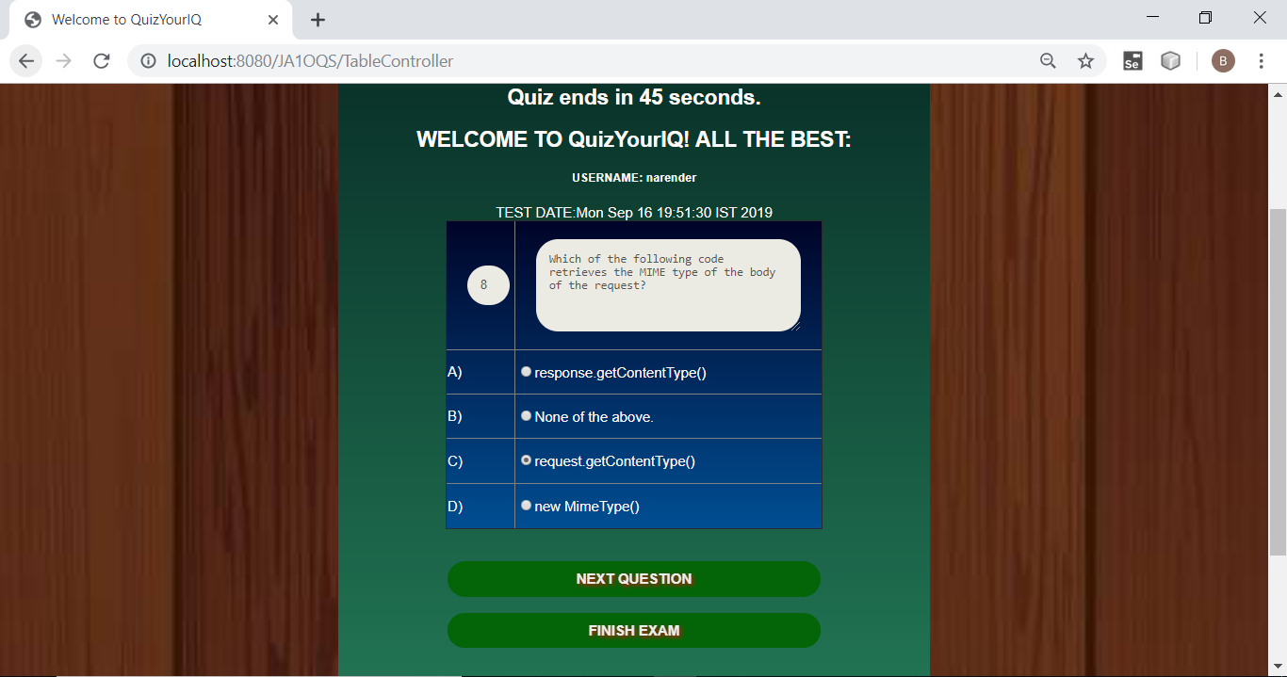

**Q9:**

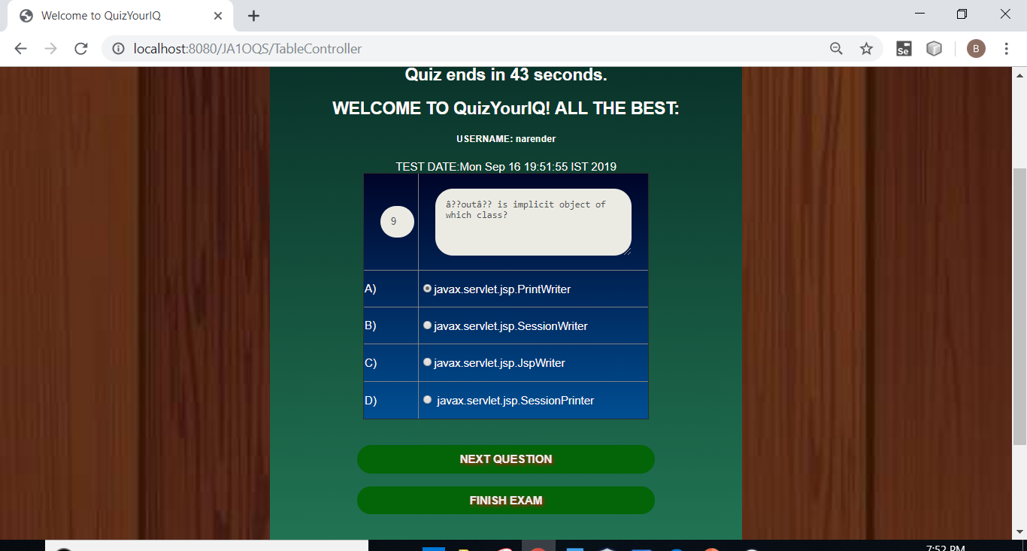

**Q10:**

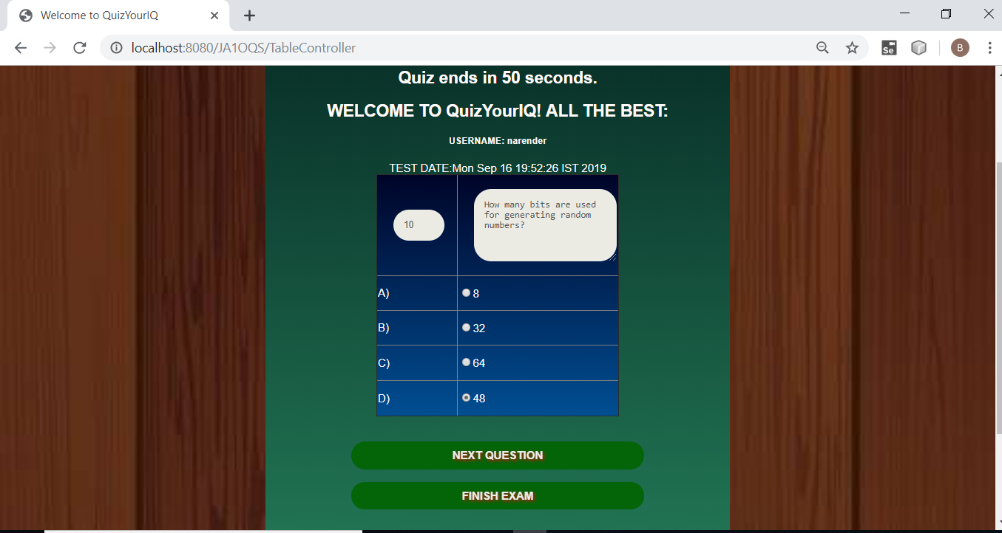

**Q11:**

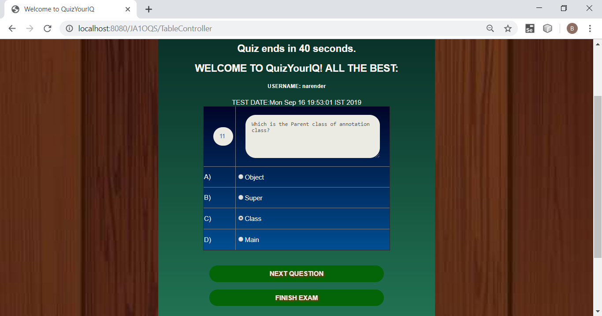

**Q12:**

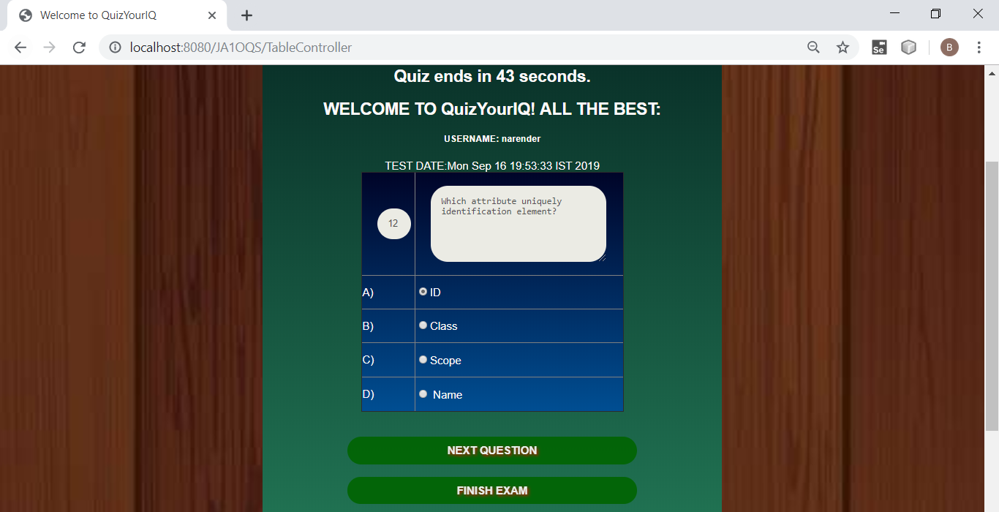

**Q13:**

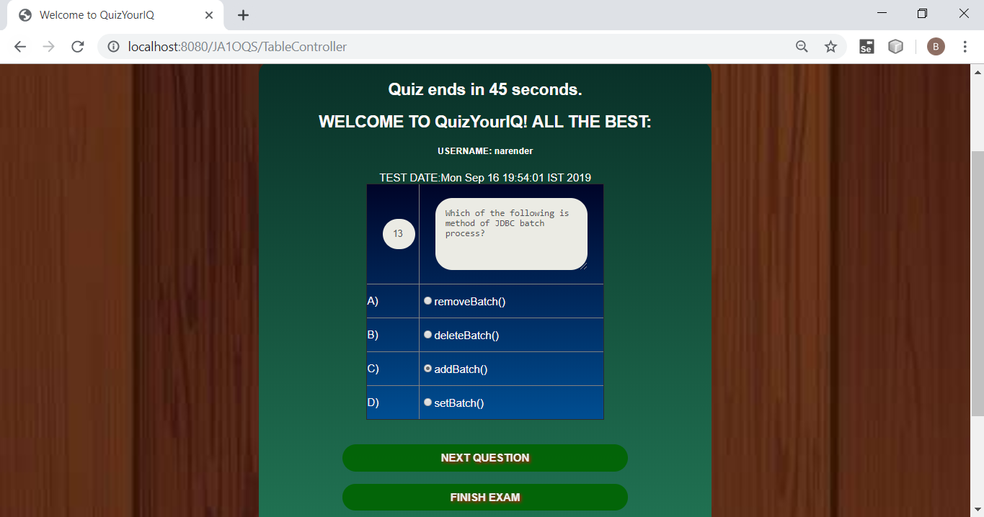

**Q14:**

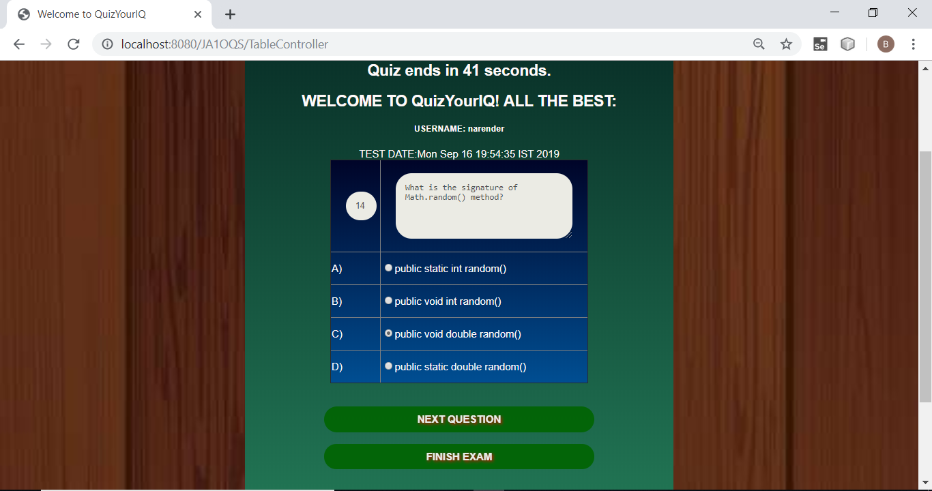

**Q15:**

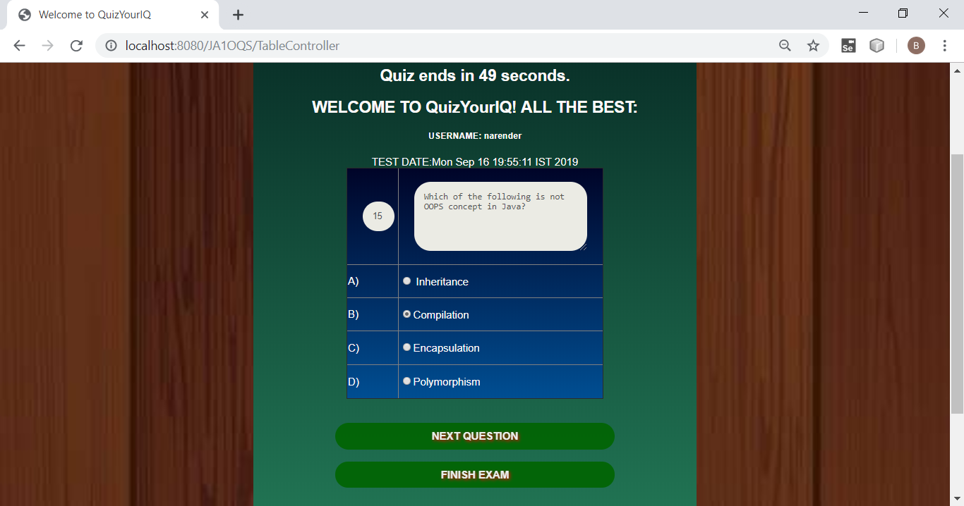

**Q16:**

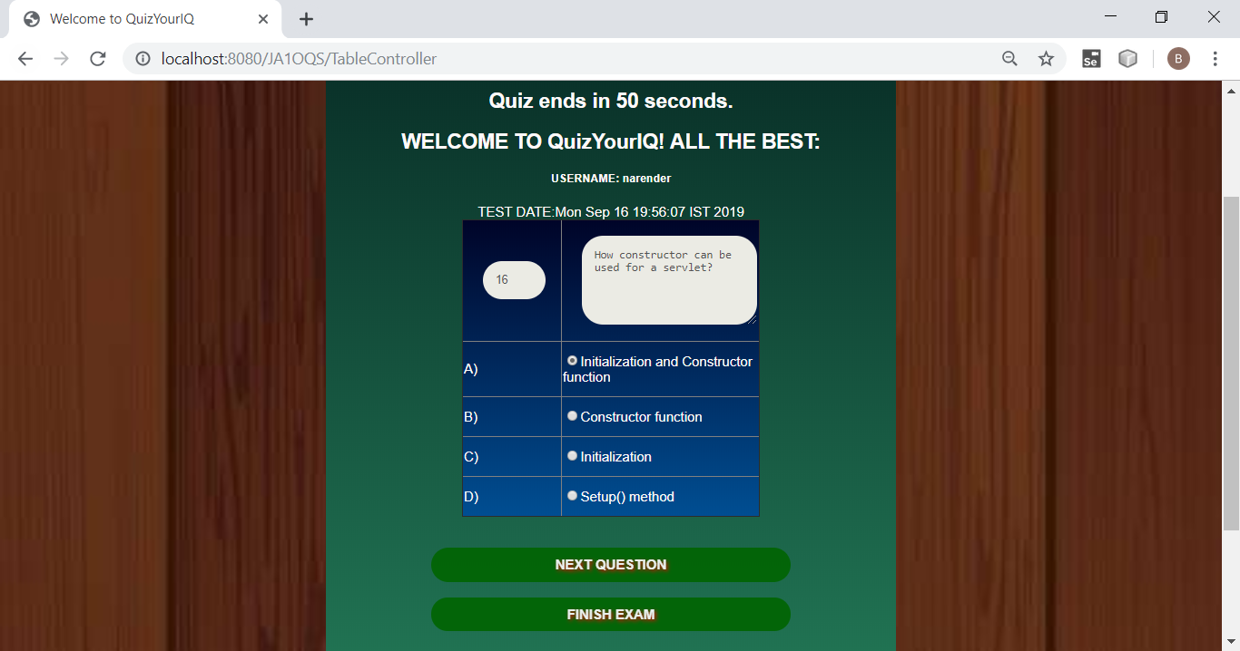

**Q17:**

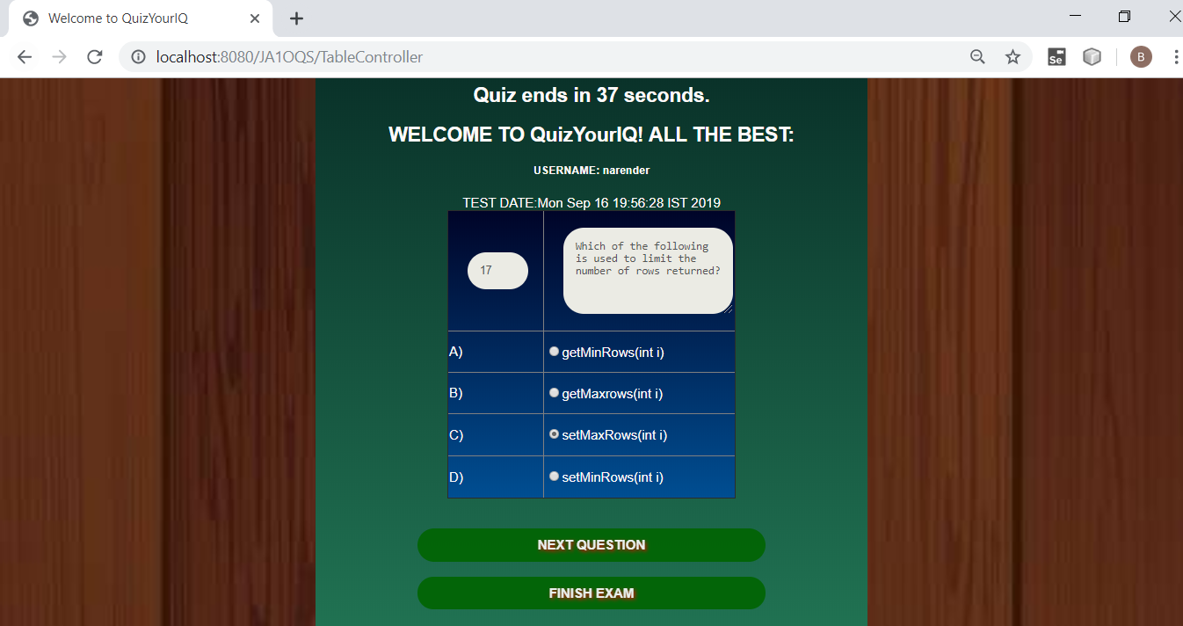

**Q18:**

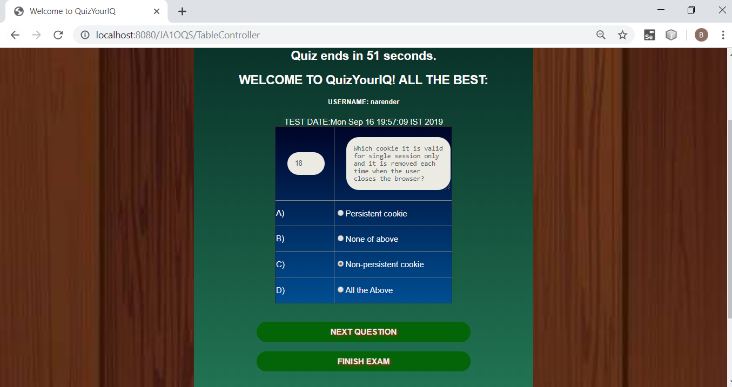

**Q19:**

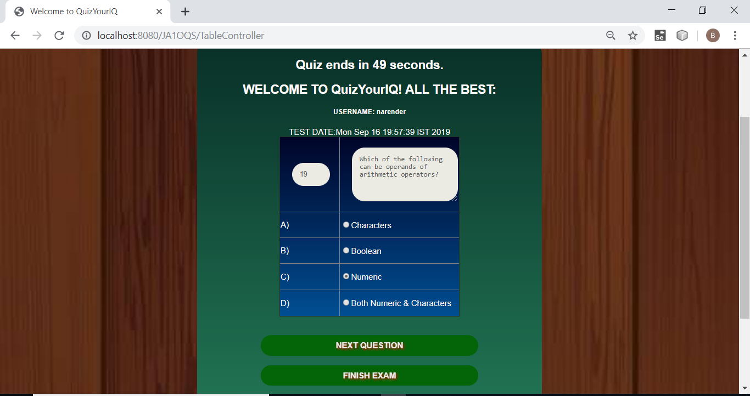

**Q20:**

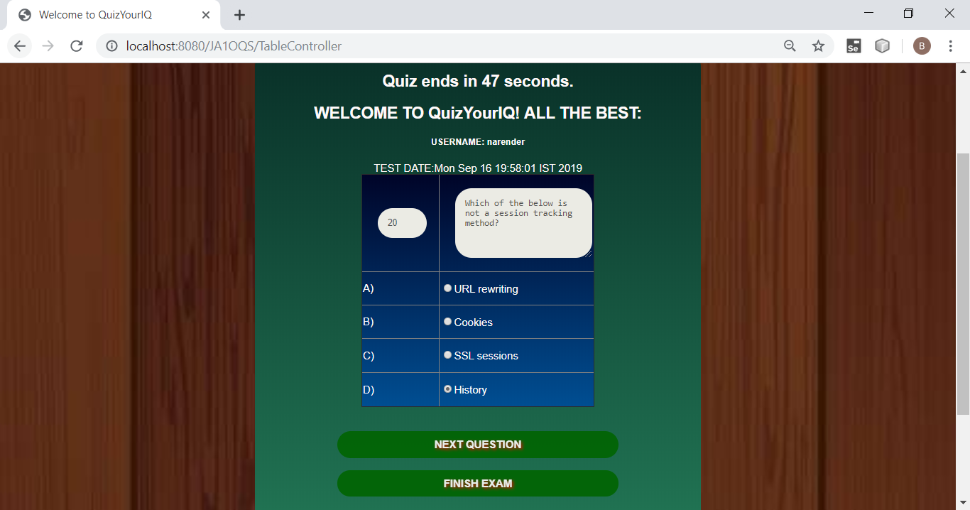

1. **PRESS NEXT OR SUBMIT TO GET THE REPORT OF THE QUIZ:**

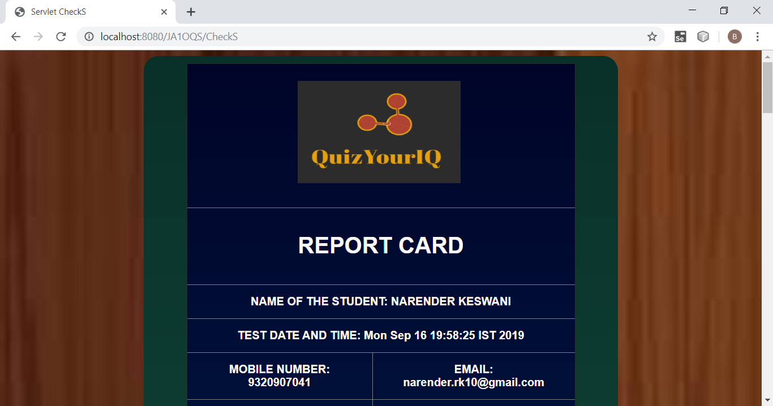

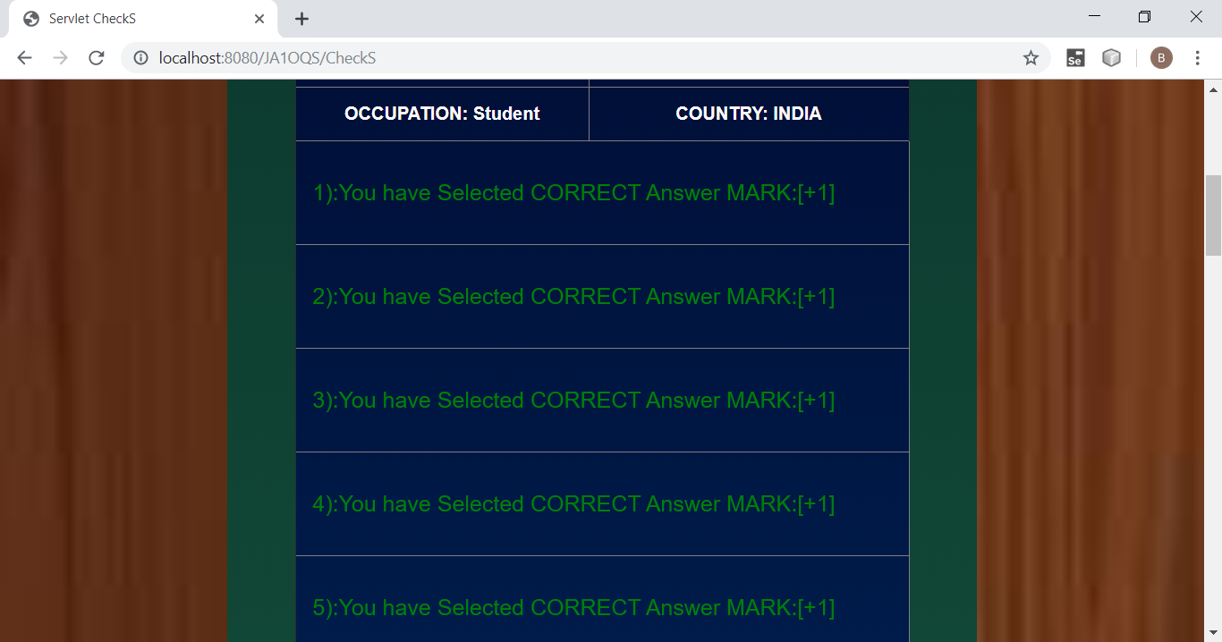

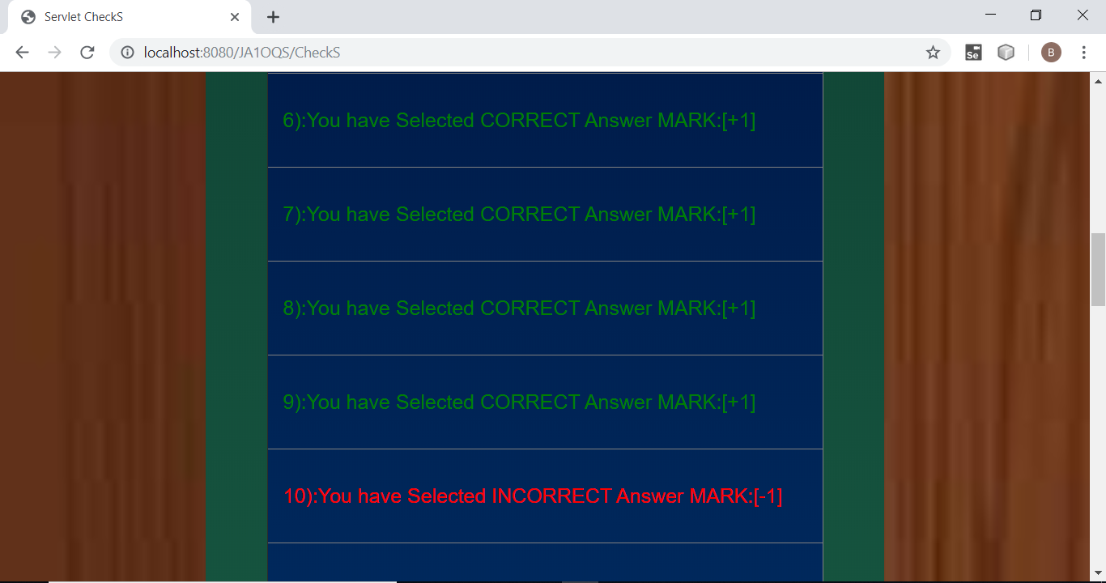

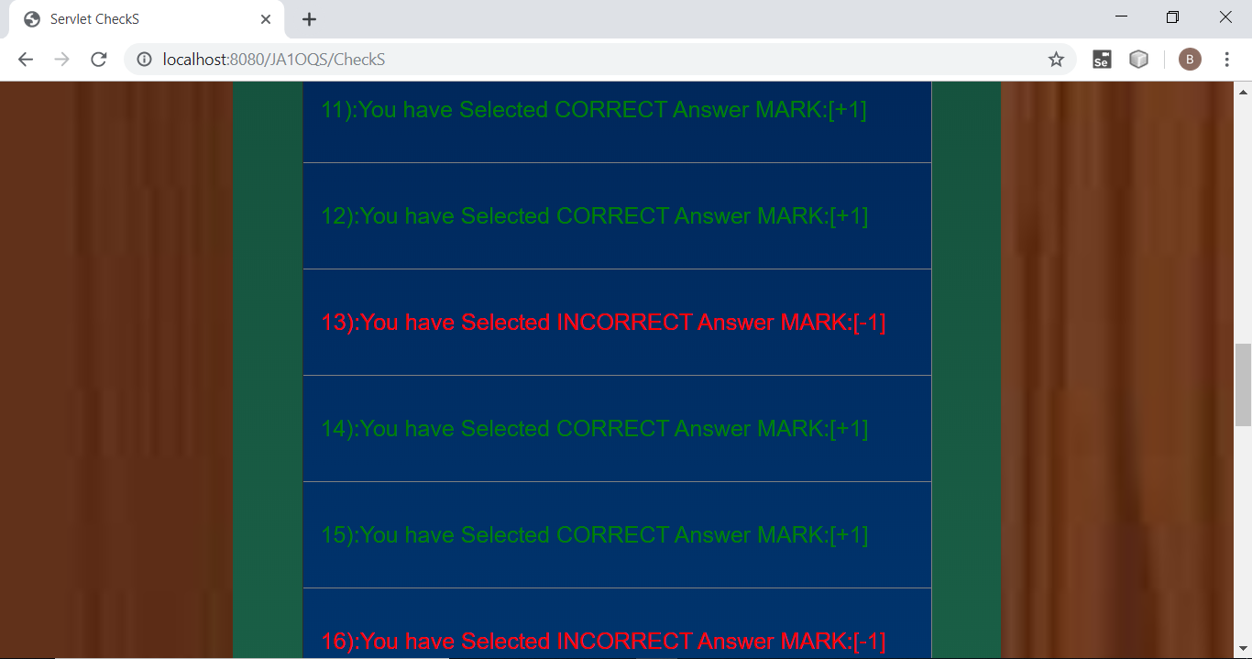

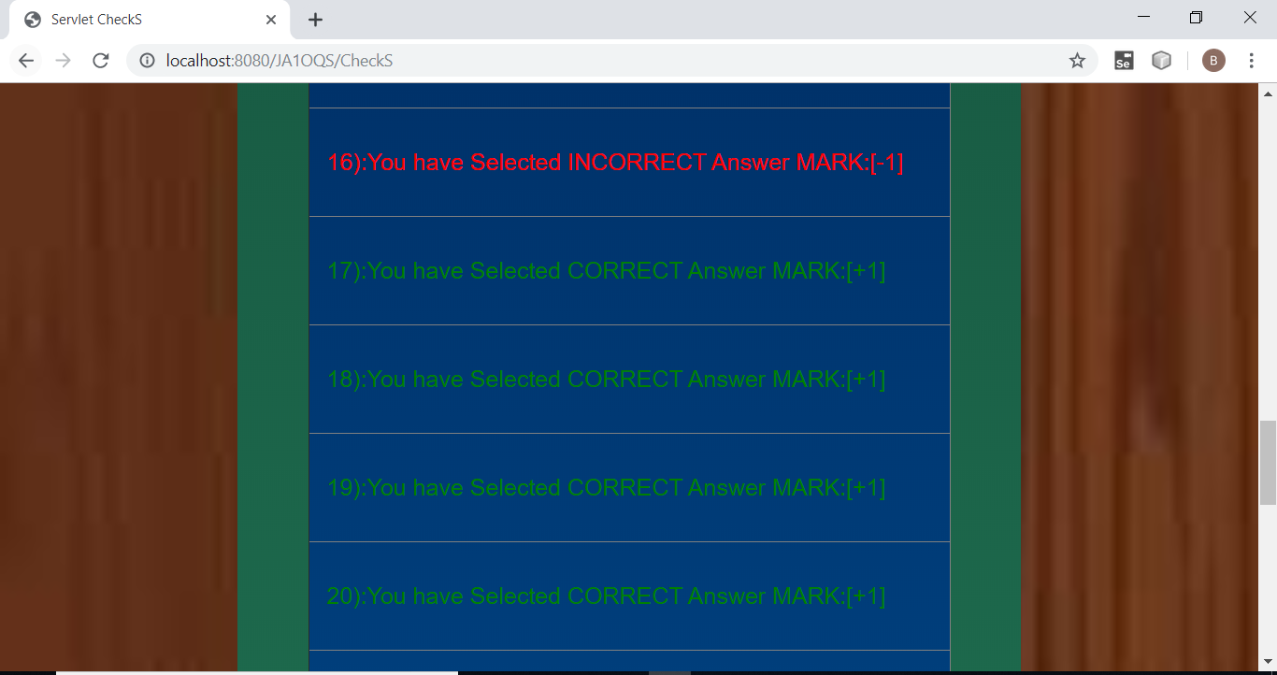

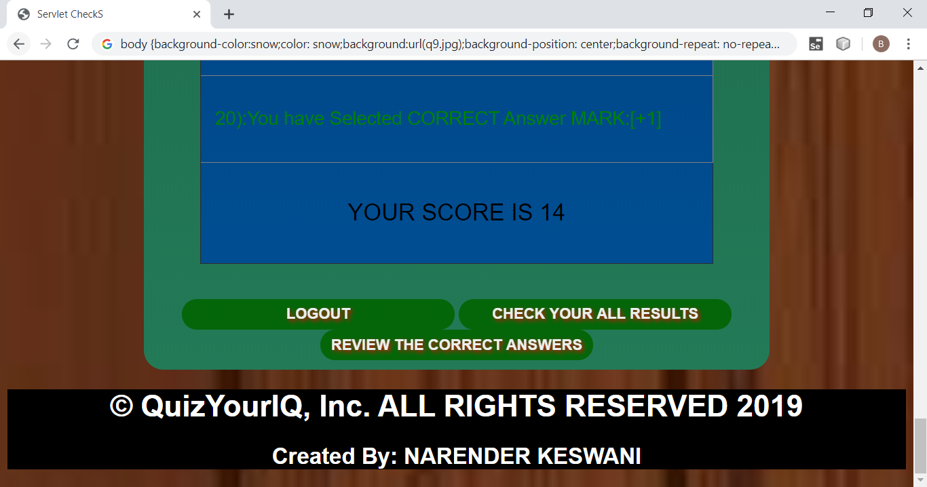

1. **PRESS ON THE “CHECK YOUR ALL THE RESULTS”:**

**NOTE:YOU WILL GET ALL THE PREVIOUS , & NEW RESULTS :**

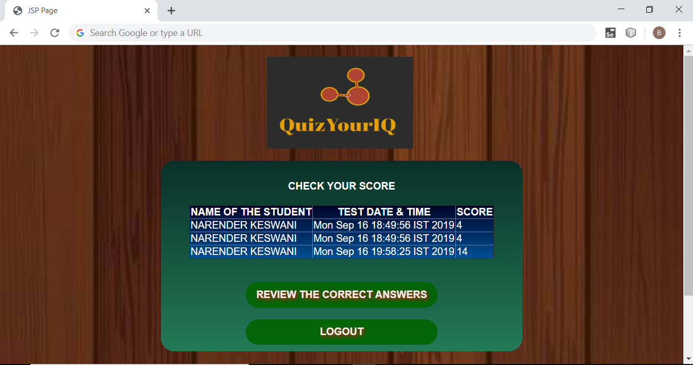

1. **PRESS ON THE “REVIEW THE CORRECT ANSWERS”:**

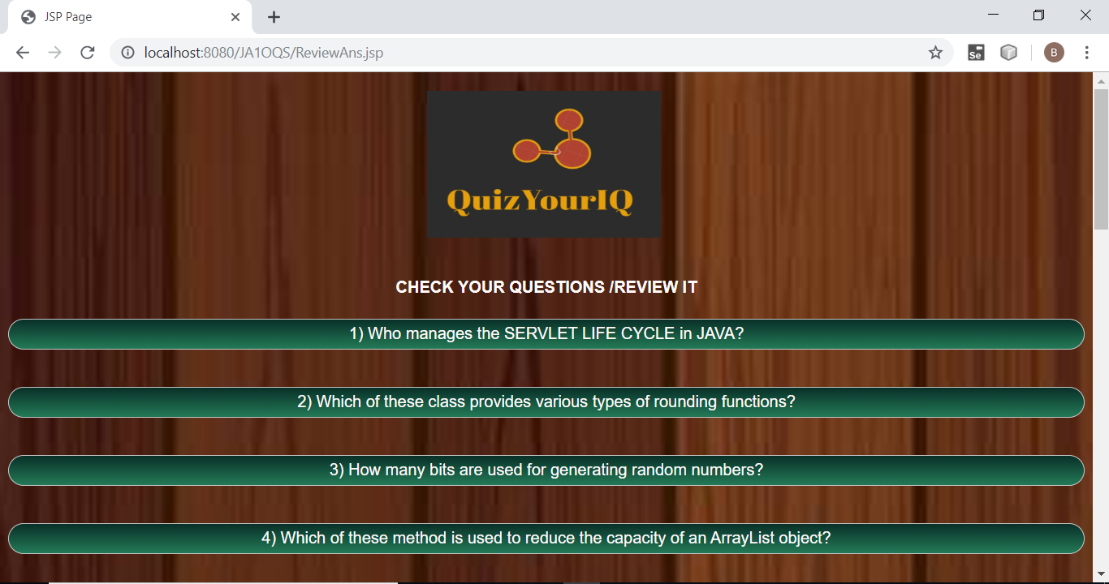

**CLICK ON THE QUESTION, YOU WILL SEE THE ANSWER:**

**NOTE: SLIDETOGGLE IS USED OF JQUERY**

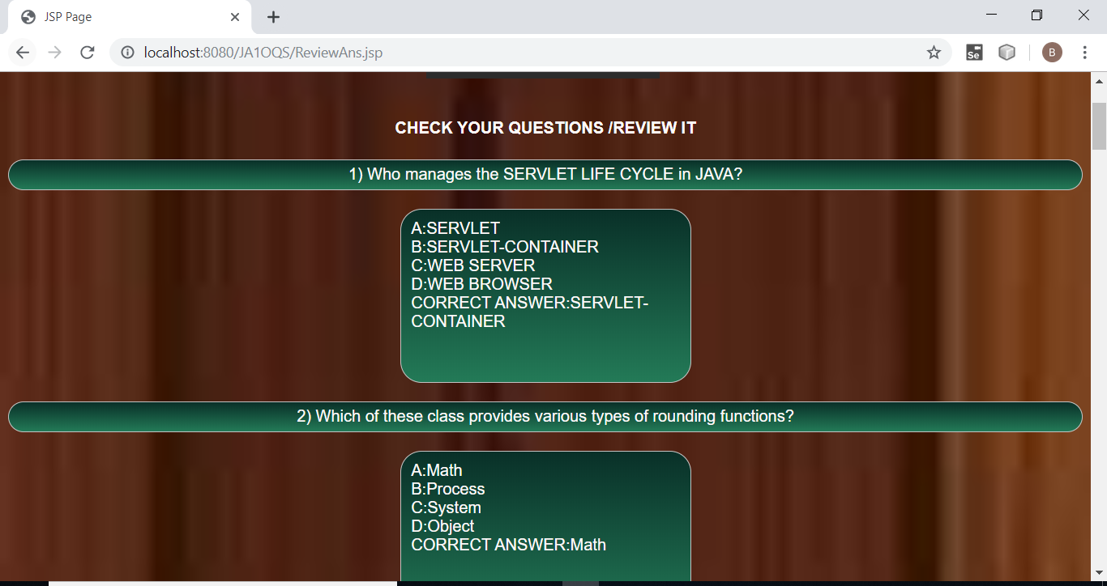

**COME BACK TO THE PAGE:**

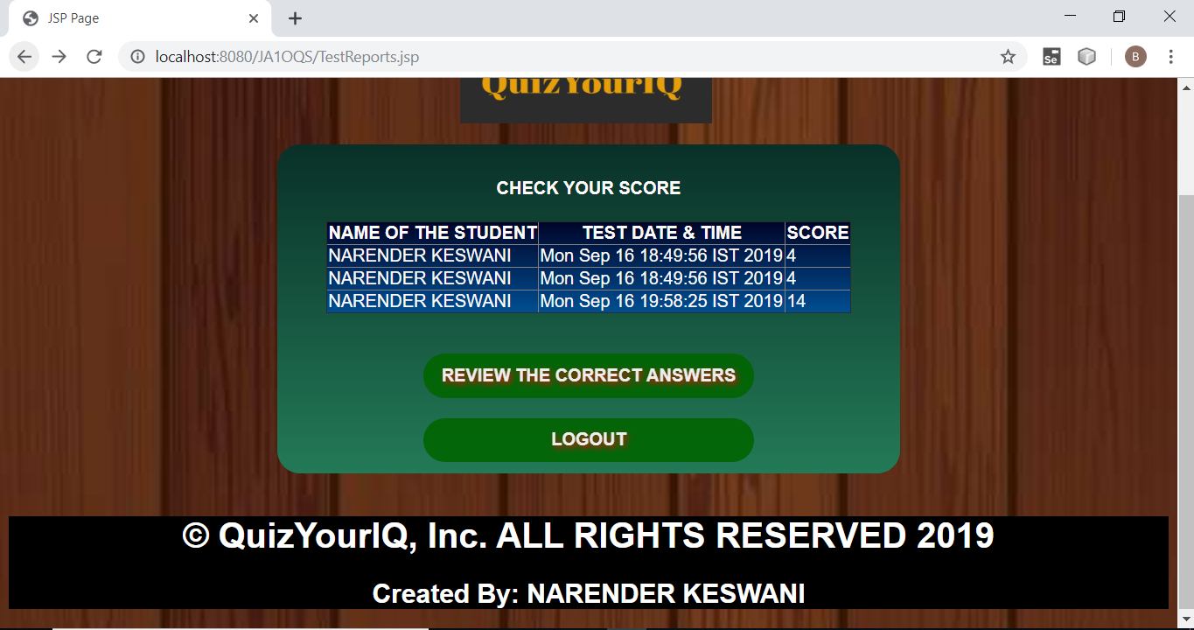

1. **PRESS ON THE “LOGOUT”:**

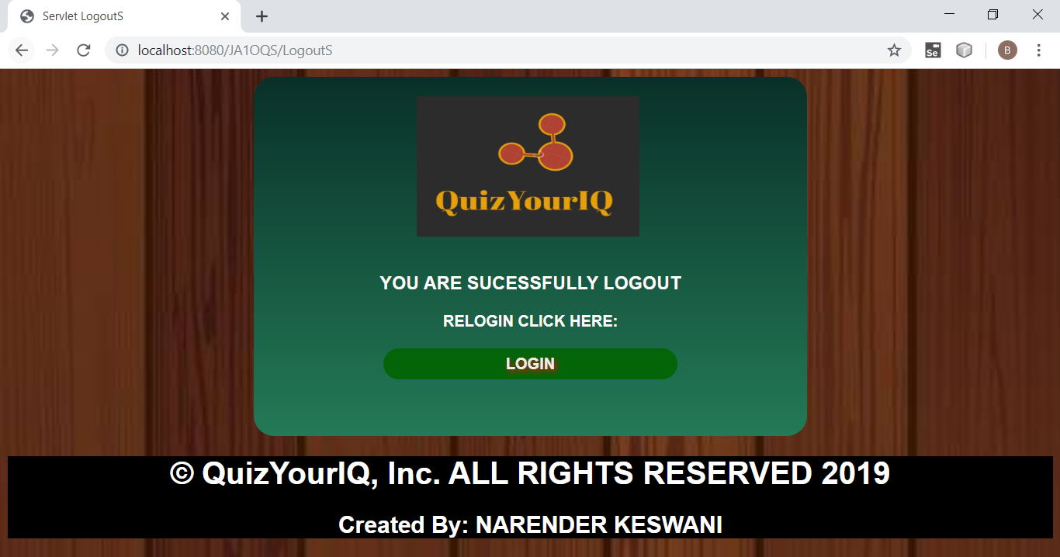

**YOU WILL BE SUCESSFULLY LOGOUT , IF YOU WANT YOU CAN RE-LOGIN IT.**

1. **PRESS ON THE “SIGN-UP” IN THE MENU BAR FOR SIGN-UP:**



**FILL THE SIGN-UP FORM :**

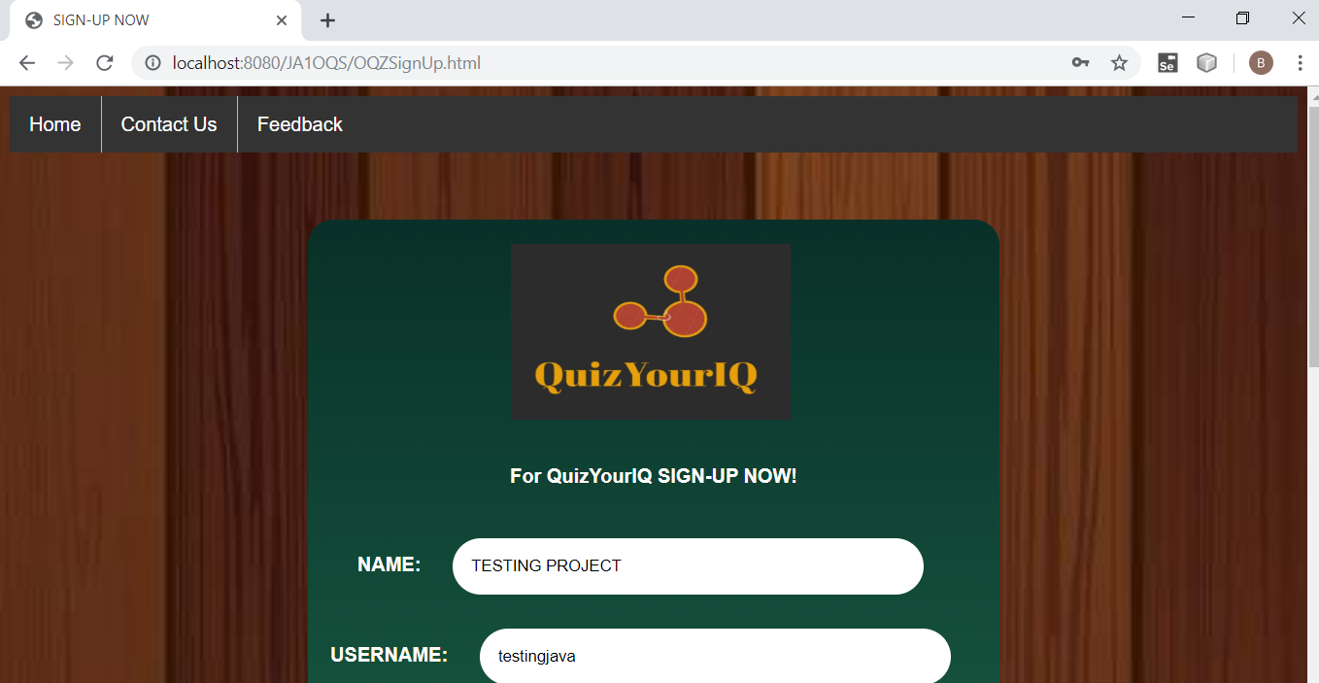

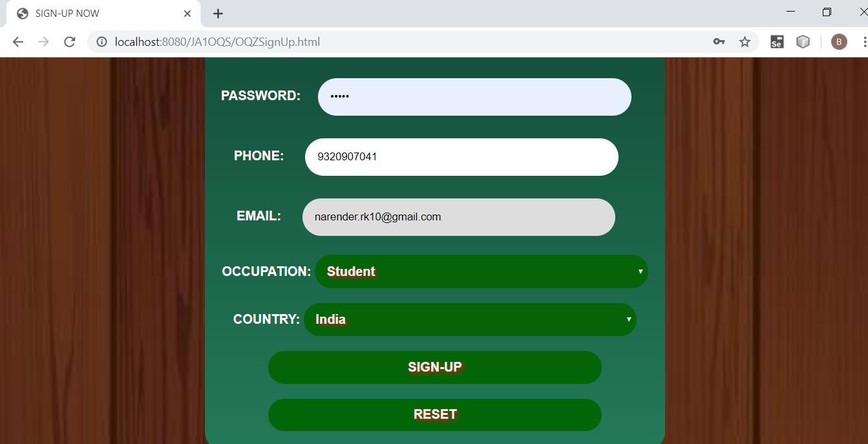

**NOW PRESS ON THE SIGN-UP BUTTON:**

**IF YOU SUCESSFULLY REGISTERED WITH US, YOU WILL GET A NOTIFICATION WITH YOUR DETAILS:**

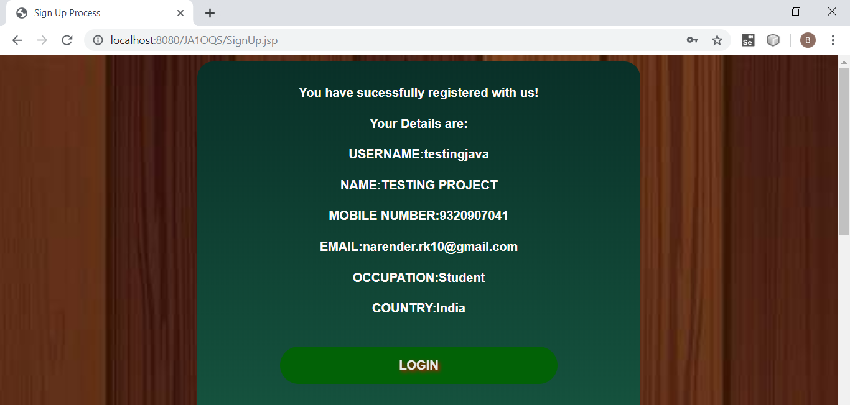

1. **PRESS ON THE “CHANGE PASSWORD”:**

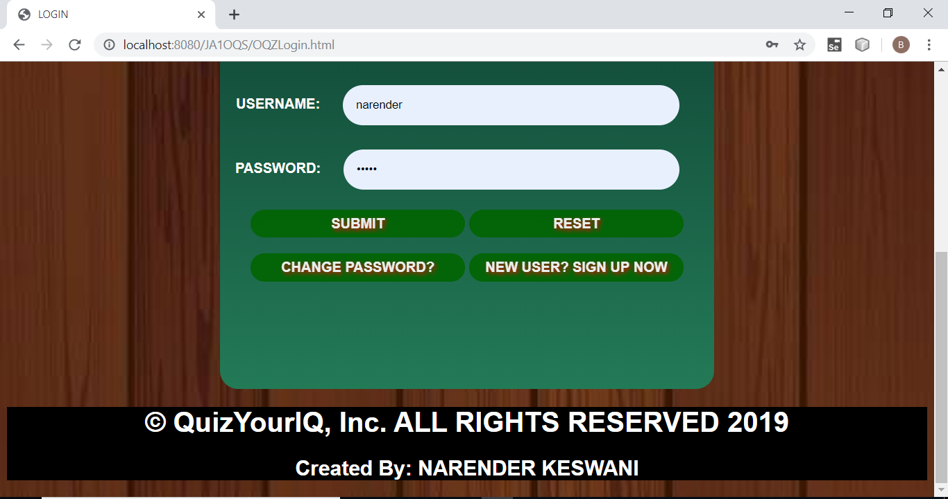

**ENTER YOUR USERNAME, CURRENT PASSWORD, NEW PASSWORD:**

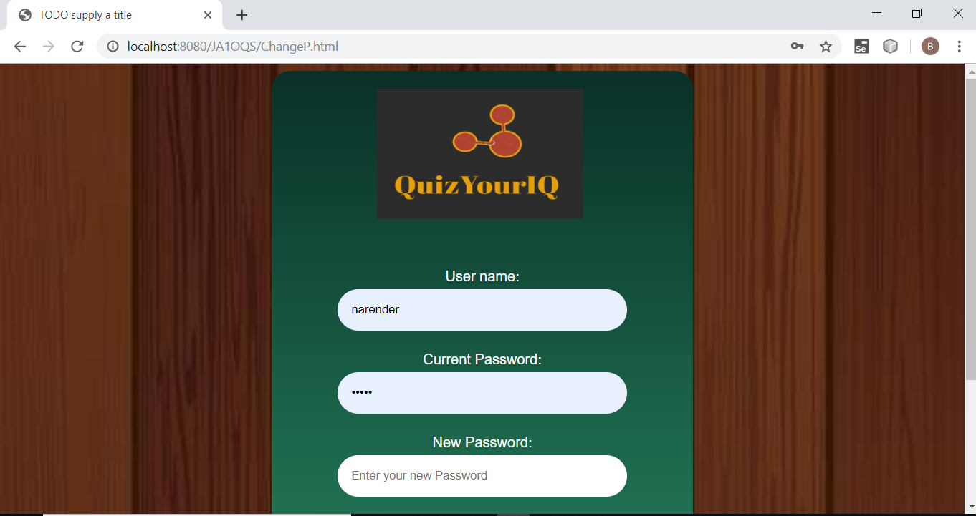

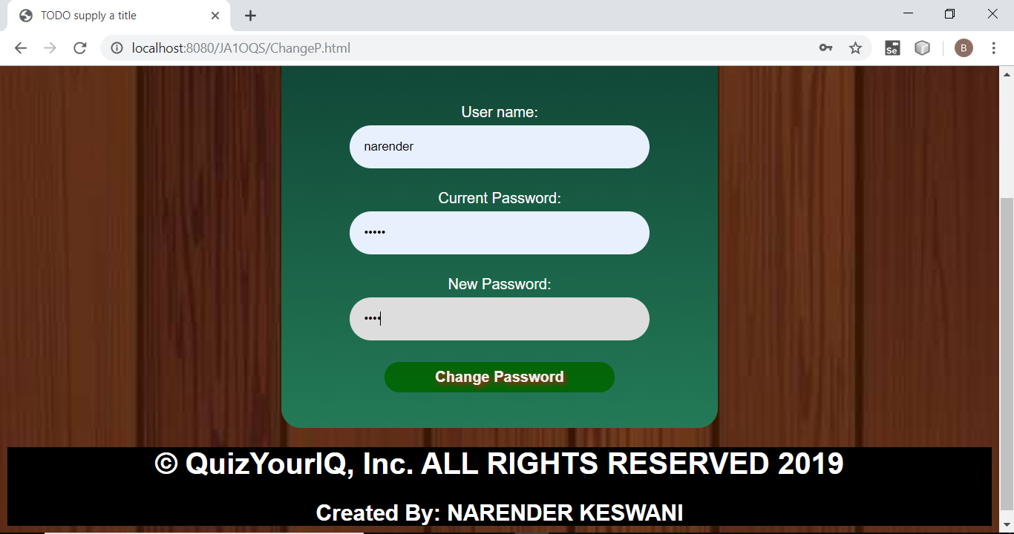

**PRESS ON THE “CHANGE PASSWORD”:**

**NOTE: YOU WILL GET A NOTIFICATION THATR YOU HAVE SUCESSFULLY CHANGED THE PASSWORD.**

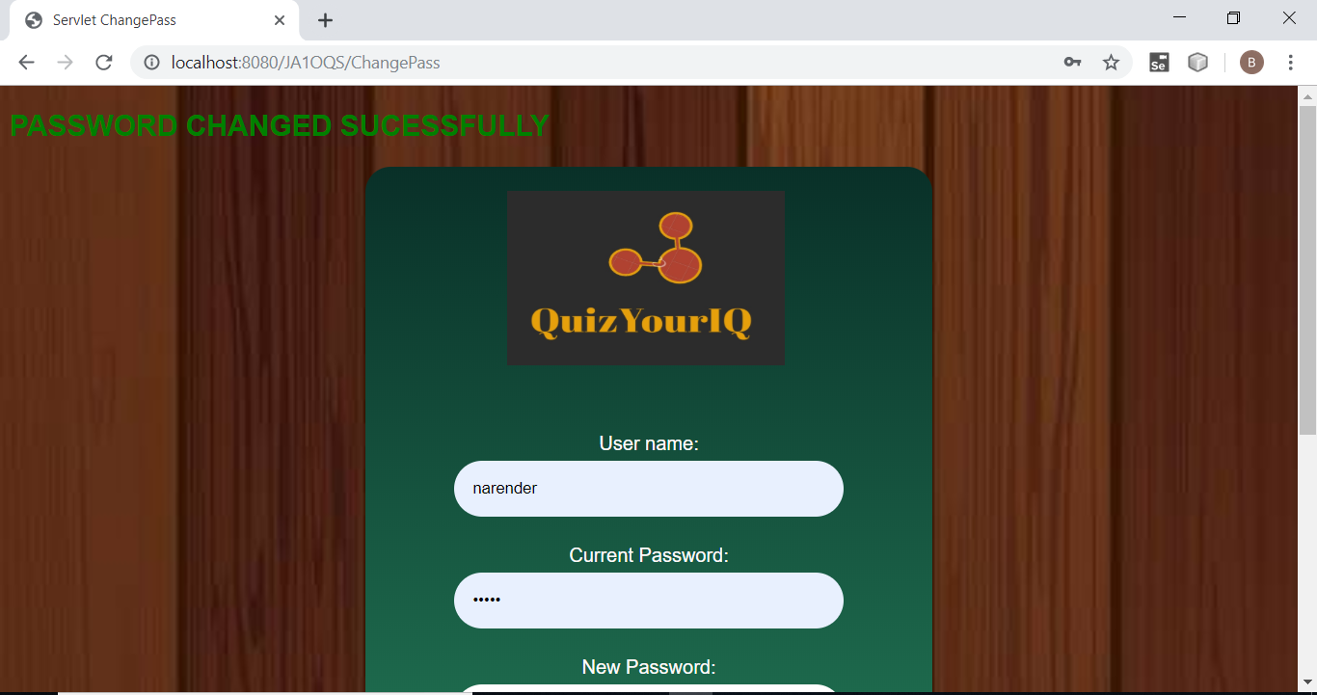

1. **CLICK ON THE “CONTACT-US “ IN THE MENU BAR:**



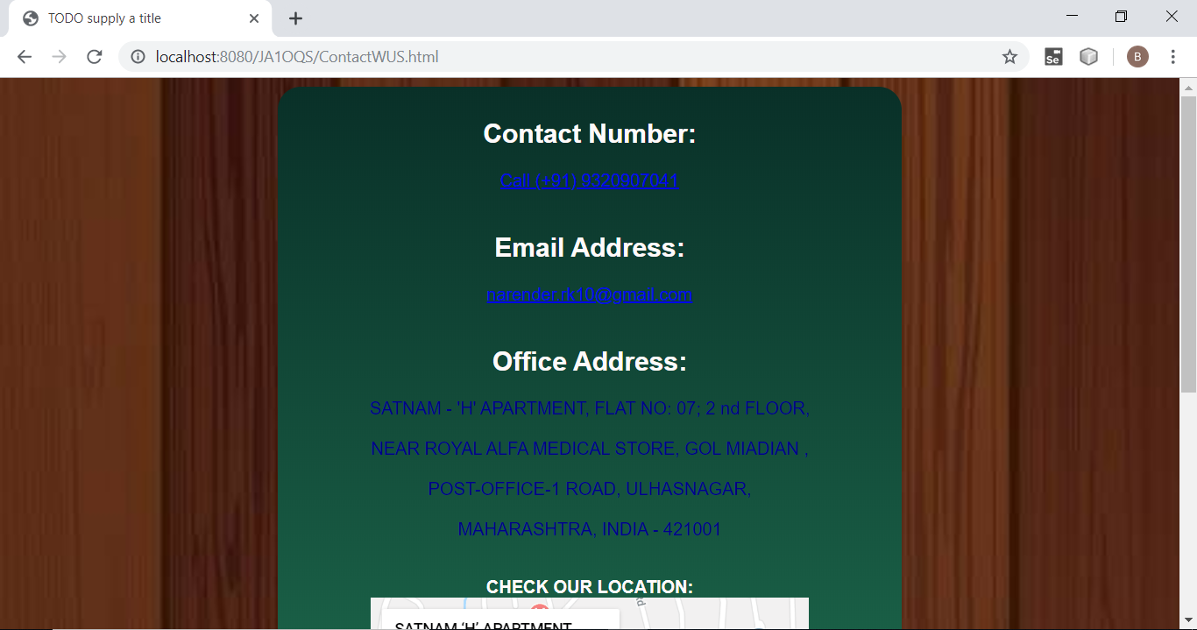

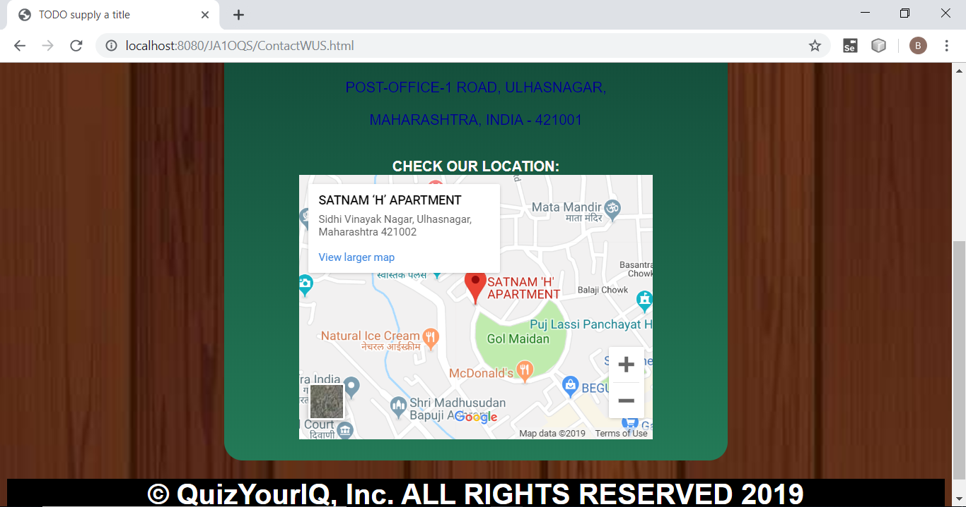

**BY CLICKING ON THE CONTACT NUMBER YOU CAN CALL:**

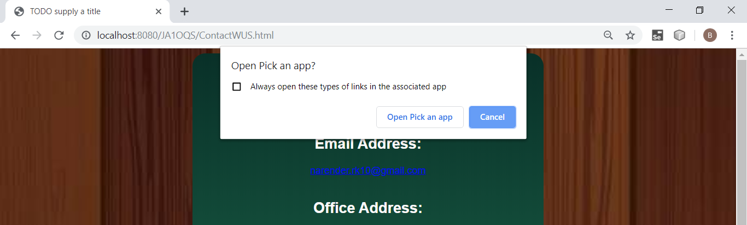

**BY CLICKING ON THE EMAIL ADDRESS YOU CAN EMAIL:**

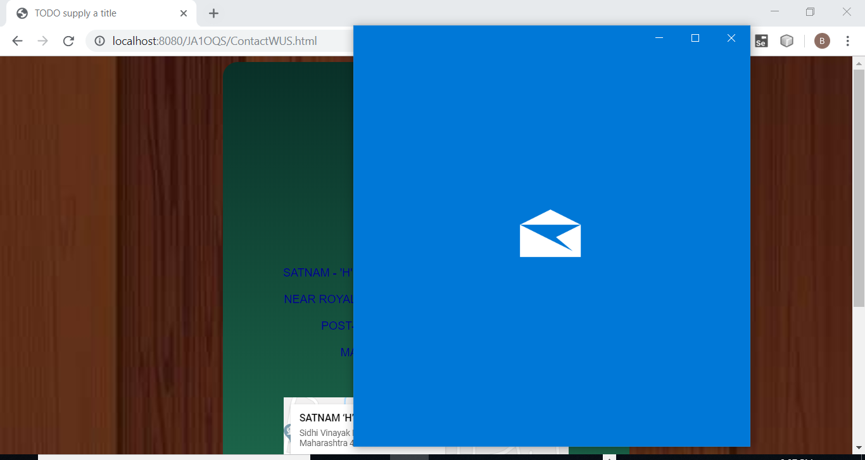

**BY CLICKING ON THE GMAPS:**

**YOU WILL REDIRECTED TO THE LOCATION IN THE MAP**

1. **CLICK ON THE “FEEDBACK” IN THE MENU-BAR:**



**ENTER YOUR FEEDBACK WITH NAME,PHONE & EMAIL:**

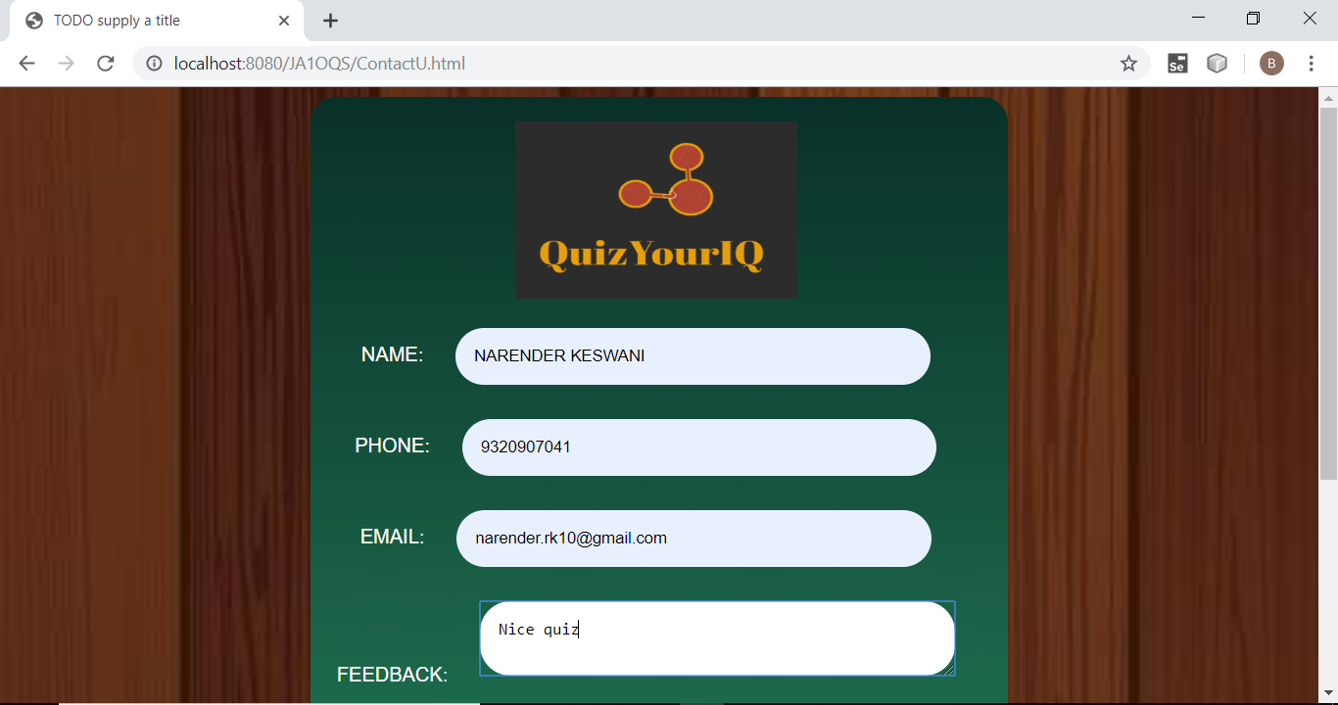

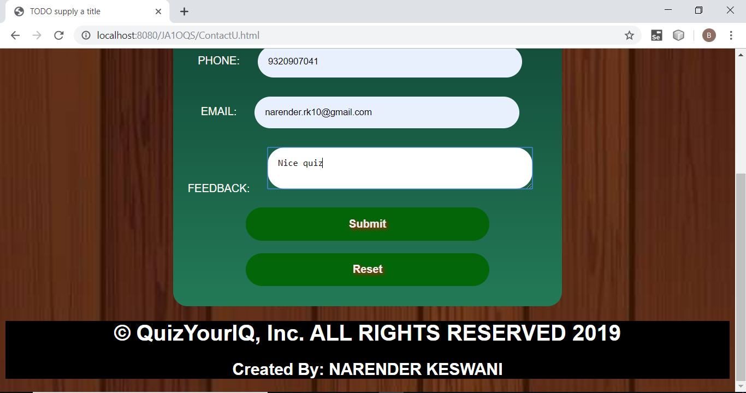

**PRESS “SUBMIT” ,YOU WILL GET A NOTIFICATION THAT YOUR FEEDBACK HAS SUCESSFULLY REGISTERED WITH US**

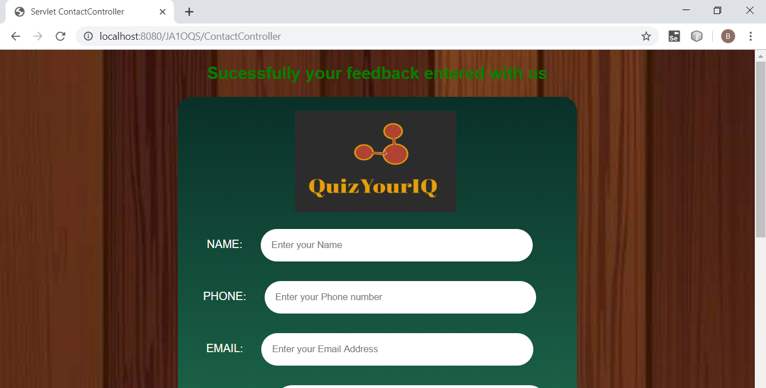

1. **CLICK ON THE “ADMIN” IN THE MENU-BAR:**



**ENTER ADMIN USERNAME & PASSWORD:**

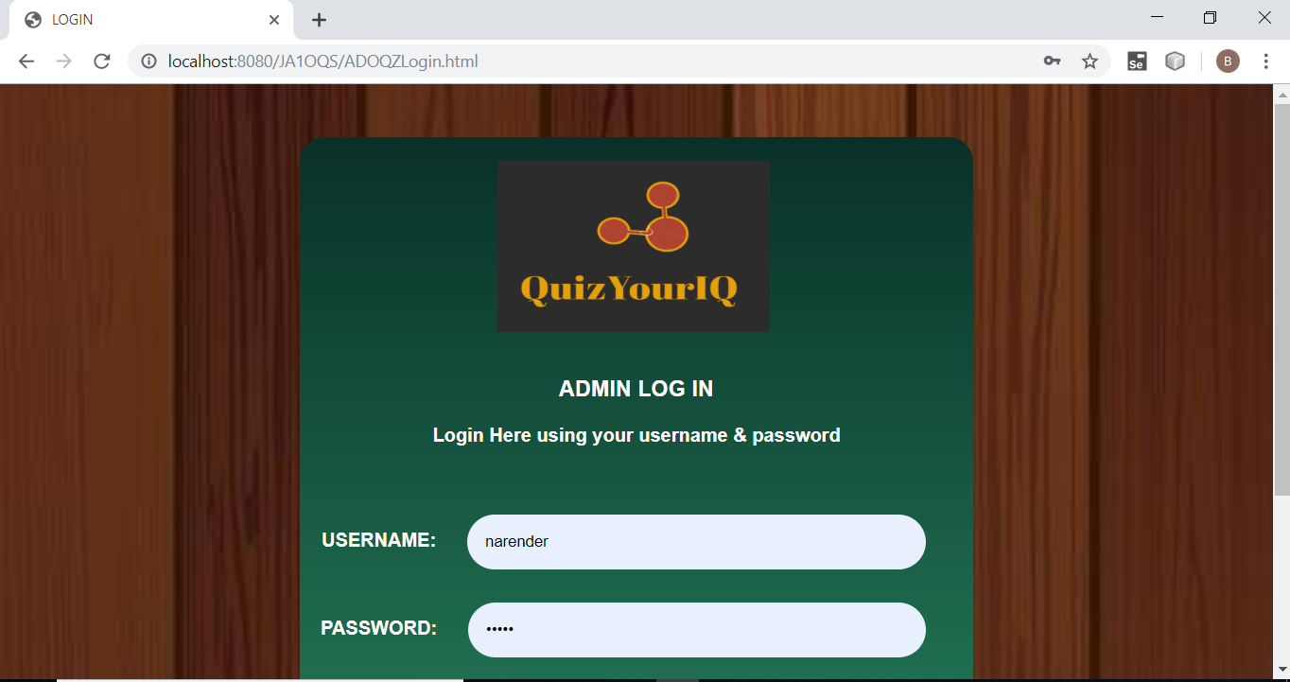

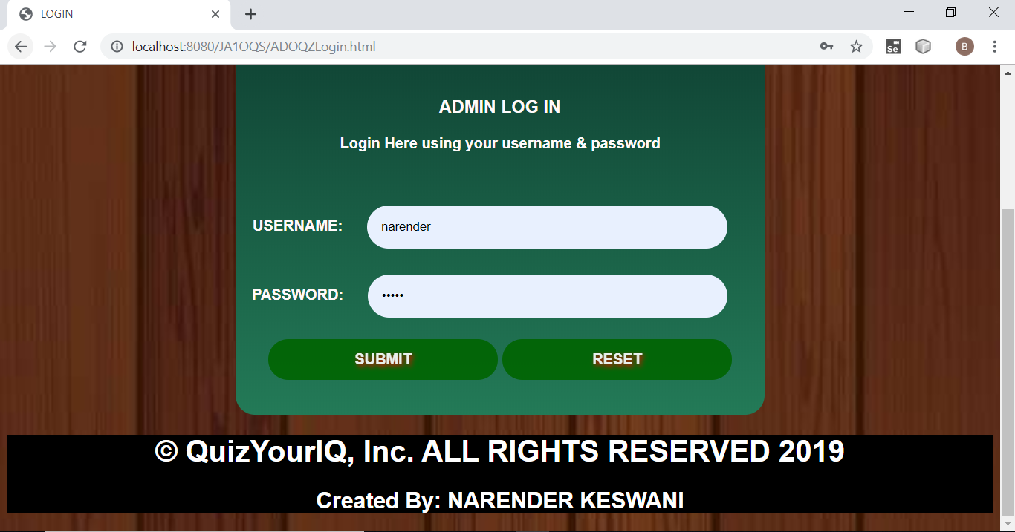

**NOW, CLICK ON THE “SUBMIT” FOR TO LOGIN.**

**& IT WILL SUCESSFULLY LOG IN .**

**IF ADMIN ENTERS THE INVALID USERNAME / PASSWORD:**

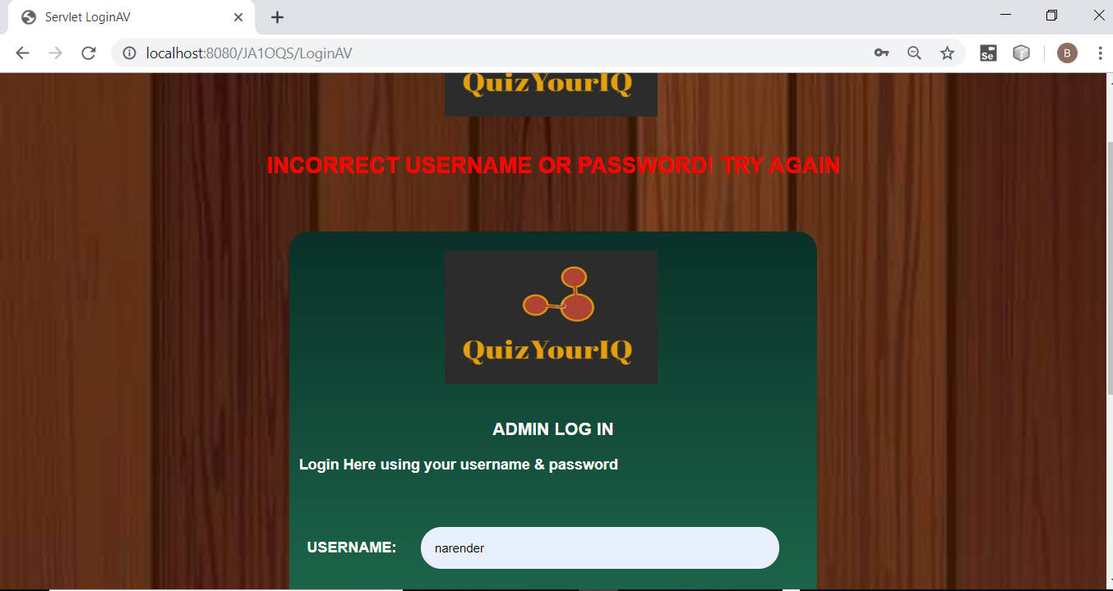

1. **CLICK ON THE “INSERT QUESTIONS” IN THE ADMIN MENU-BAR:**

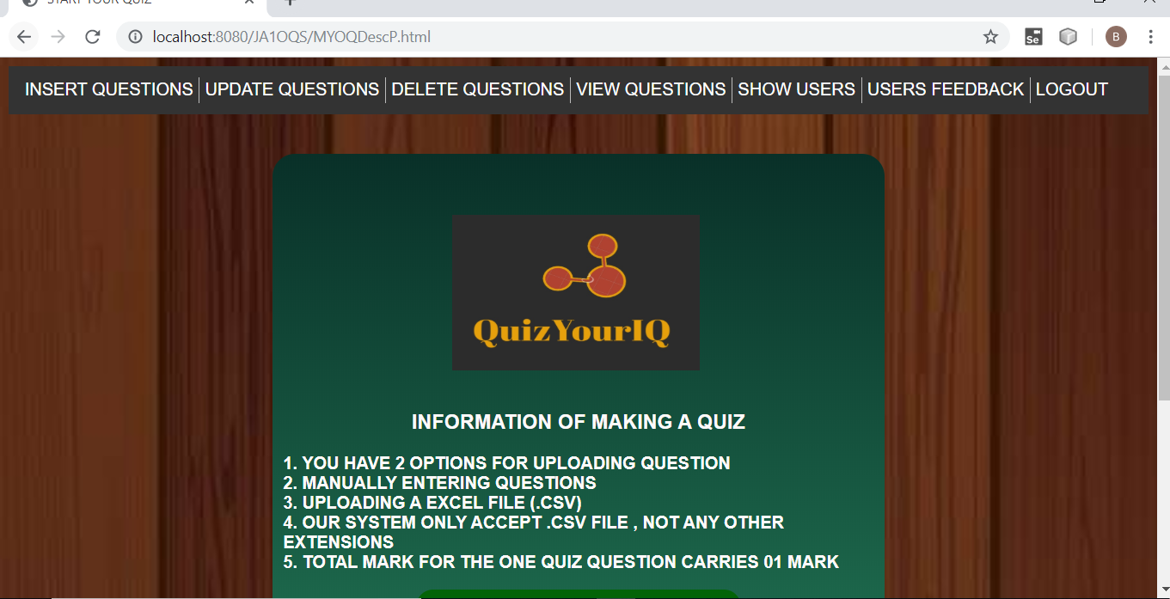

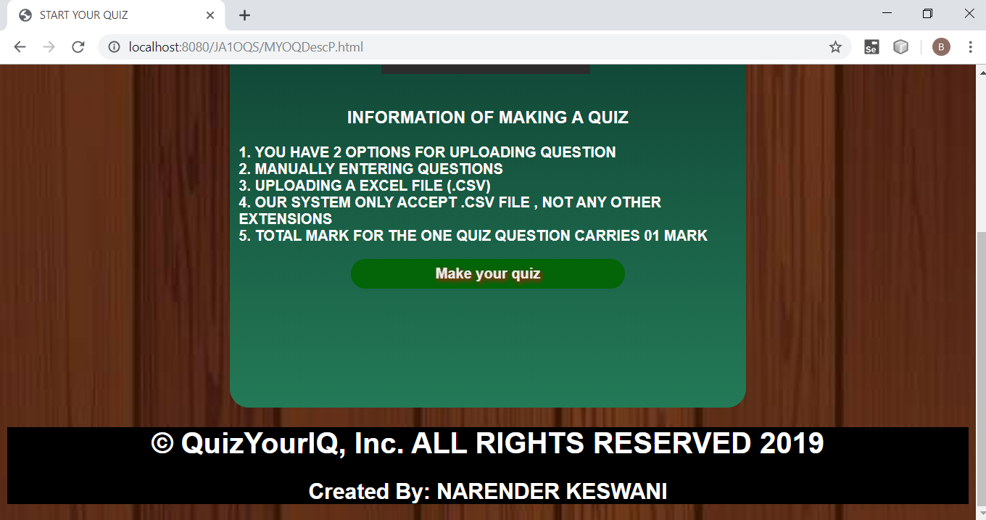

**CLICK ON THE “MAKE YOUR QUIZ”:**

**YOU WILL GET 2 OPTIONS:**

1. **UPLOAD QUESTIONS MANUALLY**
2. **UPLOAD EXCEL FILE**

**A) FOR UPLOAD QUESTIONS MANUALLY PRESS IT:**

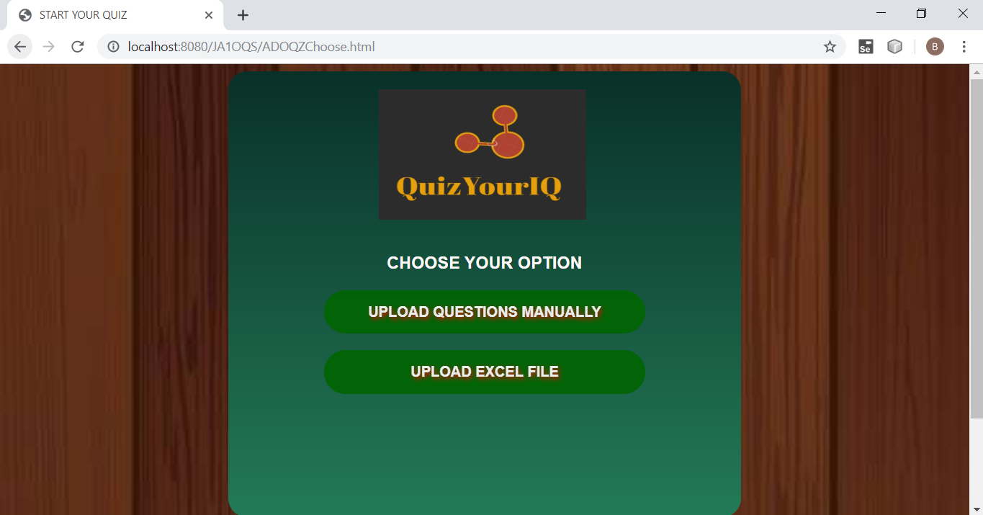

**SELECT YOUR TEST TITLE:**

**THEN INSERT QUESTIONS, 4 OPTIONS, 1 CORRECT6 ANSWERS:**

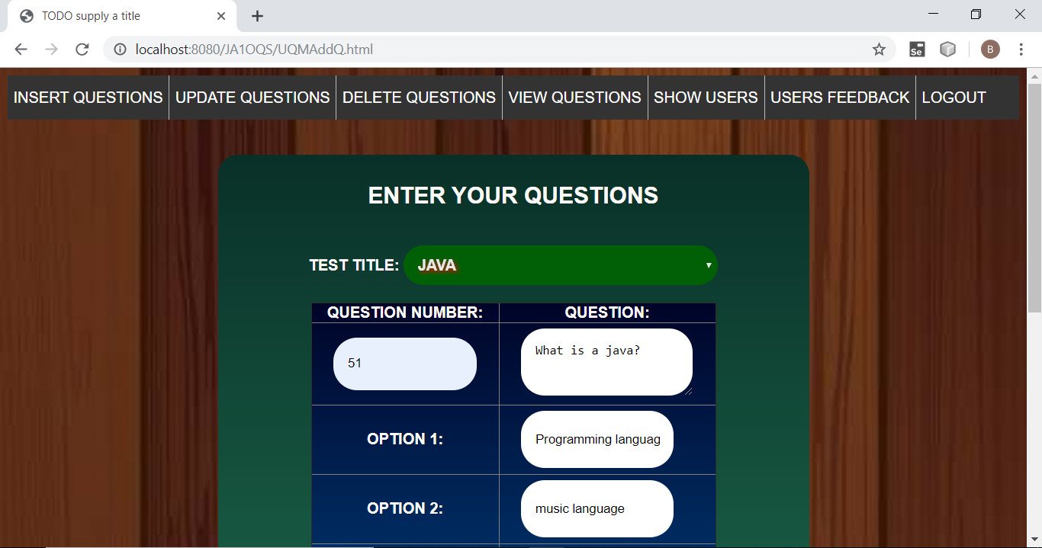

**THEN, PRESS ON THE “SAVE YOUR QUESTIONS”:**

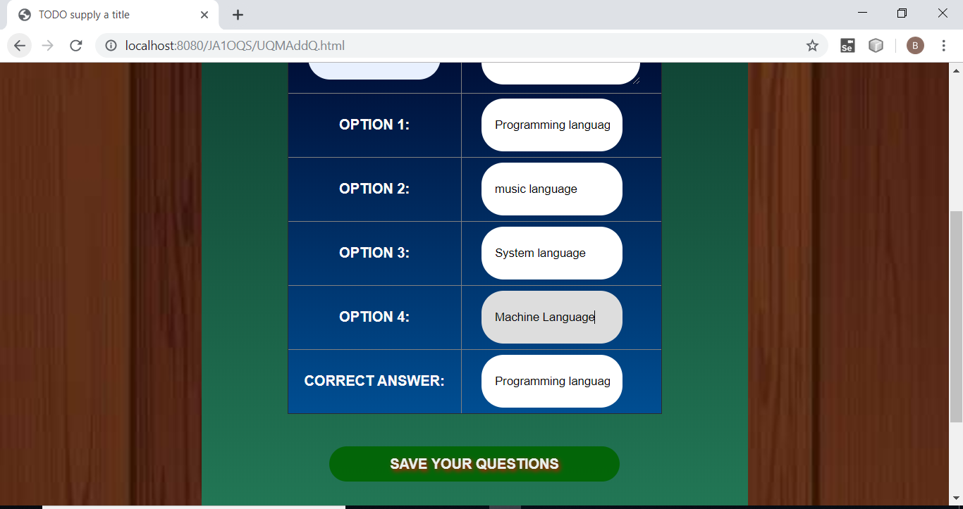

**YOU WILL GET A NOTIFICATION THAT GIVE MESSAGE “YOUR QUESTIONS ARE SUCESSFULLY UPLOADED”**

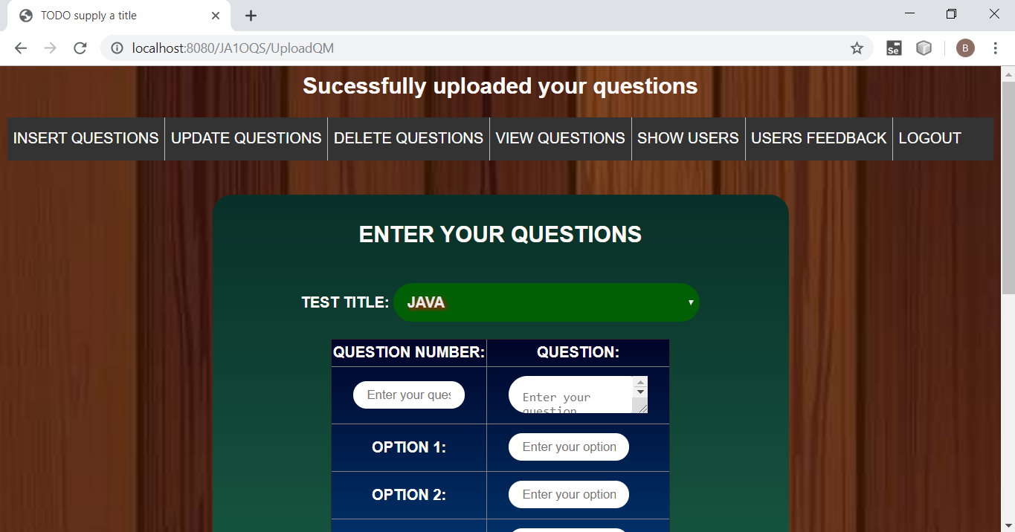

**SYSTEM ADMIN/ENGINEER CAN SEE IN THE DATABASE:**

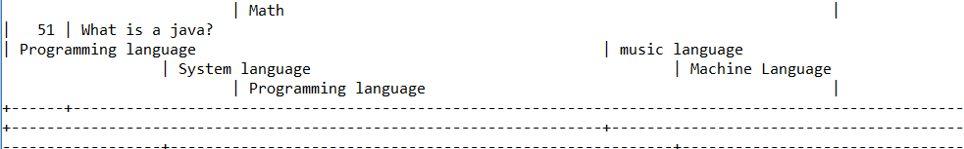

**B)PRESS ON THE “UPLOAD EXCEL FILE”**

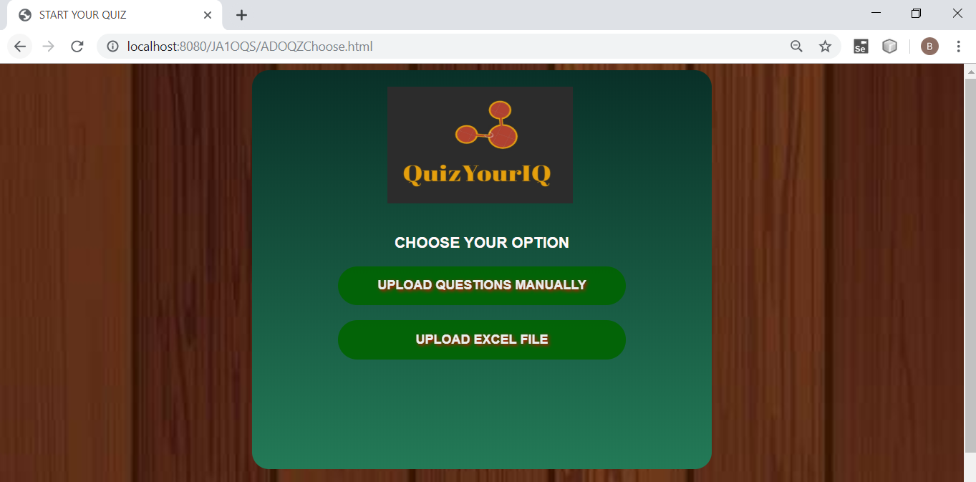

**EXCEL FILE SCREENSHOT: (qeg.csv)**

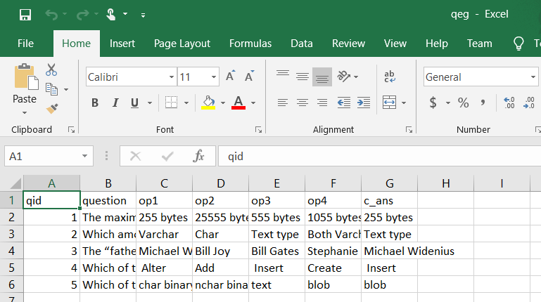

**SELECT THE TEST TITLE, AND CHOSE YOUR FILE:**

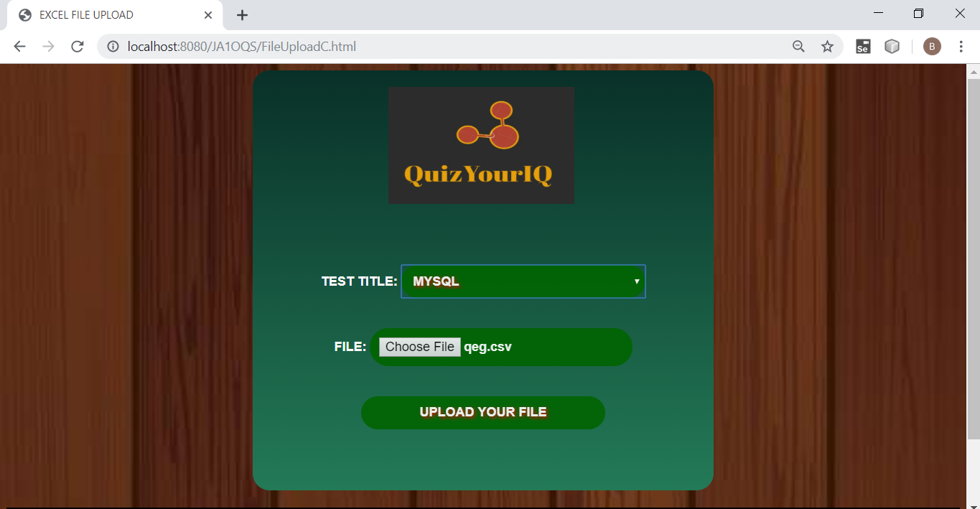

**PRESS ON THE “UPLOAD YOUR FILE”**

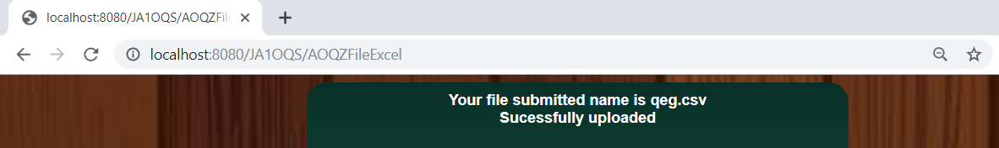

**MYSQL:**

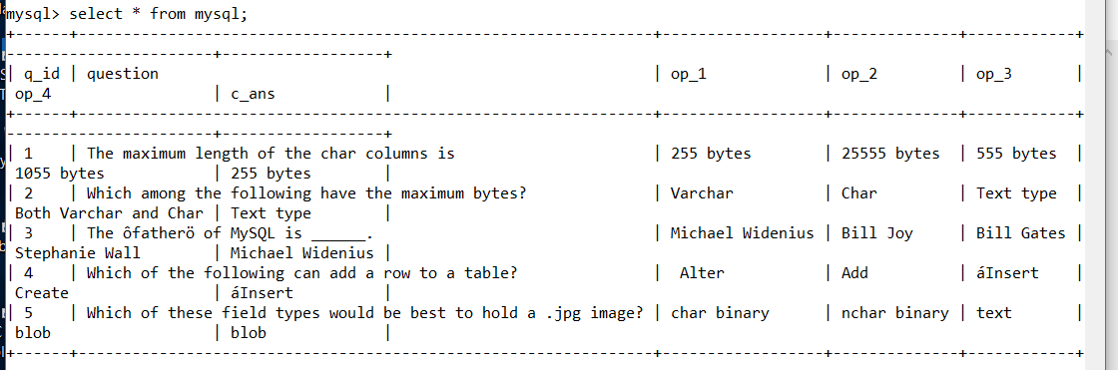

**CLICK ON THE “UPDATE QUESTIONS”:**

**SELECT YOUR QUIZ & PRESS UPDATE:**

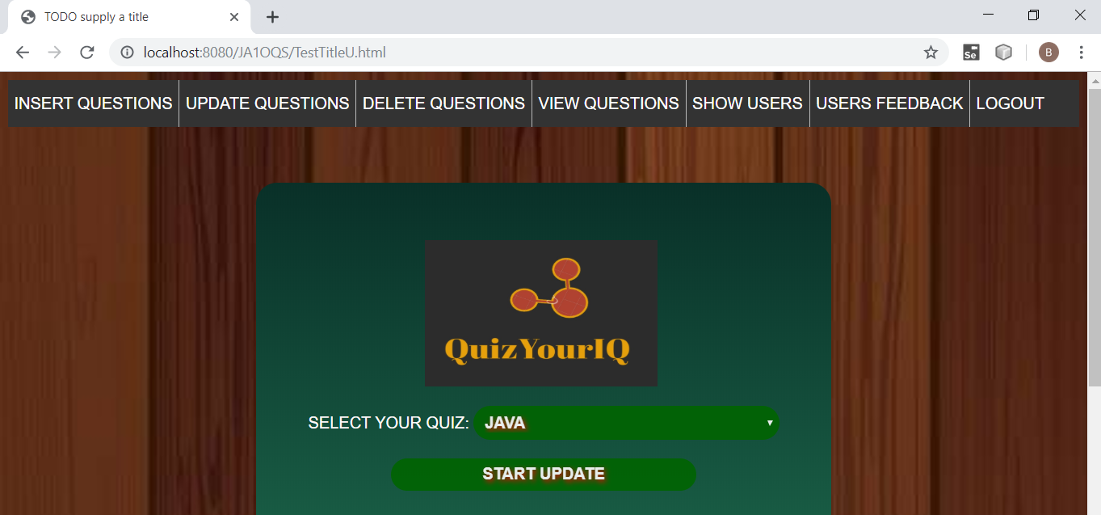

**ALL QUESTIONS WITH OPTIONS WILL BE DISPLAYED AND ADMIN HAS TO CLICK ON “UPDATE” FOR SPECFIC UPDATION OF A QUESTION:**

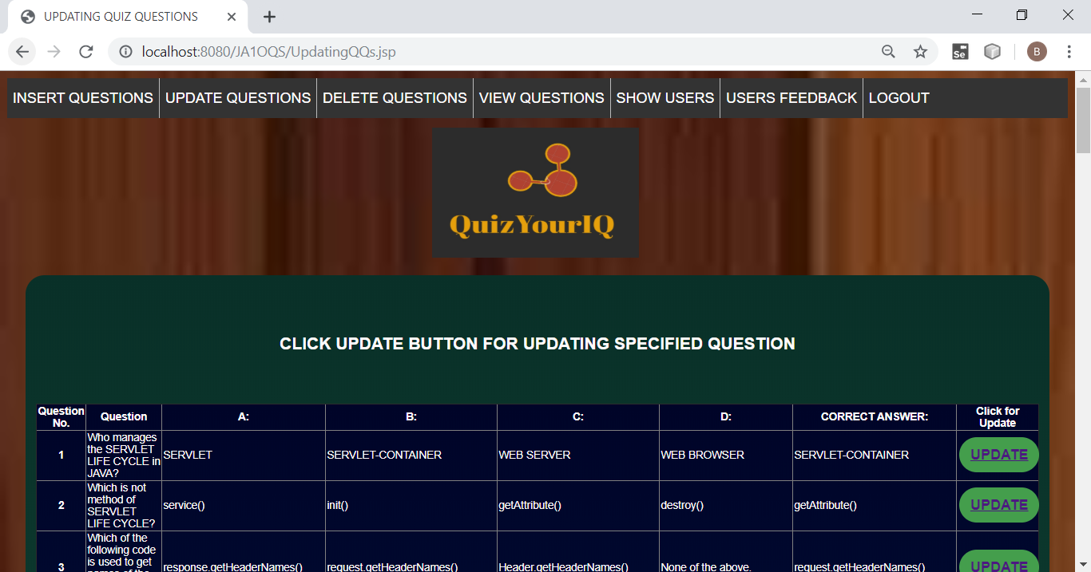

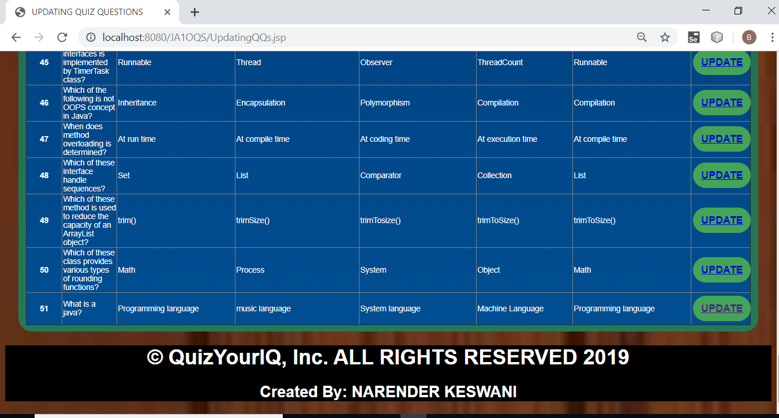

**SUPPOSE I CHOOSE 51 Q TO BE UPDATED: PRESS UPDATE:**

**EDIT IT:**

**PRESS NOW “UPDATE YOUR QUESTIONS”:**

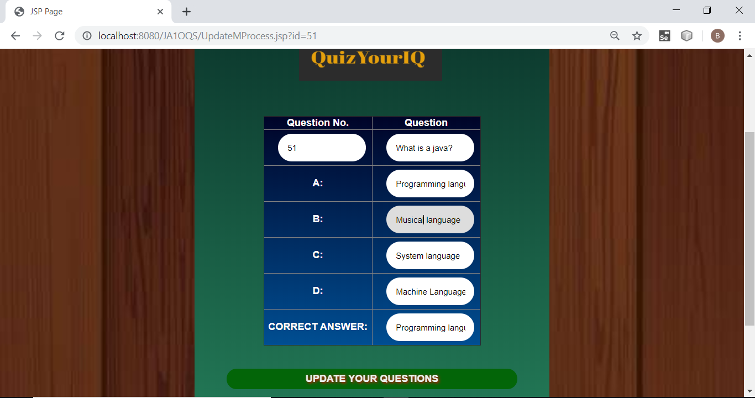

**A MESSAGE WILLA RRIVE SAYING THAT “ YOU HAVE SUCESSFULLY UPDATED”**

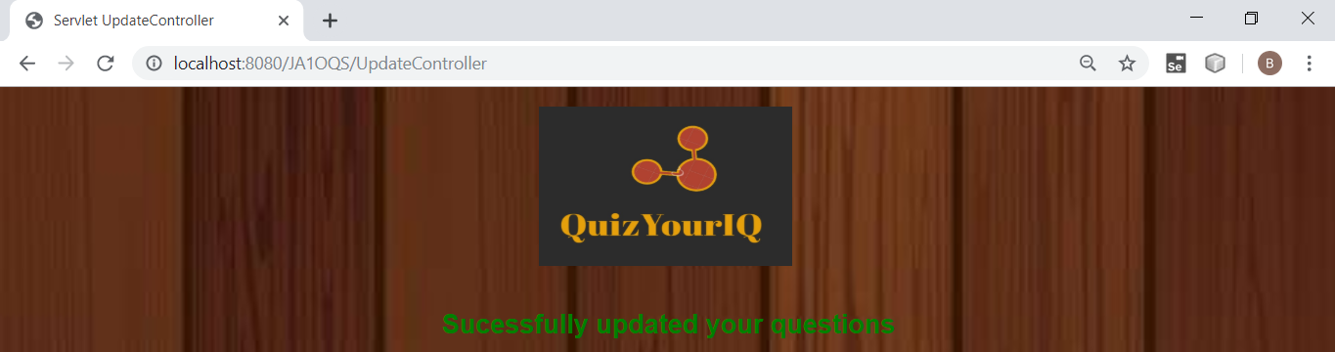

1. **SELECT TITLE:**

**PRESS ON “START DELETE”:**

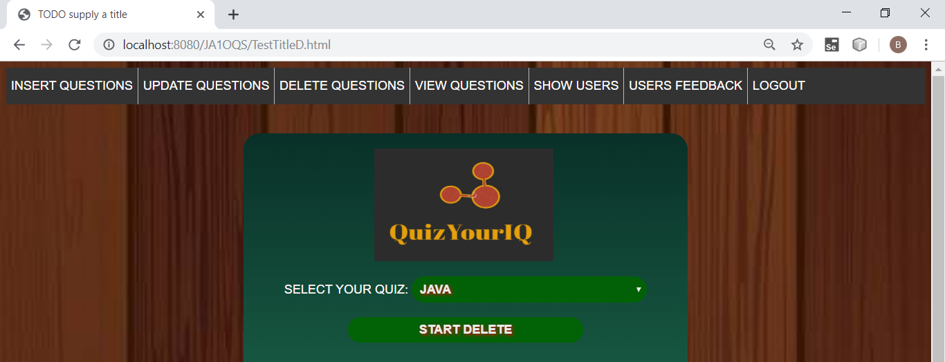

**SELECT THE CHECKBOX WHICH YOU WANT TO DELETE:**

**SUPPOSE I HAVE CHECKED Q51:**

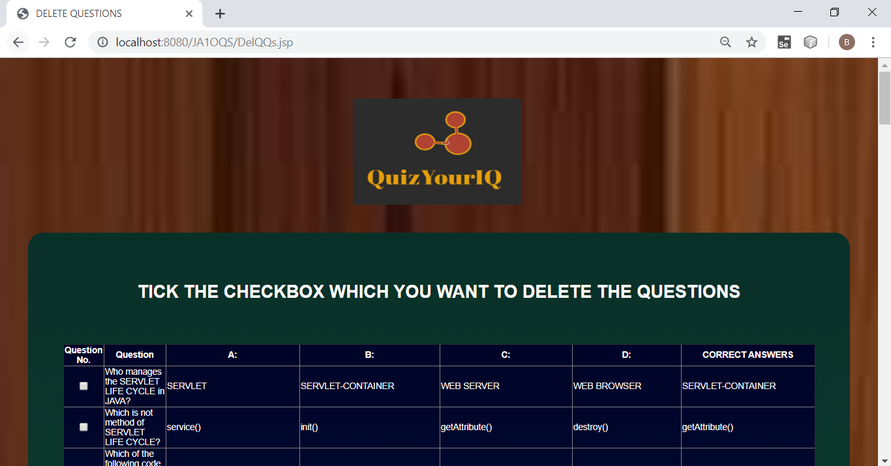

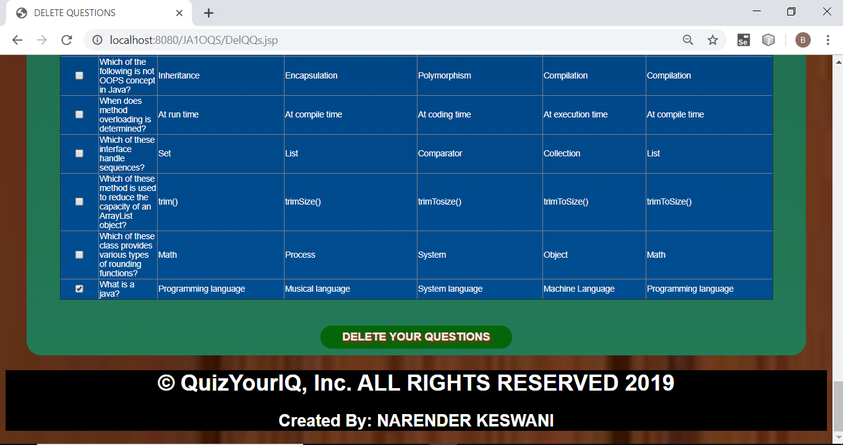

**NOW, CLICK ON THE “DELETE YOUR QUESTIONS”:**

**YOUR QUESTION/QUESTIONS WILL BE DELETED.**

1. **VIEW QUESTIONS:**

**SELECT YOUR QUIZ FIRST THEN PRESS ON “VIEW QUESTIONS”:**

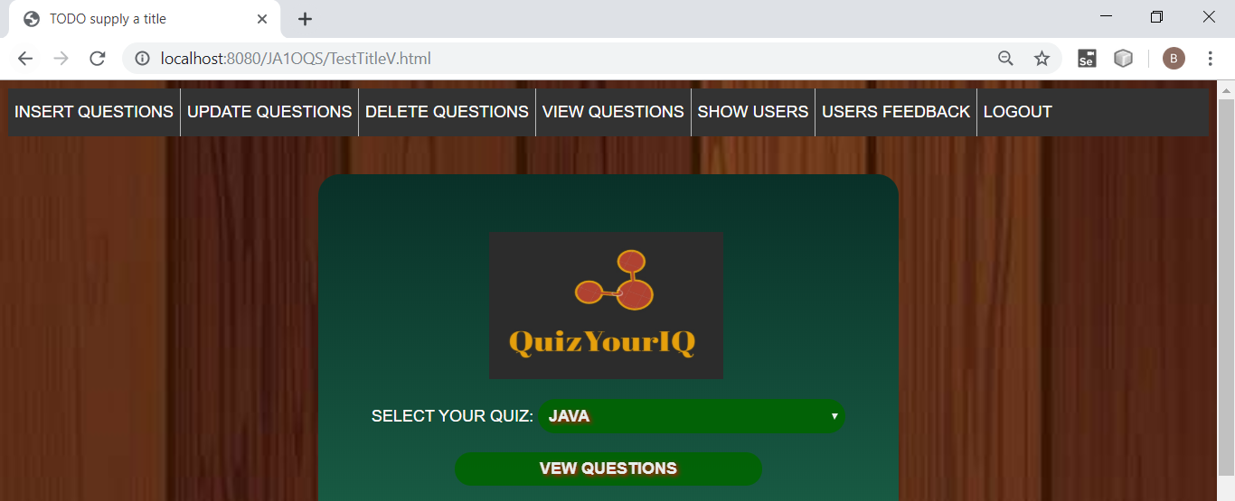

**THAT PARTICULAR QUIZ WILL BE OPENED:**

**USEFUL AFTER DELETING, INSERTING,UPDATING,ETC**

**TO CHECK THE WHETHER QUESTIONS PROPER OR NOT**

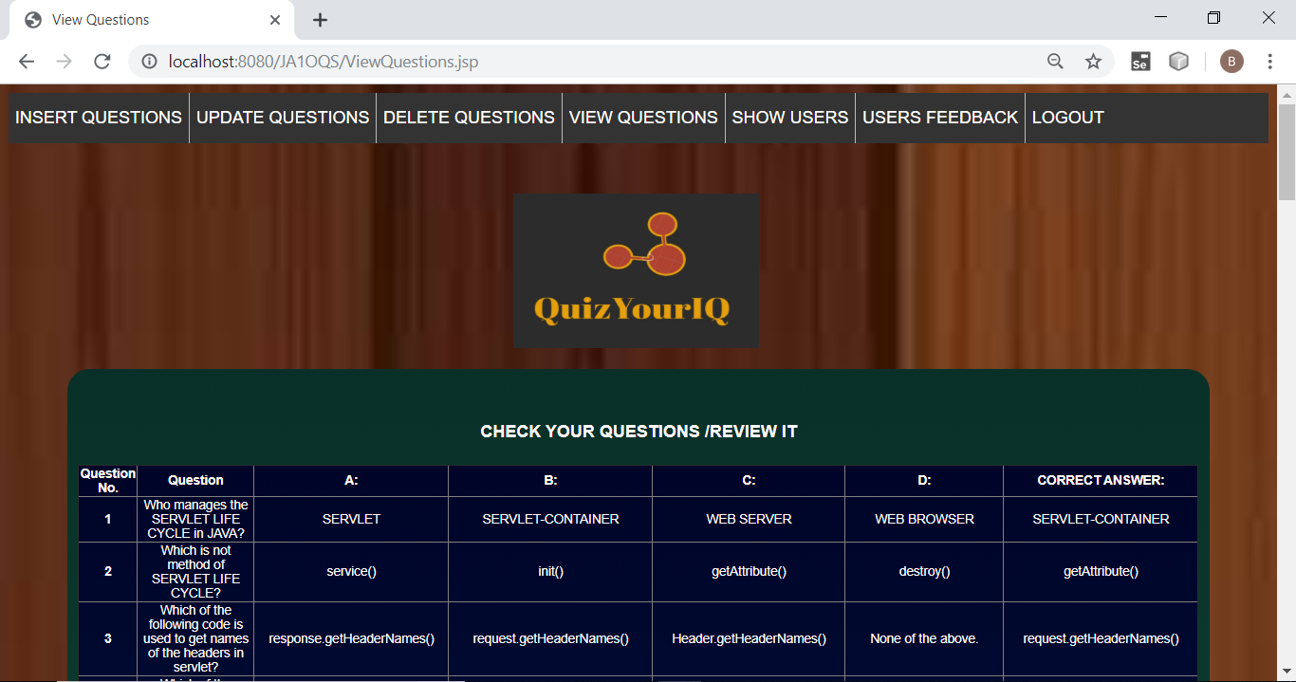

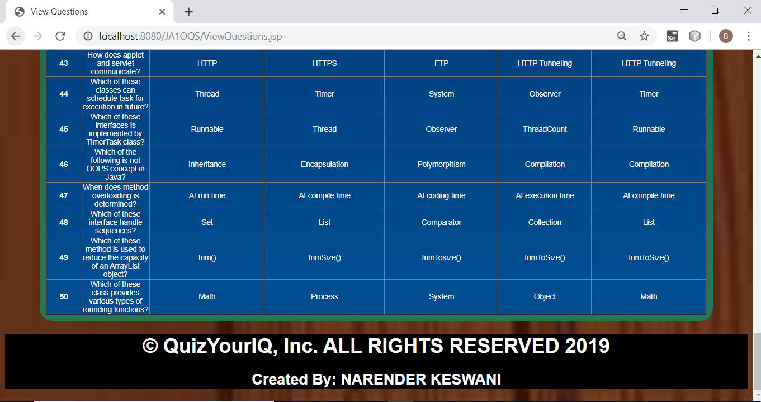

1. **ADMIN CAN CHECK HOW MANY N WHO ARE REGISTERED WITH THE SYSTEM**

**CLICK ON “SHOW USERS”**

**& VIEW IT**

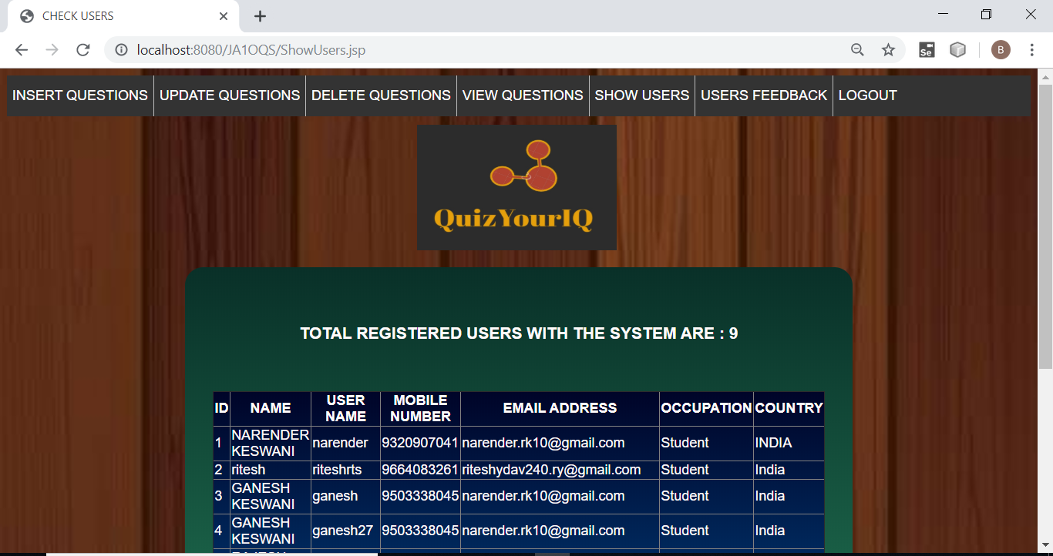

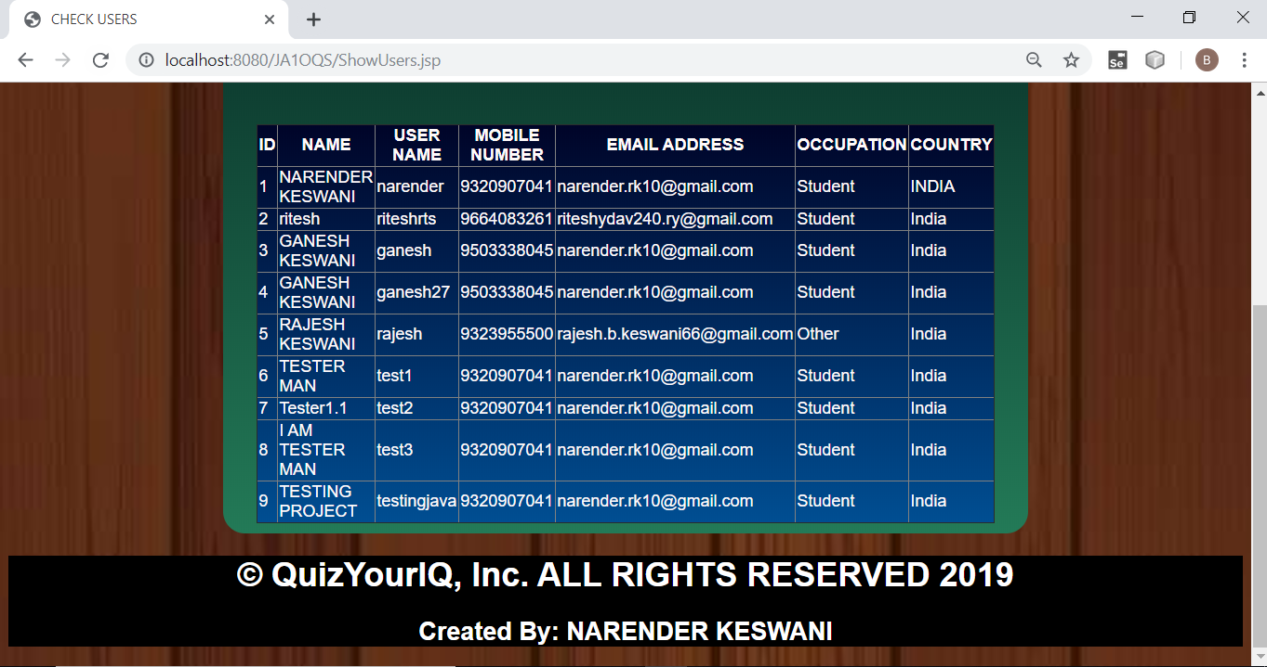

1. **ADMIN CAN SEE WHAT THE CUSTOMER/STUDENTS ARE THINKING FOR THE QUIZES AND THE SYSTEM:**

**CLICK ON THE “USERS FEEDBACK”**

**& VIEW IT**

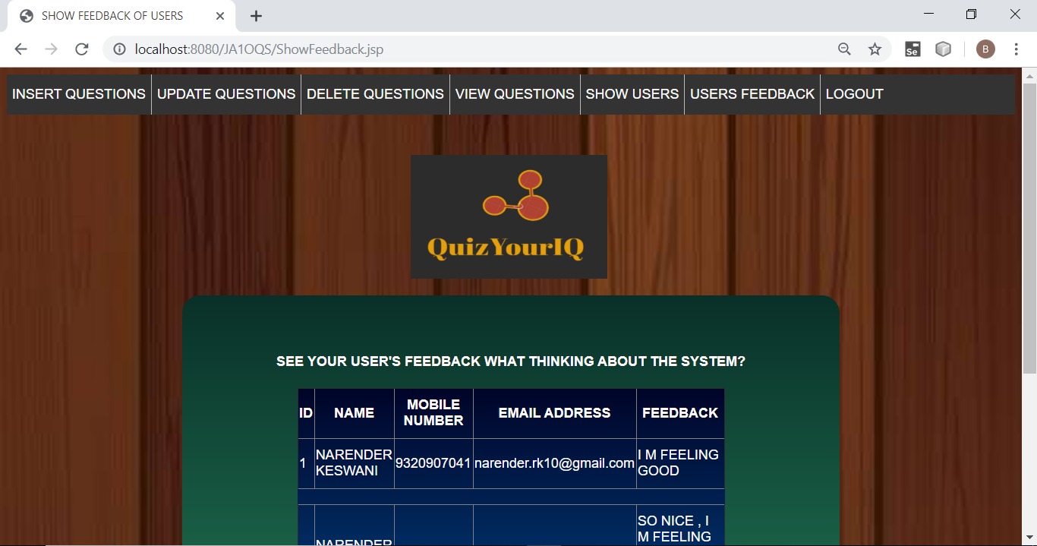

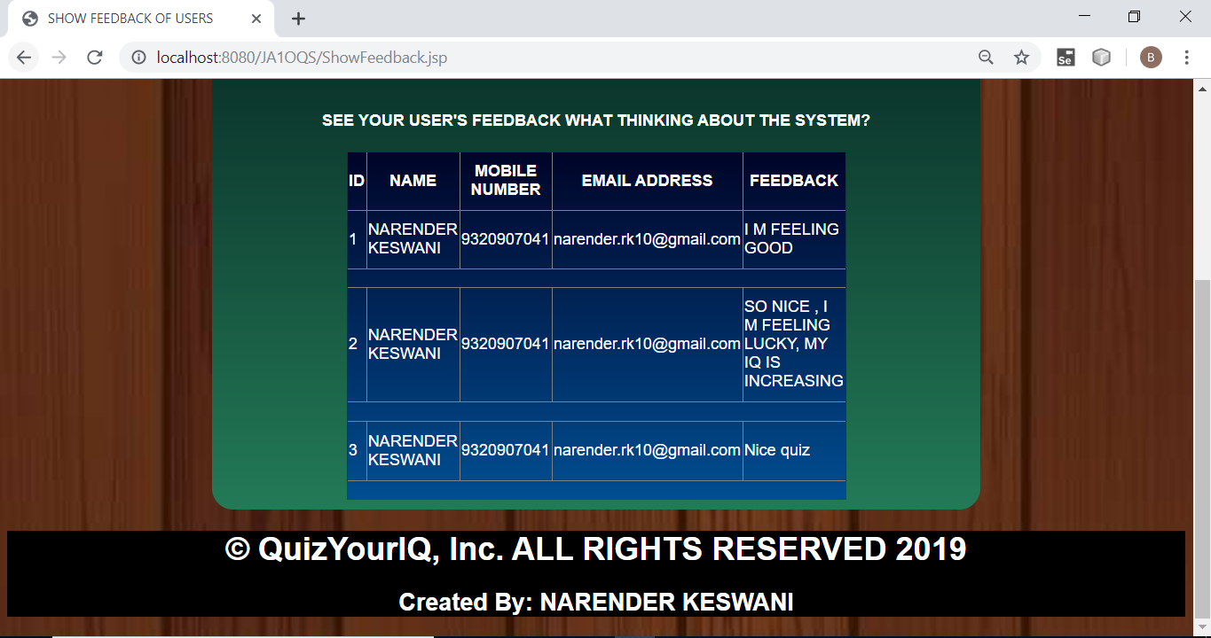

1. **IF ADMIN WANT TO LOGOUT FROM THE SYSTEM:**

**CLICK ON THE LOGOUT, ADMIN WILL BE LOGOUT.**

**IF ADMIN WANTS TO LOGIN AGAIN; CLICK ON THE LOGIN.**

